Human rights and procurement: A guide for government buyers

Human rights and procurement: A guide for government buyers
Version | Date | Comments
v1.0 | July 2021 | Published
v1.1 | September 2025 | Minor updates made – highlights:  - DHPW corporate branding  - Machinery-of-government changes  - Hyperlinks verified and updated or removed  - Document date updated  - New version history log and ‘Administration’ section added  - Updated document title  - Removed contextual policy information

The State of Queensland (Department of Housing and Public Works) 2025.
http://creativecommons.org/licenses/by/4.0/deed.en
This work is licensed under a Creative Commons Attribution 4.0 Australia Licence. You are free to copy, communicate and adapt this work, as long as you attribute by citing ‘Human rights and procurement: A guide for government buyers, State of Queensland (Department of Housing and Public Works) 2025’.
Contact us
We are committed to continuous improvement. If you have any suggestions about how we can improve this document, or if you have any questions, contact us at betterprocurement@hpw.qld.gov.au.
Disclaimer
This document is intended as a guide only for the internal use and benefit of government agencies. It may not be relied on by any other party. It should be read in conjunction with the Queensland Procurement Policy, your agency’s procurement policies and procedures, and any other relevant documents.
The Department of Housing and Public Works disclaims all liability that may arise from the use of this document. This document should not be used as a substitute for obtaining appropriate probity and legal advice as may be required. In preparing this document, reasonable efforts have been made to use accurate and current information. It should be noted that information may have changed since the publication of this document. Where errors or inaccuracies are brought to attention a reasonable effort will be made to correct them.
Administration
Version 1.1 of this document replaces all previous versions of this document and takes effect immediately.
Table of Contents
Introduction 4
Objectives and obligations of the Human Rights Act 2019 4
Your agency’s obligations 4
Your obligations 4
Applying human rights considerations to the procurement process 4
Principles 5
Preparation 5
Integrity, probity and accountability 5
Managing risk 5
Complaints mechanisms 5
Engagement 6
Procurement stages 6
Example: Undertaking a criminal history check of a potential supplier 8
Sample contract clauses 8
Complaints and remedies 9
Complaints management 9
Responsibility for resolving human rights complaints 9
Complaints processes 9
Useful resources 9
Other information 10
Frequently asked questions 11
Appendix 1 – Example procurement processes 17

Introduction
The Human Rights Act 2019 (the HR Act) protects the human rights of every person in Queensland when interacting with the Queensland Government (and other public entities). As public service employees, the HR Act makes sure we are thinking about the impact that each act and decision may have on the human rights of Queenslanders whenever we create new laws, apply policies and procedures, and undertake procurement activities.
There are 23 human rights protected under the HR Act. Details of each right, including examples, are available on the Queensland Human Rights Commission (QHRC) website.

Objectives and obligations of the Human Rights Act 2019
The HR Act aims to ensure that public functions, like procurement, are exercised in a way that is compatible with human rights. Importantly, the HR Act serves to promote a discussion and deeper understanding about the nature, meaning and scope of human rights for the Queensland community.
The HR Act forms part of the administrative law and oversight mechanisms that hold the government accountable, such as the:
- Right to Information Act 2009
- Information Privacy Act 2009
- Judicial Review Act 1991
- Ombudsman Act 2001
- Anti-Discrimination Act 1991
- Crime and Corruption Act 2001.

It also aims to ensure proper consideration is given to human rights in government decision-making. This includes decisions made during planning, sourcing and contract managing a procurement activity.

Your agency’s obligations
All Queensland Government agencies are public entities under the HR Act. They are responsible for the implementation of the HR Act, as well as efforts to embed human rights in their everyday work and build a human rights culture.
Contact your Corporate Services area for information regarding the HR Act and any internal procedures developed for your agency.

Your obligations
As a public sector employee, your acts and decisions in discharging the duties of your role, will contribute to human rights being upheld by your agency. It is your responsibility to ensure you build your understanding of the HR Act, what the human rights are, and how they may impact your procurement role specifically.

Applying human rights considerations to the procurement process
Human rights need to be considered as a part of all procurement decision-making and actions. In some cases, where you have identified that the potential human rights impact of a procurement activity is direct and significant, managing human rights risks will be an essential consideration to be included in the earliest planning stages of a procurement process and carried through to contract management.
Some examples of contracts which may have a direct or significant human rights impact are contracts which represent either large-scale or significant social, economic or environmental risks or opportunities, such as those involving resourcing like oil, gas or mining; large agricultural projects; infrastructure projects, such as for the construction of highways, railways, ports, dams, hospitals, schools; funded social and community support services; or those for the development and operation of water and sanitation systems. These project examples could potentially result in the displacement of people, damage or disturbance to food or water supplies, damage to culturally significant locations or inability to access education or health services. It is important to ensure human rights are properly considered and balanced throughout the procurement process.
The approach taken to integrate human rights considerations into your procurement process will vary from activity to activity, however, action can be taken at each stage, guided by some human rights risk management principles.

Principles

Preparation
The first step to demonstrating that proper consideration of human rights has been undertaken by any one individual, is to ensure that all procurement officers, contract managers and decision makers are adequately prepared and have capability to address human rights impacts in a procurement activity.
At a minimum, all employees who may undertake purchasing or procurement as part of their roles, are strongly encouraged to complete introductory HR Act training. Keeping a record of training completed, can be used as evidence of an officer’s capability to provide proper consideration as part of their role.
There are several resources and training options available to raise awareness of human rights and applying human rights at work. Free online training is available on the Human Rights portal and additional training courses on the QHRC website.

Integrity, probity and accountability
Considering human rights in procurement helps demonstrate a culture of ethics, integrity, probity and accountability which is central to returning respect for Queensland taxpayers’ money.
Laws, regulations and standards governing a particular project or contract, will also act to facilitate the prevention, mitigation and resolving of potential human rights impacts, for example the Building Act 1975, Disability Standards for Accessible Public Transport 2002, and Information Privacy Act 2009.

Managing risk

If a supplier is considered a public entity (as defined by the HR Act), including where the supplier performs services for or on behalf of the State as a functional public entity, it will have obligations under the HR Act, and therefore carry risk in managing its delivery in a manner consistent with the HR Act. In managing potential adverse human rights impacts consider if it is appropriate to ensure responsibilities for suppliers are made clear and agreed to in invitation documents and contracts.

Complaints mechanisms
Individuals and communities can raise concerns and make complaints about government projects or service delivery which are impacting their human rights. Ensuring your agency has a robust complaints management system and that it has been updated to include human rights complaints, will enable appropriate action to occur in a timely and sufficient manner.

Engagement
Community and early market engagement may assist procurement teams to identify potential human rights impacts, resulting from a proposed procurement activity. Early intelligence and continued checking throughout the procurement process can help to limit, reduce or address impacts as they are identified. Checks throughout the process may be simpler than an initial assessment (further detail on what this means is provided below).

Procurement stages
While human rights are required to be considered for all decisions and actions made at all levels of government, a practical way to show compliance with HR Act obligations is to conduct a human rights impact assessment at the outset of the procurement process when you have identified a requirement to procure a good or service. This initial assessment may be used as a starting point to demonstrate consideration of human rights and should be revisited at each decision-making trigger point in the sourcing, contract award and management stages of a procurement. Refer to Appendix 1 for stages of procurement and decision-making trigger points.
The following recommended actions set a minimum standard for meeting proper consideration of human rights and demonstrating a culture of ethics, integrity, probity and accountability.
Note: Examples in this document are hypothetical, for illustrative purposes and are not prescriptive. They provide guidance only and should not be relied upon in exchange for obtaining legal advice when in doubt. Decision makers need to consider the context of the procurement activity for each decision they make.

Stage | Recommended actions
Planning | Complete the online human rights decision making tool to demonstrate proper consideration of human rights for your procurement activity.  Keep in mind the following questions when considering which, if any, human rights may be impacted or limited by the decisions or actions of the procured good or service:  - what is the intended outcome of the procurement activity (e.g. build a school, purchase stationery for staff, deliver psychological support service to employees)  - what role the supplier may have (i.e. corporation, core public entity, functional public entity).  When determining if your procurement activity is going to have human right impacts be sure you understand:  the 23 human rights  the objective of the procurement  the nature and risk of the good and/or service to be procured  how the good and/or service is to be delivered (e.g. consider questions on the delivery model, and whether any risks will be transferred to the supplier)  what are the main decision points in your procurement process starting from planning through to contract award and management? (refer to Appendix 1 for examples of procurement decision-making points)  Recording your consideration and any decisions for justification and compatibility with the HR Act at this stage could constitute the initial human rights assessment.  Invitation document development  Using invitation and contract templates which include and/or reference standard terms and conditions relating to HR Act obligations and other ethical considerations (such as the Modern Slavery Act 2018). Refer to the General Goods and Services Category clauses incorporated in the standard terms and conditions (see ‘Sample contract clauses’ section below).  If the successful supplier is likely to have obligations under the HR Act, this can be made clear in the invitation document and resulting contract.  Developing and incorporating monitoring and/or reporting requirements in the invitation document and resulting contract, acts as an assurance that the supplier is meeting its obligations.
Go to market and evaluate | Revisit the initial human rights impact assessment and consider whether the assessment should be modified or adopted at this stage of the process.  Informing suppliers that they may have obligations under the HR Act and ensuring they undertake their activities in a manner that is consistent with the HR Act.  - Seeking independent legal advice if there are any challenging HR Act-related questions raised prior to invitation close and providing equal access to suppliers for any response.  - Conducting the evaluation process having regard to decisions and actions that may require a further assessment of human rights, for example:  - short-listing  - negotiation  - evaluation panel recommendation  - decision by the delegate to approve evaluation panel recommendation.  - Ensuring any HR Act-related requirements (including any terms and conditions) outlined in the invitation documents, and commitments made by the preferred supplier, are captured in the resulting contract.
Manage and administer contract | Revisit the initial human rights impact assessment and consider whether the assessment should be modified or adopted at this stage of the process.  - Managing the contract having regard to decisions and actions that may require a further assessment of human rights, for example:  - contract disputes  - contract variations, extensions, renewals and terminations.  - Ensuring any HR Act-related commitments made by the preferred supplier are delivered in accordance with agreed monitoring and reporting arrangements.

Example: Undertaking a criminal history check of a potential supplier
Privacy and reputation -s25:
A person has the right -
a) not to have the person’s privacy, family, home or correspondence unlawfully or arbitrarily interfered with; and
b) not to have the person’s reputation unlawfully attacked.
The requirement to undergo a criminal history check will impact on a person’s privacy and potentially reputation. Conducting a criminal history check may limit an applicant’s right to privacy. While recent convictions are a matter of public record, warnings and spent convictions may be considered to be private. If the criminal history check is consistent with the warnings and spent conviction regime under the Criminal Law (Rehabilitation of Offenders) Act 1986, it is likely that the right to privacy will not be engaged.
Undertaking a due diligence process to determine if a company has been engaged in actions that are criminal (i.e. wage theft, industrial manslaughter, forced labour) or are unethical (e.g. as outlined in the Supplier Code of Conduct available on the ForGov website) business practices, will limit the right where questions are asked about individuals within a business (for example, asking about the actions of individual employees or company directors). The HR Act protects the rights of individuals in Queensland. A corporation does not have human rights.
This also means that if the supplier is a sole trader, and you are undertaking due diligence to check for criminal convictions, and seeking the disclosure of other private information, the individual (as the company owner) will have their right to privacy and reputation limited during this process. This does not mean that you cannot undertake such checks, it just means that you will need to actively consider whether it is a reasonable and justifiable limitation as part of your human rights impact assessment.

Sample contract clauses
The General Goods and Services category have standard terms and conditions available on the ForGov website which includes reference to HR Act obligations and other ethical considerations (such as the Modern Slavery Act 2018). Specific wording has been incorporated, as reviewed by Crown Law, which can be inserted into agency templates and contract terms and conditions.

Complaints and remedies
There is no stand-alone legal remedy for a contravention of the HR Act. However, a person may seek relief or remedy for a public entity acting unlawfully (as provided by section 58(1) of the HR Act) if there is another ground of unlawfulness.
Monetary damages will not be available for a contravention of the HR Act itself, but a person will be entitled to any other relief or remedy they could have obtained in relation to an independent cause of action (for example, in the case of judicial review, quashing or setting the decision aside, or referring the decision back to the original decision-maker for further consideration and redetermination). These remedies may be granted even if the person is not successful in their independent cause of action (except if it is damages).

Complaints management

Responsibility for resolving human rights complaints
Accountability for Queensland Government procurement activities, including investigating associated human rights complaints, remains with the agency procuring the goods or services. Agencies should consult their internal complaints management system policy and procedures to address concerns raised by a supplier or member of the public.

Complaints processes
From 1 January 2020 an individual can make a complaint if they believe a public entity has not acted or made a decision which is compatible with their human rights, or in making a decision, failed to give proper consideration to a human right relevant to the decision. An individual must first complain to the public entity involved. If they are not satisfied with the response after 45 business days, an individual may complain to the QHRC. In exceptional circumstances, the QHRC has the discretion to accept complaints earlier than 45 days. A human rights complaint can only be made after 1 January 2020 about an act or decision that occurs after 1 January 2020.
The Guide: Incorporate human rights into your complaints processes may be useful to assist you in preparing to receive and respond to human rights complaints from 1 January 2020. You should also refer to your agency’s internal complaint handling process.

Queensland Human Rights Commission
If someone has made a human rights complaint to a government agency and is unsatisfied with the agency’s response, they can escalate their complaint to the QHRC.
The QHRC’s role includes:
- promoting understanding and acceptance of human rights in Queensland
- providing education about human rights
- dealing with human rights complaints.
The QHRC will decide whether to accept a complaint and how to resolve it. One option is through an independent dispute resolution process.
Find out more information about the complaints process and potential resolutions on the QHRC website. Complaints can be made by submitting an online form on the website or contacting the QHRC on 1300 130 670.

Useful resources
Thinking about human rights and applying human rights at work can be challenging. This document provides hypothetical examples that show how human rights can apply in each procurement stage. It provides scenarios considering privacy and reputation and establishing an SOA.
Other guides that may be helpful:
- Nature and scope of the protected human rights—this guide provides detailed information about each of the protected human rights. Learning more about the rights will help you identify where they are engaged in your work. This document also provides examples of “policy triggers” for each of the protected rights to help highlight when these rights are relevant to your work.
- When human rights may be limited—this guide provides a list of questions to ask if you are thinking about limiting someone’s human rights.
- Human rights in decision making—this guide explains how to think about human rights when you make decisions at work.
You can find these and other useful resources on the Human Rights portal.
The QHRC has published a range of guides, tools, fact sheets, case studies, podcasts and videos to help with understanding and applying human rights. These can be accessed via the QHRC Resources webpage.

Other information
- A set of principles for integrating human rights considerations into government contracts is outlined in the Report of the Special Representative of the Secretary - General on the issue of human rights and transnational corporations and other business enterprises; Principles for responsible contracts: integrating the management of human rights risks into State-investor contract negotiations: guidance for negotiators (published by the Human Rights Council in 2011).
- The UN Guiding Principles on Business and Human Rights.
- ‘Protect, respect and remedy’ Framework.
- Human Rights training accessible through the QHRC website

Frequently asked questions
- Are all acts or decisions in a procurement process subject to s 58 (1) of the Human Rights Act 2019?
Yes, every act or decision, regardless of significance, made by a public entity (you) in the process of undertaking a procurement activity, is subject to human rights obligations under s58 (1) of the Human Rights Act 2019 (HR Act).

Section 58(1) of the HR Act provides:
It is unlawful for a public entity —
(a) to act or make a decision in a way that is not compatible with human rights; or
(b) in making a decision, to fail to give proper consideration to a human right relevant to the decision.

This includes acts and decisions ranging from minor administrative decisions associated with low value/ low risk direct purchases, to more significant milestone or core decision points, such as deciding the procurement method or obtaining delegate approval of the tender documents to go to market.

An act is defined in the HR Act to include a failure to act or a proposal to act. Ordinarily, to act is to perform actions, to do things.
A decision (to decide, to make a decision) is to come to a judgement, conclusion or resolution and should be applied broadly for the purposes of the HR Act. The word decision is not defined in the HR Act.

However, there are exceptions. Section 58(1) of the HR Act will not apply if:
- you could not reasonably have acted differently or made a different decision because of a statutory provision, a law of the Commonwealth or another State or otherwise under law. or
- the decision you do or make is in your private capacity, rather than in your capacity as a ‘public entity’.
- How do I give ‘proper consideration’ to human rights?
Human rights issues may arise during the course of a procurement process which warrant a stand-alone human rights impact assessment, such as initially during planning, or during the process at a core decision point. While there is no minimum level of detail required to evidence proper consideration there are some factors which will trigger further investigation.

More detailed consideration of human rights will be required where:
- the extent of the impact on human rights is significant
- a large number of people are impacted (e.g. regional community in the building of a dam, vaccination requirements for aged care facility visitation)
- the people impacted are more vulnerable (e.g. children, people with disability)
- there is adequate time available to give proper consideration (note: poor planning resulting in short planning timeframes does not remove the obligation to assess human rights considerations)
- the decision-maker is senior and/or has particular expertise (e.g. Director-General, Chief Financial Officer, General Counsel)
- Crown Law provides detailed advice on the compatibility assessment (e.g. for introduction of new Bills, Regulations or Acts).

These factors are relevant to whether a comprehensive human rights assessment report should be carried out and recorded (for example, a particularly large and obvious impact on human rights). If in doubt, procurement officers should err on the side of caution and record consideration of human rights and seek independent legal advice if necessary.

- What ‘level of evidence’ or documentation does the consideration need to have in order for me to discharge my obligations under s58 of the HR Act?
Key point – there is no minimum level of evidence or documentation, however it is recommended that any consideration made includes an assessment of risk, and if the risk of the human rights impact is significant, it is recommended to document the human rights assessment as suggested below.
It is important to note that for human rights, risk is not necessarily associated with monetary value, it is the potential risk of an individual’s human rights being impacted and sufficient proximity of the impact to the decision made, as described in Q7. Each agency will need to determine, in its procurement procedures, what level of documentation (if any) they require based on the potential or actual impact on human rights of the procurement activity and the decisions made.
For example, if a human rights complaint is received:
- Low risk of impact on human rights – a verbal affirmation or written statement that human rights have been considered (e.g. email, declaration) may be appropriate e.g. buying stationery on a corporate card.
- High risk of impact on human rights – more detailed consideration (e.g. HR impact assessment report) may be necessary E.g. land acquisition to build a dam, funded accommodation support services.

For a minor decision, made by a procurement officer, it may be enough to obtain a verbal or written statement from the person that they considered human rights. In the event of a human rights challenge, this may be further supported by evidence that the person undertook human rights training and that human rights have been embedded into agency policies and procedures that the person followed when making the decision. Other cases will require more detailed consideration of human rights (and evidence of that more detailed consideration could be through a HR impact assessment report).

Clearly, it is not feasible for public entities to record a detailed human rights impact assessment for every act or decision across a procurement process, nor is it necessary. Which acts and decisions require a more comprehensive HR impact assessment comes down to a risk assessment. Risk profiling for your procurement activity will be subject to internal risk assessment processes, but can be guided by what constitutes ‘proper consideration’ as described in Q2.

To further assist, Appendix 1 identifies three broad types of procurement processes available once an initial procurement requirement is identified:
- a direct purchase
- a new contract or arrangement/panel or
- use of an existing arrangement/panel.

There may be other types of procurement processes, however the approach to considering human rights will remain consistent.

Appendix 1 suggests that each procurement process may have the following core decision points:
a) deciding to procure goods and/or services (this is not included in the diagram, but is assumed to be the first step)
b) deciding whether the procurement requires a direct purchase, using a new contract or arrangement/panel, or using an existing arrangement/panel
c) going to market and evaluating
d) approving: the direct purchase, the need to seek tenders or quotes for a new contract or arrangement/panel, or approving the purchase from an existing arrangement/panel
e) evaluating quotes or offers and deciding to either cancel the process or award the contract/purchase
f) preparing the management and administration plan and proceeding to manage the contract or arrangement/panel.

Procurement processes involve multiple discrete acts and decisions, some of which are associated with core decision points, and others to progress administrative processes or minor sub-tasks. When undertaking an initial human rights impact assessment consider whether these are the core decision points for your particular procurement process (as identified in Appendix 1), or whether there may be more or less.

It is appropriate to document consideration of human rights at each of these core decision points as they are major milestones in the procurement process. You are not required to undertake a comprehensive assessment at each core decision point. It is sufficient for you to review the initial assessment and note whether the assessment is adopted or modified.
For the range of sub-task actions, human rights will also need to be considered. However, as a general rule, you would not need to document that consideration of human rights. This is only a general rule, as each procurement process will be different and may require a departure from the general rule. If in doubt, procurement officers should err on the side of caution and record consideration of human rights.
- When do I need to undertake a HR Impact Assessment?

A practical way to show compliance with s58 of the HR Act is to conduct a human rights impact assessment at the outset of a procurement process. Your agency may have developed a template for internal use, however retaining a record of the online tool process may be sufficient in most instances. This can then be reviewed throughout the procurement process at core decision points and where the procurement officer deems it appropriate.

- Can I use the outcome of an initial HR impact assessment for a procurement activity instead of undertaking a new assessment for each subsequent act or decision in the procurement process?

Yes, subject to reconsideration at each core decision point in the procurement process. At each core decision point in the procurement process, the initial human rights impact assessment can either be adopted or updated as required. Section 58 of the HR Act will still apply to more minor acts and decisions (associated with sub-task actions) between major milestones (core decision points), where procurement officers will need to still turn their minds to human rights. However, these considerations do not need to be documented.

In the event that those more minor acts or decisions (associated with sub-task actions) are challenged on human rights grounds, the procurement officer will be able to give evidence that human rights were taken into account throughout the process, by showing records (e.g. file notes, initial HR impact assessment documentation, training records, policies and procedures) of consideration at core decision points in the process either side of the challenged act or decision and providing a statement.
Examples: Evidence required to show proper consideration of human rights
- In the establishment of a standing offer arrangement (SOA) an initial HR impact assessment should be completed as part of the planning stage of the procurement process. This consideration, and outcome, can then be either adopted or modified as the process continues until the SOA is finalised. The final outcome of which should be made available as part of the Buyers Guide on the Queensland Government Arrangements Directory.
Government agencies seeking to source from the SOA for a particular procurement activity, should treat that procurement process as separate to the establishment of the SOA, and undertake separate consideration of human rights accordingly.
This can include review of the initial HR impact assessment undertaken as part of the establishment of the SOA, consideration of your particular procurement activity’s potential human rights impact (i.e. the purpose, intended outcome and supplier status) and decision to either adopt the initial HR impact assessment outcome, or modify. Documentation of this consideration should be appropriate to defend any potential challenge to the act or decision.
- In the purchase of pens for a workshop session from Office Works using a corporate card, the decision to purchase and the outcome of acquiring pens is a minor procurement decision, and in turning your mind to human rights, has no foreseeable impact on an individual. In this instance, it is reasonable to not have documentation of consideration of human rights. If challenged as part of a complaints process, the officer could provide verbal acknowledgement that human rights were considered or a written declaration as evidence. The proximity of the decision to buy pens, and any impact to an individual’s human rights was not foreseeable, nor is the decision sufficiently close to or direct enough to impact an individual’s human rights.

- Do I need to advise a potential supplier that they may have obligations under the HR Act as part of tender documentation and subsequently in contractual documents?

No, however while there is no legislative requirement to do so, informing a supplier that it is a functional public entity would be consistent with the purposes of the HR Act to protect and promote human rights, as well as to build a human rights culture in the Queensland public sector.

Procurement officers are public entities, required to act compatibly with human rights under s 58(1) of the HR Act. Therefore, the acts or decisions of a procurement officer will more likely be compatible with human rights if the supplier they procure to provide services is itself required to comply with human rights.

There is no straightforward way to determine whether a particular supplier would be a functional public entity under ss 9 and 10 of the HR Act. As part of the procurement planning process, a broad assessment can occur based on a number of factors including whether the supplier is delivering a functional service (as proxy to) for the government. The answer will be clearly ‘no’ in some cases (such as private schools), clearly ‘yes’ in some cases (such as privately run prisons), and closer to the borderline in other cases.
Greater certainty can be provided by:
  - setting out human rights obligations in the contract with a third party
  - making it a condition of the contract that the entity choose to be subject to human rights obligations under s60 of the HR Act.

The sample contract clauses may help to provide this certainty. But note that the sample contract clauses only incorporate human rights obligations where the HR Act is applicable to the Supplier. The sample clauses may need to be amended in appropriate cases.

For example, the following information was provided to suppliers (via letter) with existing contracts with the Queensland Government upon commencement of the HR Act in 2020 (such as housing service providers, sports organisations).

Obligations under the HR Act

The HR Act applies to public entities as defined under the HR Act. Your organisation may be a public entity under section 9(1)(h) which states that a public entity includes an entity whose functions are, or include, functions of a public nature when it is performing the functions for the State or a public entity (whether under contract or otherwise). There is a checklist available to help you determine if your organisation is a public entity under the HR Act at www.forgov.qld.gov.au/human-rights-resources. You can also find further information on the QHRC website: https://www.qhrc.qld.gov.au/your-responsibilities/for-public-entities.

From 1 January 2020, public entities and their employees must make decisions and act compatibly with human rights and, when making decisions, must properly consider human rights. A breach of these obligations under the HR Act will be unlawful.

It is essential that employees understand their obligations under the HR Act and how the HR Act applies to their work. Information for public service employees, which may also be useful for your organisation, is available at www.forgov.qld.gov.au/humanrights.

- Am I impacting an individual’s human rights by engaging a procurement method which is not open? For example, using set-asides for small and medium enterprises or direct sourcing from one supplier.
This depends on whether an act or decision’s impact on human rights is foreseeable or sufficiently proximate.
Procurement methods are defined within the QPP. They include:
- Open offer method: This is a procurement method where all interested suppliers may submit an offer.
For example, an open tender is an ‘open offer method’. In addition, common-use supply arrangements as defined in the QPP, including standing offer arrangements and panels, will usually be established via an open tender (where any interested supplier may submit an offer to be on the arrangement/panel).
- Selective offer method: This is a procurement method where suppliers that have met pre-established criteria are invited to offer. Set-asides are a form of selective offer method.
For example, suppliers may be required to hold a certain qualification, accreditation, certification or licence that is relevant to the good/service being procured. Arrangements that may be ‘selective’ include:
  - pre-registration processes/systems
  - pre-qualification system (PQC).
- Limited offer method: This is a procurement method where the agency invites a supplier/s of its choice to offer.
Limited tenders usually only occur in very specific circumstances, such as under states of emergency or if goods and services can only genuinely be provided by one supplier (e.g. where a supplier holds exclusive rights/patents for an essential good). Other terms sometimes used to refer to a ‘limited offer method’ include sole supply, sole source, single sourcing, and direct supply.

The decision as to what type of procurement method you might use, including a set-aside, is likely to occur after the decision has been made to undertake a procurement of a good or service, and in that sense you should have already completed an initial human rights assessment taking into account certain recommended actions as described in the Planning stage section of this guide.
The HR Act protects the rights of individuals in Queensland. A corporation does not have human rights. The decision to choose a procurement method that is not open may impact a corporation’s suitability or opportunity to supply to government for certain activities, where a desired procurement outcome might be achieved pursuant to meeting a government target or commitment, or value for money.

Note:
A sole trader is an individual for the purposes of the HR Act. A sole trader engaged by the department to perform public functions could be a public entity for the purposes of the HR Act.
Therefore, in dealing with tenders and other offers from sole traders, the requirement to act or make decisions in a way that is compatible with human rights and to give proper consideration to a human right relevant to the decision, remains the same.
Any indirect impact of this decision or act on an individual’s human rights (e.g. as the company owner or shareholder) can be gauged by comparing the practical ability of a person to exercise their human rights with the decision or without the decision occurring. A human right may be impacted if it is relevant and where it may be affected and/or limited by the act or decision.

However, you will not need to consider an impact which is not foreseeable or sufficiently proximate.
Subject to the target supply market, it is unlikely that there will be sufficiently proximate impacts on an individual when choosing a limited or selective procurement method and therefore this should be considered when revisiting the initial human rights assessment. Where there is a procedural component (e.g. tender criteria that asks for details on individual’s vs company information) care should be taken to consider whether it is a reasonable and justifiable action as part of your subsequent human rights impact assessment prior to progressing to the next stage of the procurement (e.g. releasing the tender to market).

Appendix 1 – Example procurement processes
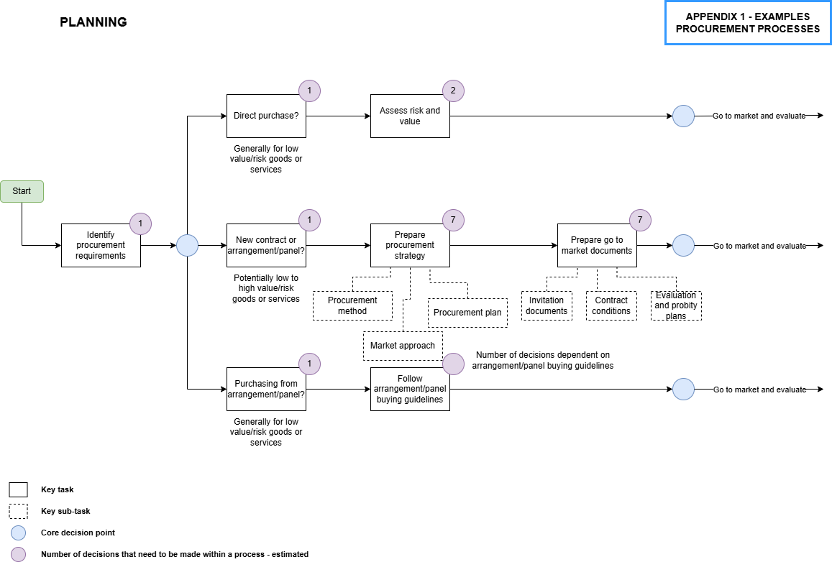
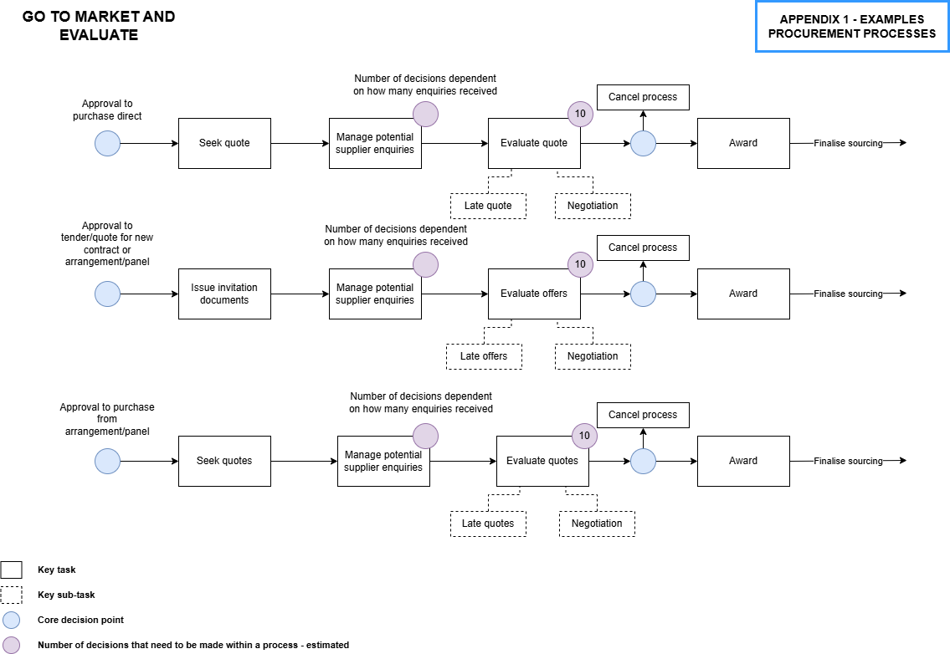
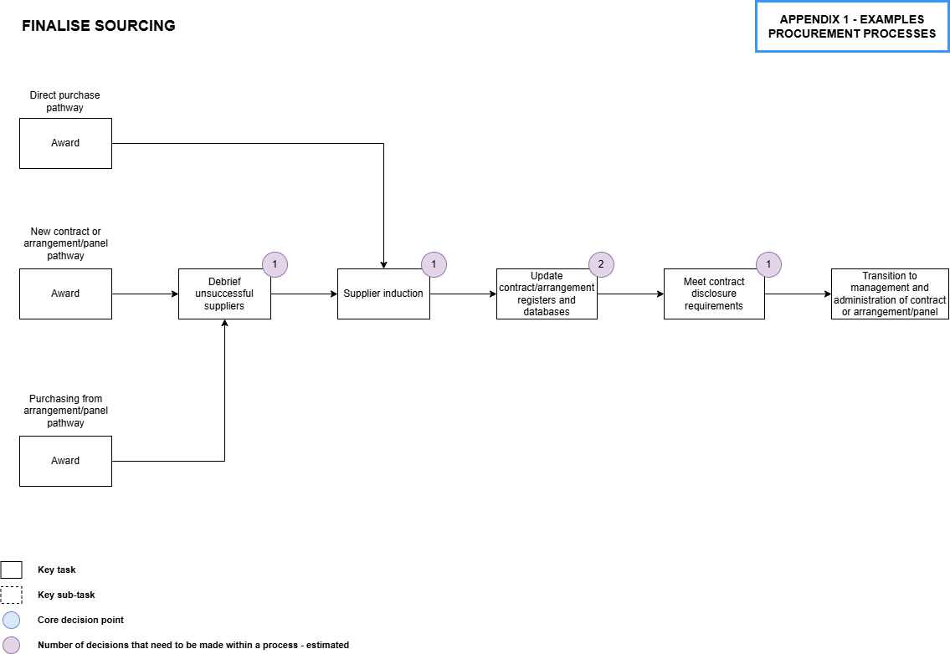
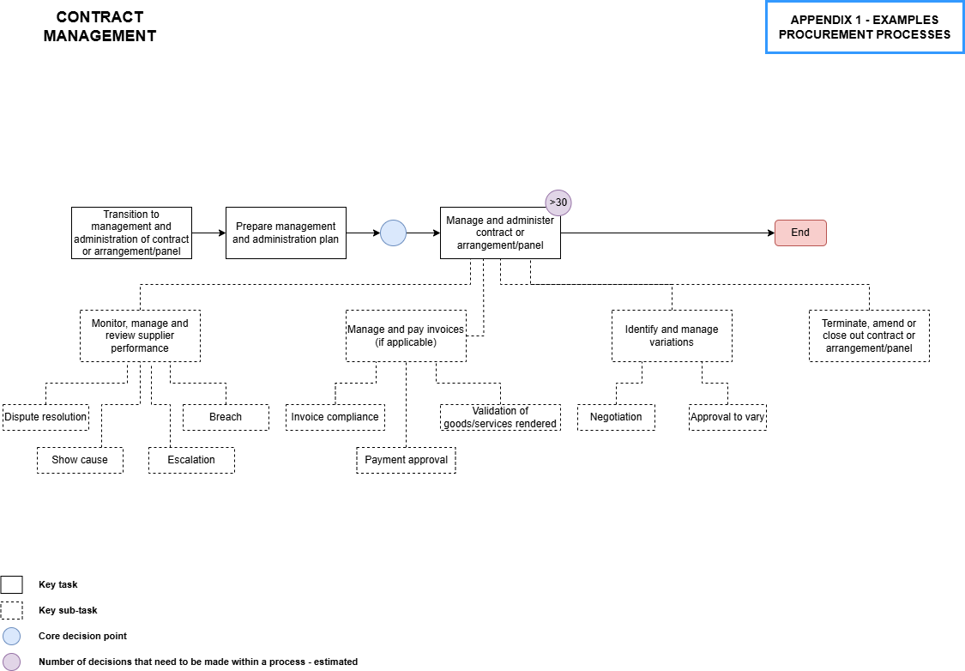

Based on extensive research for the United Nations Human Rights Council Report, Principles for responsible contracts: integrating human rights risk management into State/investor contract negotiations: guidance for negotiators https://www.ohchr.org/Documents/Issues/Business/A.HRC.17.31.Add.3.pdf and acknowledged in https://www.lawcouncil.asn.au/publicassets/23a50215-bed6-e611-80d2-005056be66b1/1601-Position-Paper-Business-and-Human-Rights-and-the-Australian-Legal-Profession.pdf
Adapted from United Nations Human Rights Council Report, Principles for responsible contracts: integrating human rights risk management into State/investor contract negotiations: guidance for negotiators https://www.ohchr.org/Documents/Issues/Business/A.HRC.17.31.Add.3.pdf

