Planning your HCD approach checklist
  - HCD in Queensland Government
Use this checklist to address each phase of the HCD approach, determine the activities appropriate to your project, and where support is required.

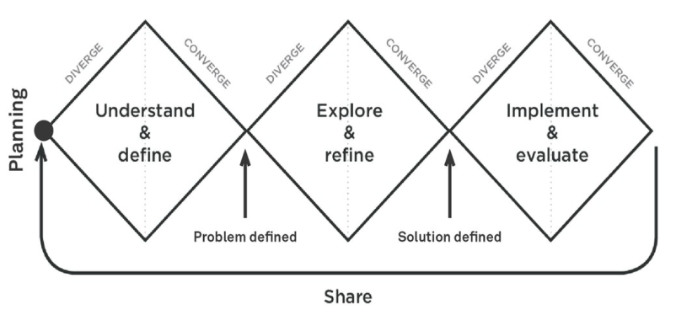

Mark when done | Activity | Blockers | Additional support required
 | Set up a project space/wall/online space (Miro is a great option) for collaborative working and sharing with stakeholders

Understand phase

Define and understand
Mark when done | Activity | Blockers | Additional support required
 | Clearly identify and articulate the design challenge
 | Clearly define the audience - the people involved or effected
 | Identify and digest relevant secondary research that may already exist

Plan research
Mark when done | Activity | Blockers | Additional support required
 | Identify with whom you will conduct research
 | Identify the appropriate research method(s)
 | Plan the research activities, equipment, materials & logistics
 | Recruit participants for research

Conduct research
Mark when done | Activity | Blockers | Additional support required
 | Conduct research with customers to understand the problem space
 | Write up research notes and observations

Analysis and synthesis
Mark when done | Activity | Blockers | Additional support required
 | Analyse and synthesise the research findings into themes and insights

Articulate the research findings
Mark when done | Activity | Blockers | Additional support required
 | Identify who you need to communicate the research findings to
 | Articulate your research findings and share

Define phase

Redefine and prioritise
Mark when done | Activity | Blockers | Additional support required
 | Identify and prioritise opportunities
 | Refine or redefine the problem to be solved by creating well defined problem statements

Determine success criteria
Mark when done | Activity | Blockers | Additional support required
 | Identify what the success criteria of a potential solution should be

Explore and refine

Concept generation
Mark when done | Activity | Blockers | Additional support required
 | Generate multiple concepts to solve the problem

Prioritise and test
Mark when done | Activity | Blockers | Additional support required
 | Prioritise the concepts to be tested
 | Plan prototyping activities and recruit participants
 | Iteratively prototype, test, and refine the concepts to narrow in on a solution

Communicate the vision
Mark when done | Activity | Blockers | Additional support required
 | Define the purpose and audience for communicating the vision for the solution
 | Articulate your research findings and share

Implement and evaluate

Plan and implement the solution
Mark when done | Activity | Blockers | Additional support required
 | Prioritise and roadmap the elements and features of the solutions
 | Create detailed designs
 | Conduct time, budget, and resource planning and estimates for implementation
 | Implement

Evaluate and iterate
Mark when done | Activity | Blockers | Additional support required
 | Evaluate the impact
 | Iterate the solution

Share phase
Mark when done | Activity | Blockers | Additional support required
 | Share the research insights and outputs
 | Share your project approach

