--

#### Eliminating modern slavery in government supply chains Framework and road map of priority actions 2022 to 2023

### Eliminating modern slavery in government supply chains

Queensland Government procurement has a major role to play in responding to and eliminating one of the greatest challenges to human rights, modern slavery. It’s not only about the people living and working internationally, it happens right here, in Queensland and across Australia.



Our supply chains are complex, and the global nature of trade means we are at increased risk of exposure to modern slavery.

From construction to catering, each year government agencies do business directly with thousands of suppliers, small and large, and indirectly with their supply chains. It is through this spend that the public sector is well positioned to influence its suppliers and their supply chains to change.

Our plan to eliminate modern slavery in supply chains is one that provides a unique opportunity to lead by example in its response, educate and build capability of both buyers and suppliers, raise awareness and deliver a collaborative procurement response aimed at motivating and facilitating government, business and community action.

### Strategic priorities

All road map actions are aligned with the principles and priorities of the *Buy Queensland* approach to procurement, alongside the intent of the *Modern Slavery Act 2018* (Cth), to ensure Queensland Government procurement is not inadvertently contributing to, or being complicit with, modern slavery practices in its supply chains.

### Our framework

This framework demonstrates our commitment to eliminate the exploitation of vulnerable Queenslanders from modern slavery and further drive ethical procurement practices throughout supply chains. It is designed around four enabling areas of focus: our policy, our process, our people and our suppliers.

The supporting roadmap priority actions have been co-designed and developed with Queensland budget sector agencies, government-owned corporations, large statutory bodies, industry and academia, and benchmarked against best practices nationally and globally. More detailed action plans to supplement the priority actions for each focus area will be progressively developed.This ensures that the Queensland Government’s significant investment of taxpayer money is not used to support unethical suppliers benefiting from modern slavery.

An estimated 40.3 million people are in modern slavery globally.

(Source: The Global Slavery Index 2018)

#### Our process

Government agency procurement tendering systems, operational policies and processes include provisions which aid implementation of the policy commitment and maintain value for money considerations beyond price.

#### Our policy

The procurement policy environment sets a clear commitment to eliminating modern slavery in government supply chains. We will do this through the Queensland Procurement Policy, the Ethical Supplier Mandate (ESM) and Ethical Supplier Threshold and reinforcing the Supplier Code of Conduct.

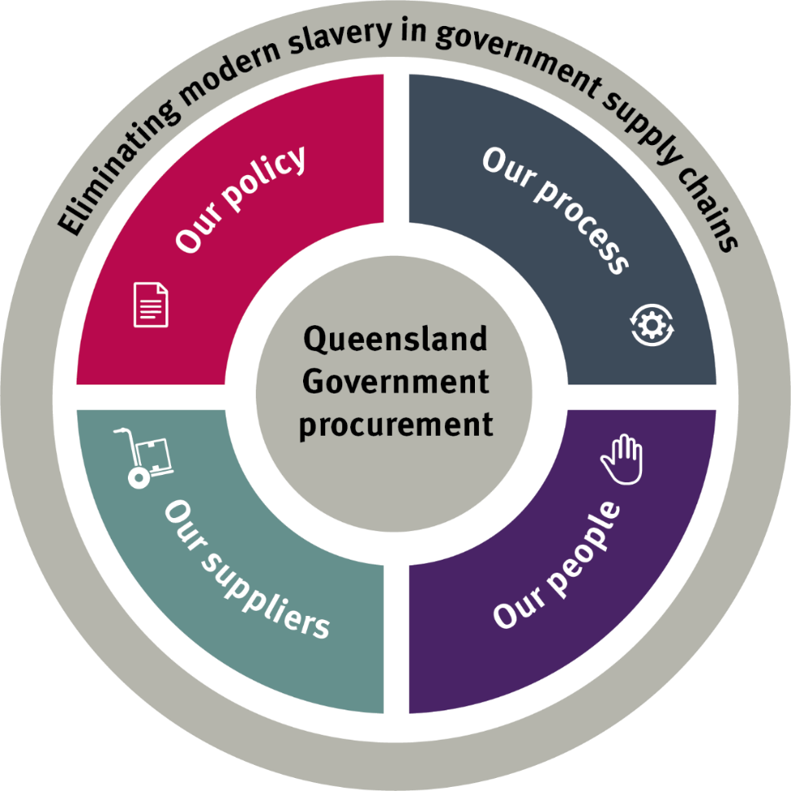



Approximately $12 billion in at-risk products are imported into Australia annually.

(Source: The Global Slavery Index 2018)

In 2020-21, the Queensland Government invested approximately $18.55 billion on goods and services provided to support Queensland communities.

(Source: FY20/21 Procurement spend data)



#### Our people

Government buyers, decision makers and contract managers have the capability, knowledge and tools to play their part in eliminating modern slavery.

#### Our suppliers

The current and potential suppliers to government understand the ethical, environmental and social expectations of them to behave and conduct business ethically and actively address the risk of modern slavery.

#### Our community

The most vulnerable members of the Queensland community, women, children and new arrivals, are protected and participate in quality, safe, secure jobs.

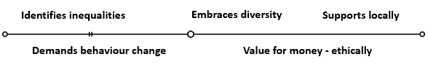



|  |  |  |  |  |  |  |  |
| --- | --- | --- | --- | --- | --- | --- | --- |
| Our policy | | Our process | | Our people | | Our suppliersEliminating modern slavery road map of priority actions 2022 to 2023 | |
| Phase 1: Establishment actions and responsible area – January 2022 to April 2022 | | | | | | | |
| **Actions** | **Responsible area** | **Actions** | **Responsible area** | **Actions** | **Responsible area** | **Actions** | **Responsible area** |
| Release the ***Eliminating Modern Slavery in Queensland Government Supply Chains*** *and* ***Roadmap of priority actions 2022-23***.  Release a **Continuous Improvement Guide for suppliers (**refer to **Tool 5)** regarding compliance with the Supplier Code of Conduct – including Clause 4.4. | Queensland Government Procurement  Queensland Government Procurement | Develop an **Eliminating** **Modern slavery toolkit**:   * **Guide** with current research and references to ESM compliance * **Tool 1: Procurement planning questions** * **Tool 2: Sample contract clauses** * **Tool 3: Protocol for reporting modern slavery** * **Tool 4: Supplier self-assessment questionnaire template** * **Tool 5: Supplier Code of Conduct - continuous improvement guide** * **Supplier Code of Conduct and declaration template (updated)**. | Queensland Government Procurement | Establish a **Modern Slavery Community of Practice** for non-reporting entities.  Release **targeted communication** via the Buy Queensland buyer (and supplier) eNewsletters.  Establish a **modern slavery webpage**.  Promote **modern slavery training** for buyers (general). | Queensland Government Procurement  Queensland Government Procurement  Queensland Government Procurement  Queensland Government Procurement | Request a **Supplier Code of Conduct declaration** for high-risk suppliers and/or ensure the **Supplier Code of Conduct compliance** is embedded into **contract Terms and Conditions**. | Government agencies |
| Phase 2: Implementation actions and responsible area – April 2022 to October 2022 | | | | | | | |
| **Actions** | **Responsible area** | **Actions** | **Responsible area** | **Actions** | **Responsible area** | **Actions** | **Responsible area** |
| Propose wording for a **modern slavery commitment** and/or target.  Government agencies embed procurement policy updates into **governance planning** documents such as Category Strategies, Agency Procurement Plans.  Develop and implement **compliance auditing and reporting processes** related to the **Supplier Code of Conduct.** | Government agencies  Procurement Industry Advisory Group  Government agencies  Category lead agencies  Queensland Government Procurement | Government agencies embed **changes into internal systems and processes**, where existing mechanisms for modern slavery do not exist.  Amend **standard contracts clauses and agreement terms** for all categories to include specific reference to compliance with *Modern Slavery Act 2018* and the *Human Rights Act 2019* (where applicable), in addition to the existing reference to the *Disability Discrimination Act 1992* (refer to **Tool 2**). | Government agencies  Government agencies  Category lead agencies | Establish **modern slavery procurement champions** at the Executive Level.  Develop **communications strategies** and **resource packs** for government executives and buyers including:   * information sheets, case study examples, key messaging.   Establish an internal **information sharing platform**. | Government agencies  Queensland Government Procurement  Queensland Government Procurement | Promote **modern slavery training** for suppliers (general).  Develop **communications strategy** and **resource pack** for government suppliers including:   * information sheets, case study examples. | Queensland Government Procurement  Queensland Government Procurement  Sponsoring agency (Procurement-related Policy) |
| Phase 3: Future state actions and responsible area – late 2022 onwards | | | | | | | |
| **Actions** | **Responsible area** | **Actions** | **Responsible area** | **Actions** | **Responsible area** | **Actions** | **Responsible area** |
| Develop modern slavery **procurement performance measures and compliance processes** in consultation with government agencies.  Release **matured Queensland Procurement Policy**. | Queensland Government Procurement  Government agencies  Queensland Government Procurement | Continue discussion with the Australian Government, through the Intergovernmental Network on Modern Slavery in Public Procurement (IGNMSPP) regarding a **centralised system to identify ethical suppliers**, including ethical accreditations and/or risk profile information. | Queensland Government Procurement | Conduct **regional briefings** across the state at government office locations for all staff.  Integrate into a procurement practitioner **awards program** to celebrate agencies that go above and beyond in eliminating modern slavery from their supply chains. | Queensland Government Procurement  Queensland Government Procurement  Government agencies | Develop and test **contractual remedies** to evidence supplier behaviour change towards modern slavery.  Determine best strategy to deliver **interactive supplier engagement experiences** regarding modern slavery. | Queensland Government Procurement  Government agencies  Queensland Government Procurement |