Human-Centred Design

What is Human-Centred Design?
Human-centred design (HCD) is an approach to problem-solving that places the needs of people at the centre of the process. For government, these people are all of us, the people of Queensland. HCD involves people in all stages of the process - from gathering insights, to exploring many ideas through testing and refining possible solutions, to the evaluation of the effectiveness of the outcome.

How is HCD approached?
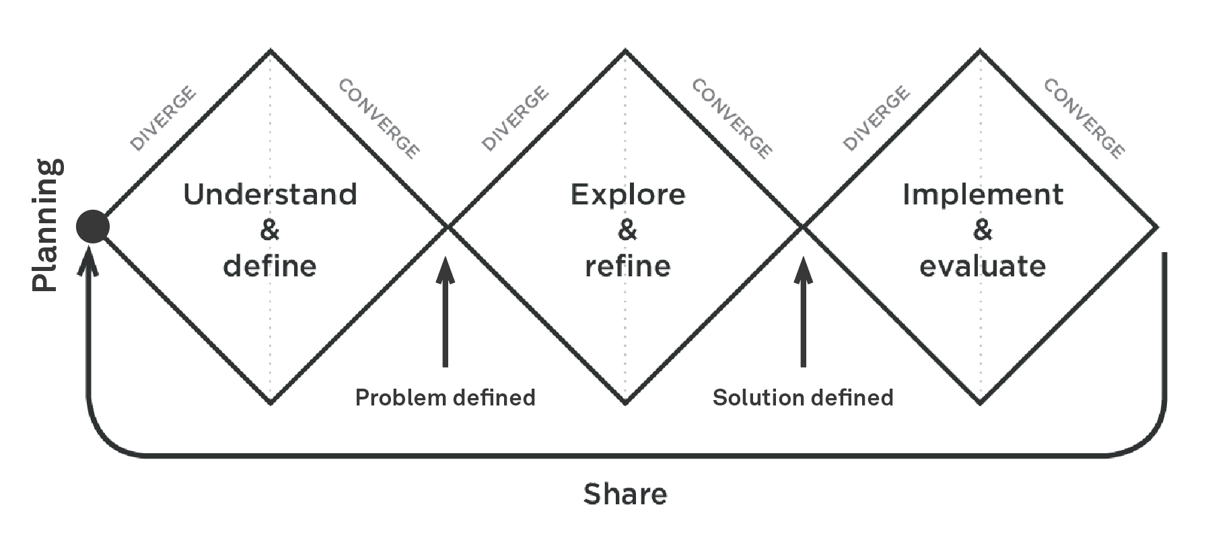
The HCD approach, as we define it for government, consists of three phases as well as ‘planning’ and ‘sharing’ activities.
- Understand & define: Are we solving the right problem?
- Explore & refine: Are we solving the problem in the right way?
- Implement & evaluate: How well is the solution meeting the needs of people?
Planning: Who, what when, where and how?
Sharing: How can we externalise and share our process and outcomes?

Why use HCD?
A HCD approach ensures that you are solving the right problem and coming up with the right solution by putting people at the centre of the design process. This approach has a range of benefits for our customers, the people of Queensland, as well as for government.

Benefits for the people of Queensland | Benefits for government
Services that meet the real underlying needs of customers  An improved customer experience of your product or service  Less stress and frustration when using a product or service  Removal of cognitive load when determining how to use services  Increased popularity and use of services by customers | Creates an image of government to its public as being people-centred  Provides an external, customer perspective of the problem at hand  Helps paint a picture of the wider context in which the problem lies  Systems and services that meet the needs of people tend to cost less in support - they don’t need additional assistance (or training)  Can increase productivity and improve operational efficiency  Reduced project risks of a ‘failed’ service  Builds organisational resilience  Helps staff understand and build empathy for customers

Where has HCD been used in government?
HCD practices are being applied by government locally, nationally, and internationally. For us in Queensland Government, we have applied HCD practices to the Victims of Crime project, HCD Toolkit creation, Seniors project, Queensland Treasury Jobs project and the Digital Engagement project. Some examples of projects in other government jurisdictions include New Approach to Child Projection in NSW, Enabling change with Aboriginal families in SA and How the BOM put user’s needs first.

Queensland Government - Housing and Homelessness case study
This project was triggered by the need for the Fortitude Valley Housing Service Centre (HSC) to relocate. While the primary scope focussed on the physical space and customer experience of the HSC, the design process allowed for a broader understanding of the customers journey, stakeholders and employees.
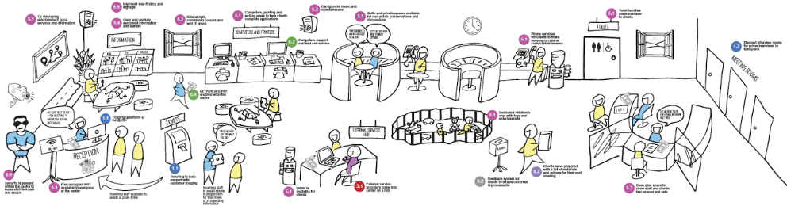
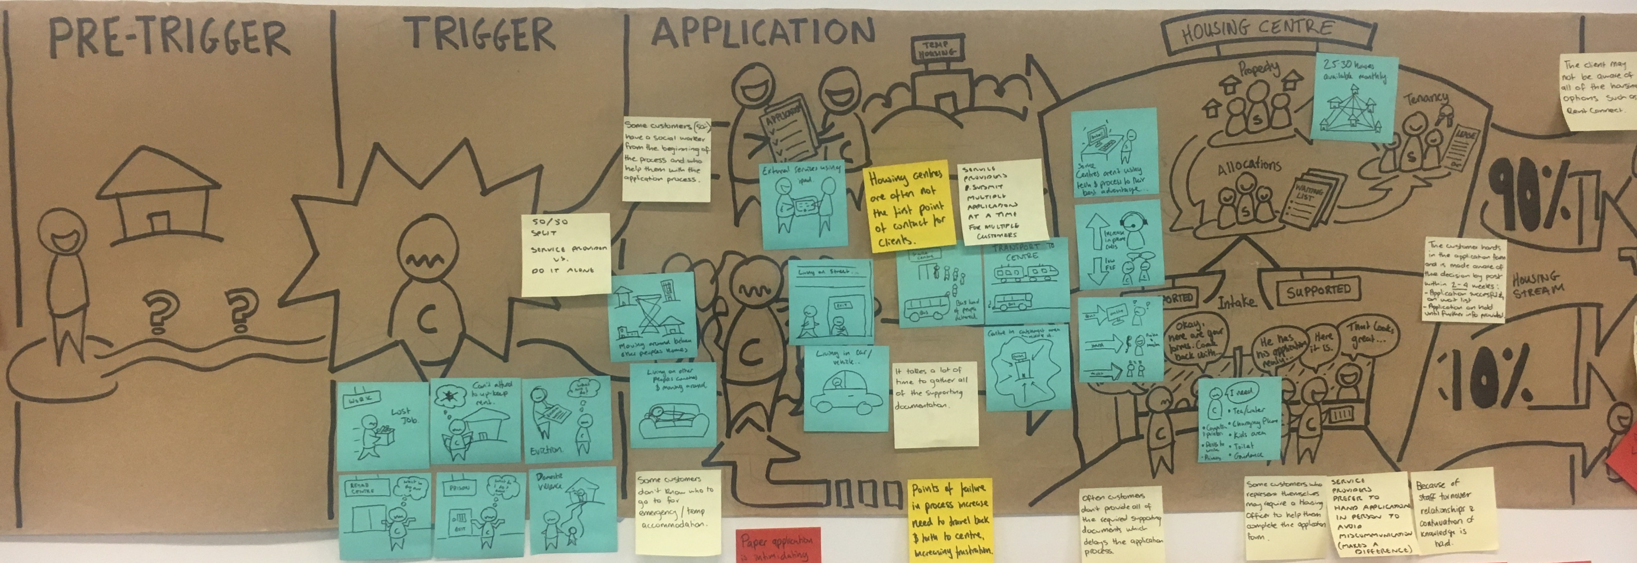
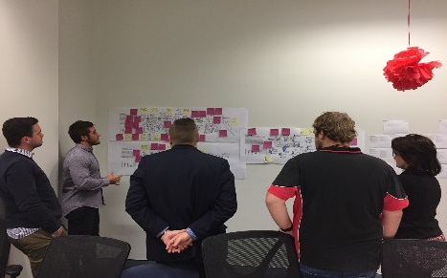
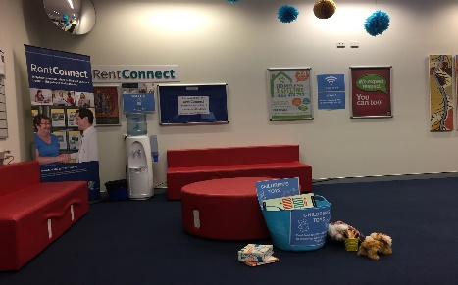
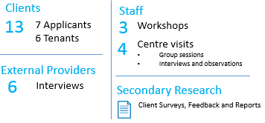
Research
Testing and prototyping sessions were conducted in a live environment which enabled the project team to further refine these concepts. Further sessions were conducted with all staff members which allowed them to provide feedback and further refine these concepts.

The customer’s journey was mapped and key insights, pain points and opportunities were then identified
Concepts: Based on pain points and insights from research an ideation workshop was conducted. Staff, stakeholders and service providers attended the workshop and came up with ideas which translated into 38 concepts.

Live testing at the HSC
Testing with HSC staff

The Housing and Homelessness Division, who continue to test the concepts further in the Fortitude Valley HSC. The Division plans to roll out this process across the State, with a focus on place based staff, customer and stakeholder engagement. Further investment is being made at the initial contact phase to better understand customer needs and ensure the most appropriate service is provided.

Want to know more about HCD?
For further information around HCD or available training contact hcd@hpw.qld.gov.au

