Create accessible Word documents
  - Empowered and confident: disabling the barriers

Why make documents accessible?
Making accessible documents ensures that they are usable by the widest range of users, but also ensures your document is easier to edit and navigate. It is important to make these changes to Word documents to accommodate disability. For example, many people who are blind or of low vision use screen readers which read aloud information on the screen such as text or image descriptions provided through alternative text (Alt Text).
If you plan, format, and structure your document correctly in the beginning, it will ensure the file is not only accessible but can also be converted into a variety of different alternate formats (e.g. PDF or braille) while retaining its accessibility features.

Appropriate use of colour
When using colour, you must make sure that any information conveyed with colour is also conveyed in black and white. For example, if you’re using colour to identify key words in a document, make sure that you also make them stand out in another way (for example, by putting them in bold; italics are not recommended).

Colour contrast
You must provide high colour contrast to the text in your document. A good example of high colour contrast is black and white; while an example of poor colour contrast is light yellow and white.

Styles
When considering a style, it is important to consider which fonts are more legible and will benefit more users from the outset, especially those with low vision. Styles are formatting instructions automatically programmed into Word. Styles are used in lieu of the buttons on the toolbar (for example, the “Bold” button, or the “Bullets” button). Use them to create:
- titles (using the ‘title’ style)
- headings (using one of many ‘heading’ styles)
- subtitles (using the ‘subtitle’ style)
- bulleted lists (using one of the ‘list bullet’ styles)
- numbered lists (using one the ‘list number’ styles)
- words in italics (using the ‘emphasis’ style)
- words in bold (using the ‘strong’ style)
- underlined words (using the ‘subtle reference’ style)
- any other styles created.

To use a style
- Click on Home in the ribbon toolbar. The fourth box from the left in the home ribbon is the Style box.
- Before typing in any text, select the style you would like to use.
- For example, click on Title if you wish to create a title. Type in your title. Press enter, and your text will revert to the Normal (default) style. From here, you can continue using the appropriate styles. For instance, you could start writing your text in the Normal style, or you may want to create a heading. To create a heading, click on a Heading style, and then input your text.
- To see a list of more styles, click the expansion arrow at the bottom right corner of the Styles box. Go to Options in the bottom right corner, and in the new window which pops up, select All styles in the first drop down menu. Select OK and the Styles window will now show many more styles.

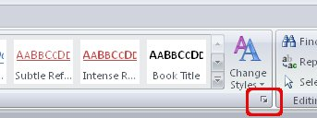

To modify a style
- Right Click on the icon of the particular style in the menu.
- Select Modify. A new window will open.
- Click Format (found in the bottom left corner of the window).
- In the pop-up menu, select the change you wish to make. For example, if you wish to change the written text, select Font
- Changes which are made to one style will appear throughout the document where that particular style is used.

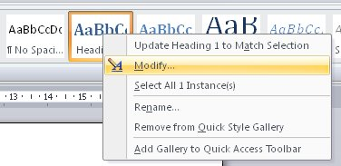

Headings
Headings are a type of ‘style’ which makes it easier for various adaptive technologies to navigate a document. Many people do not create headings correctly, either making font sizes bigger or in bold rather than using the formats already provided by Word. By using ‘headings’, you are creating a real structure in your document which will be correctly read by assistive technology and will make the page more usable for everyone.

In Microsoft Word®, there are several different styles of ‘headings’ to choose from. See the instructions on how to use/modify ‘styles’ to learn how to incorporate ‘headings’ into your text.

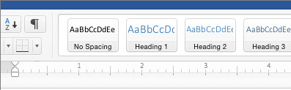

Alternative text
Any pictures, graphs or text boxes within a document must be given alternative text. Alternative text must give an accurate description of what the item is, so that the user’s assistive technology may convey what information is demonstrated by the item. It is a best practice to avoid WordArt, SmartArt and text boxes as they may be inaccessible by screen readers.

When entering alternative text you will notice there is a Title and Description field. The ‘title’ field is used to enter text that when read to someone using a screen reader, it allows the user to decide whether to listen to the text provided by the ‘description’. However, it is generally recommended that the main ‘ALT’ text should be put into the ‘description’ field.

- Select the image and right click inside the image. A menu will appear.
- Select Format Picture.
- In the Format Picture window, select the Size and Properties tab on the right and select ALT TEXT
- Then insert the ALT Text into the Description field, not the Title field

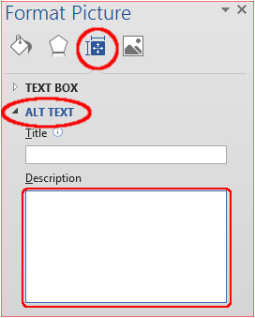

How to create good alternative text
- Consider the content and function of your image.
- If it provides content to your document, make sure that the information the image provides is described in the ALT text.
- If your image only provides a function (for example, providing a portrait of a historical figure described in the text) you need only describe the image. In the case that the image is of a historical figure, write his/her name as the ALT text.
- Try not to use ‘Image of...’ or ‘Graphic of...’ as ALT text. That is usually evident to the person reading the ALT text.
- Do not repeat the information which is contained in the document itself into the ALT text. If it's already in the document, that should be enough.

Wrapping style of non-text elements
To ensure the accessibility of non-text elements, the ‘wrapping style’ should be set as ‘in line with text’.

- Select the image/text box and right click inside the image. A menu will appear.
- Select Wrap Text
- Select In line with text

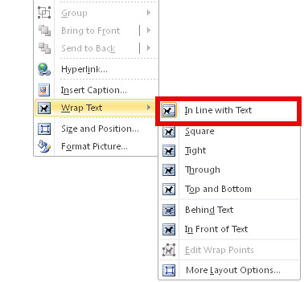

Columns
Use the Microsoft Word® tool to create columns. If you create columns using spaces and tabs, it will not be recognised as a column by assistive technology.

Inserting columns
- Click on Page Layout in the toolbar.
- Select Page Setup box.
- Click on Columns inside the box.
- Select the number of columns you want and click OK.

Tables
Use the Microsoft Word® tool to create tables. If you use the ‘Draw Table’ tool, it will be difficult for your table to be read by assistive learning technology.

Inserting a table
- Click on Insert in the toolbar.
- Select Tables.
- Select the number of columns and rows you want and click OK.
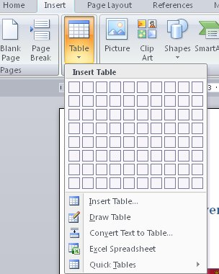

Table headings
- Click anywhere in the table.
- Go to the Design tab at the top of the page.
- Check the Header Row check box.
- Type (or retype) your column headings.
- Press the Enter key.

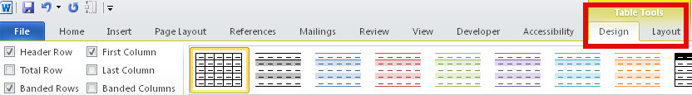

Inserting table heading rows
The table should include a Heading Row, which consists of text included at the top of the table which helps interpret the data. If a table is longer than a page, Heading Rows must be repeated at the top of the table on each of the following pages. To repeat the header row when a table spans more than one page:

- Click on Table Properties and select the Row tab.
- Check the option which reads: Repeat as header row at the top of each page.
- Click OK.

Hyperlinks
To link your document to a website or another document, you may use hyperlinks. When doing so, make sure that the Hyperlink has context and describes where it leads. It should not just read “click here”, and should make it clear what the destination of the link is (example, the web link www.queensu.ca should be written as "Queen's University").

Inserting a hyperlink
- Highlight the text you wish to be the link.
- Click on Insert in the toolbar.
- Select Hyperlink from the Links box. A new window will pop up.
- You can hyperlink to a web site, place in this document, or an email address. Select the type of link you want, enter the information then select OK.

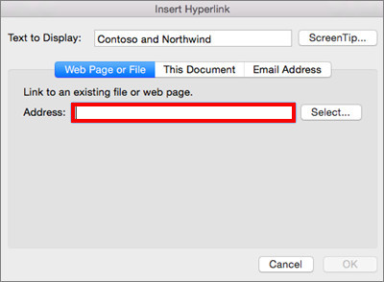

Graphs and charts
To make Charts and Graphs accessible, it may require explanations to explain the content. There are two actions recommended to make these items accessible.

The first is to add a short caption preceding them that describes their content. The second is to provide an alternative presentation of the findings. For many charts, the best alternative format in which to present data is a table with the original figures. Some graphics should include good alternate text but also a text description of the data contained in the image.
To add a caption:
- Right click near the edge of the chart, graph or table and choose Insert Caption
- Word gives you a few default options for your caption. If you’d like to create your own select New Label and enter your caption into the pop-up dialog box.

Tools to avoid using
Adding Text Boxes, Quick Parts, Word Art, and Drop Caps should be avoided since content can be inaccessible or difficult for persons with low vision.

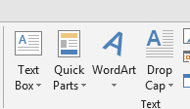

Using MS Office’s accessibility checker
MS Word comes with a new accessibility checker that can aid in checking for problems in your document. This tool makes it easy to identify problems in your document and explains what needs to be fixed.

Word for windows
To test your document for accessibility-related issues:
- Go to the File Tab and select Info
- Click the Check for Issues button and select Check Accessibility.
- A dialog box appears on the right with a list of accessibility-related errors. Feedback on each item, as well as tips on how to make the proper repairs, is included. Selecting an item in this report will take you to that item in the document.

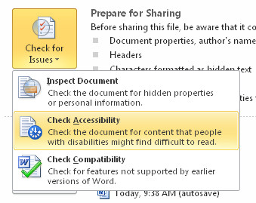

Word for Mac
- Select Review
- Then Check Accessibility

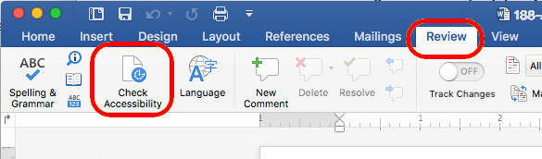

External Resources
Microsoft’s guide, Create Accessible Word Documents, offers online video tutorials and a reference sheet that may be used offline. Closed captions are available for videos by selecting the CC button.

