Reading Room Request Service
ArchivesGateway user guide
Queensland State Archives
July 2020
Security classification: Public

Table of contents
Table of contents 2
Introduction 3
Definitions and references 3
Brief overview of reading room request process 4
1. Requests to view restricted records 5
2. Reading Room requests 5
1.1 Create a Reading Room requests 5
Add details of date and time for request 6
Add physical representations to the request 6
1.2 Submitting a Reading Room requests 8
1.3 Cancelling a request 9
Cancel a pending request 9
Cancel a retrieved request 11
3. Use the comments/discussion feature 11
More information 13

Introduction
This user guide provides an overview and instructions of how to search your agency’s records in ArchivesGateway and request to access those records in the Reading Room at Queensland State Archives (QSA).
The information in this guide applies to all government agency staff involved that use ArchivesGateway to manage and access their records at QSA.
Other user guides are available for other functions within ArchivesGateway. See the more information section for details on how to find and access these other user guides.
See the ArchivesGateway user guide: Manage users and locations for information on how to access and login to ArchivesGateway, create users and set user permissions.
See the information on QSA research facilities for information on coming to QSA and using the Reading Room.
Note: Currently, all visitors to the Reading Room need to pre-book a session. To book a session and find out more about accessing the Reading Room, see the Reading Room Bookings in Eventbrite.

Definitions and references
Relevant definitions of recordkeeping and archival terms used in this guide can be found in the glossary on the For Gov website.
See recordkeeping and archival terms and their definitions.

Brief overview of reading room request process

Requests to view restricted records
If you are requesting closed or restricted records, the person accessing the records must have permission to access these records.
If they do not have permission, you will need to follow the process to grant or provide access to the restricted records.
The access to restricted records form must be completed and submitted to QSA at least 1 week before the intended visit.
This form must be completed for anyone in your agency that does not currently have access or another agency that requires access to these records.
Ensure you include the details of the person requesting the records in the Reading Room request form in ArchivesGateway using the Comments/Discussion feature.
Anyone requesting to view restricted records in the Reading Room at QSA will need to show their government ID to QSA staff before they will be allowed to view the records.
See the advice on how to Provide access to closed records on the website for more information.

Reading Room requests

Create a Reading Room requests
To create a Reading Room request:
- Navigate to the ‘My Reading Room Requests’ tab along the top bar.
- Select the ‘Create Reading Room Request’ button.
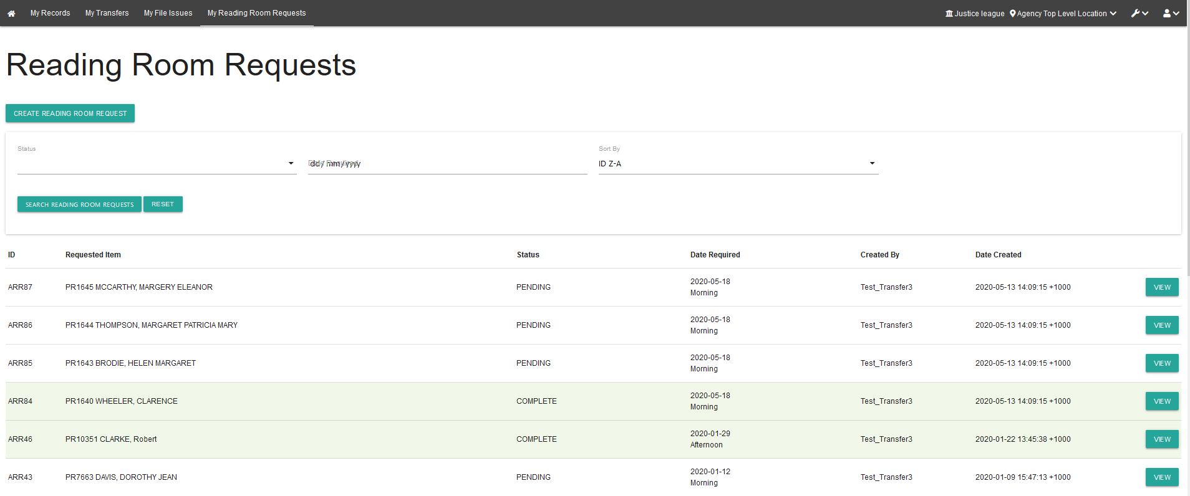

Add details of date and time for request
- Choose the date you would like to view the records – this can be any date that the Reading Room is open
- Indicate whether you would like to view the requested records in the morning or afternoon.
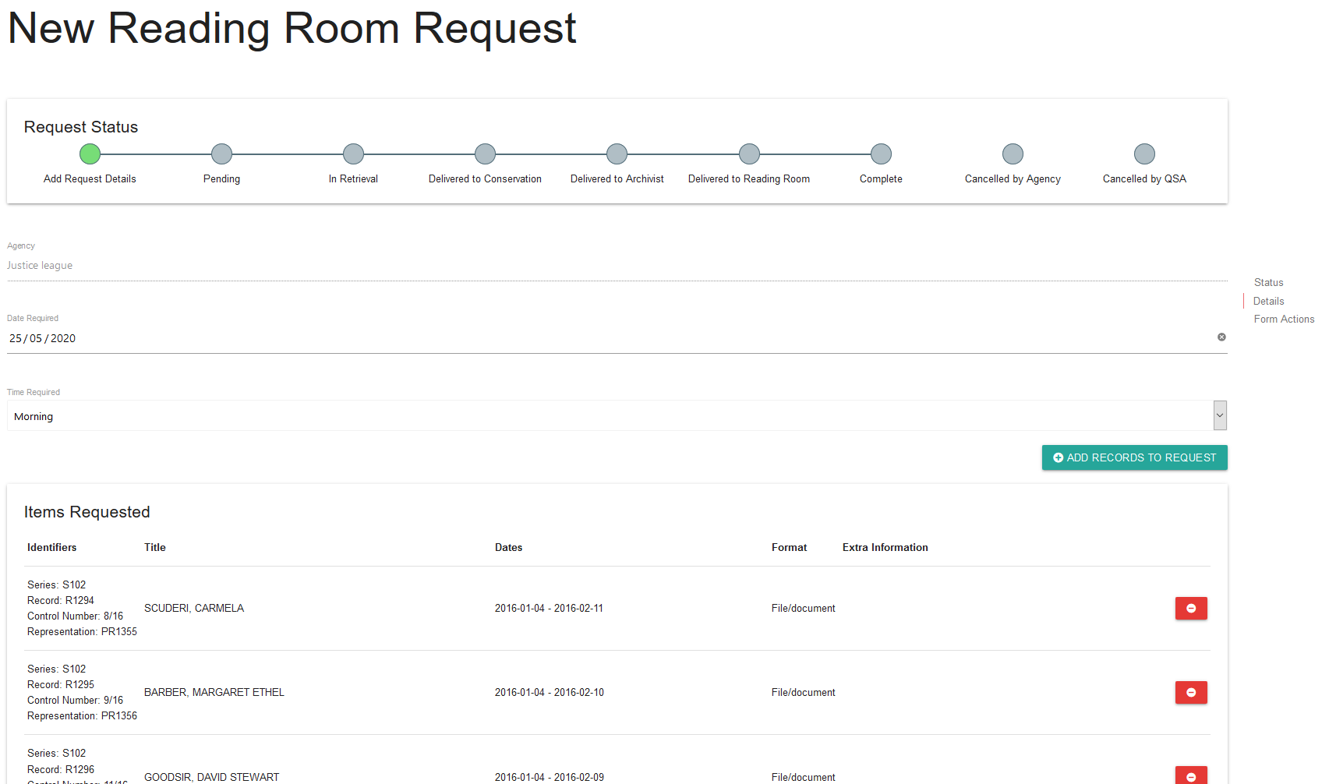

Add physical representations to the request
You will need to add the physical representations you would like to view at QSA to the request.
- Click on the ‘Add Records to Request’ button.
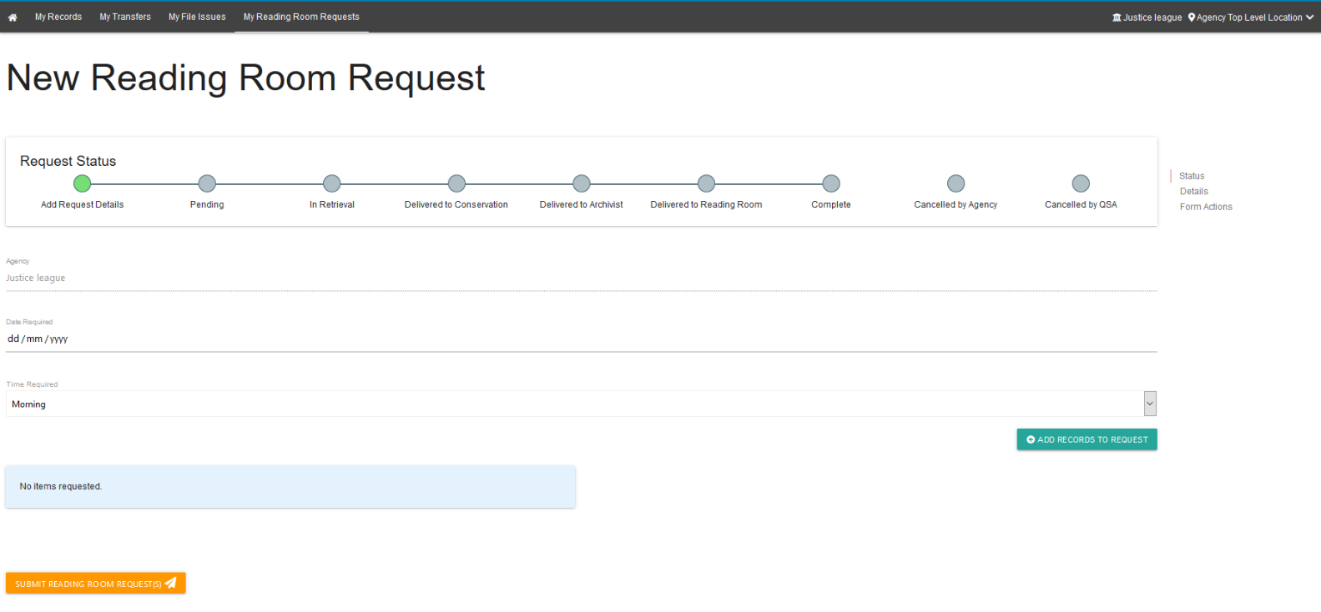
- In the new window, search through your agency’s records.
- Add the required physical representations to the request.
Note: This window has the same search functionality as the ‘Controlled Records’ search page. See the ArchivesGateway user guide: Searching and search requests service for more information.
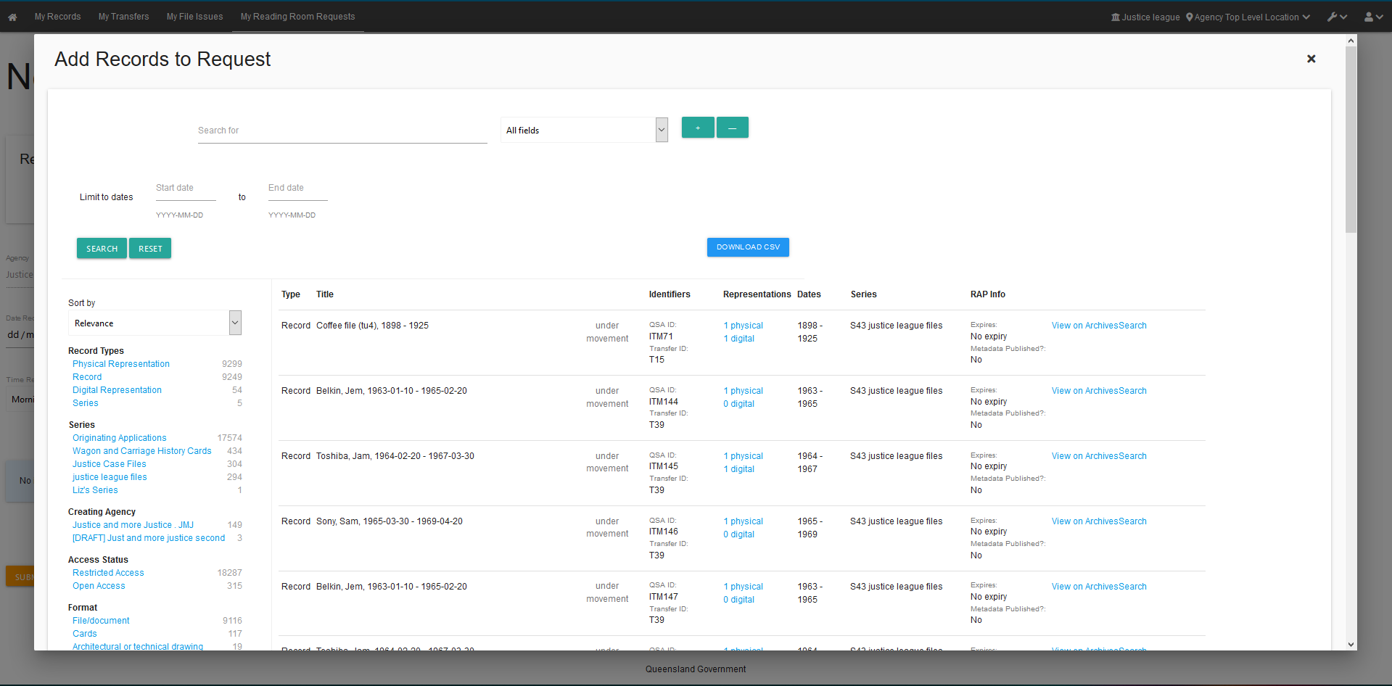
- Click on the ‘Add’ button next to each of the physical representations you would like to view in the Reading Room.
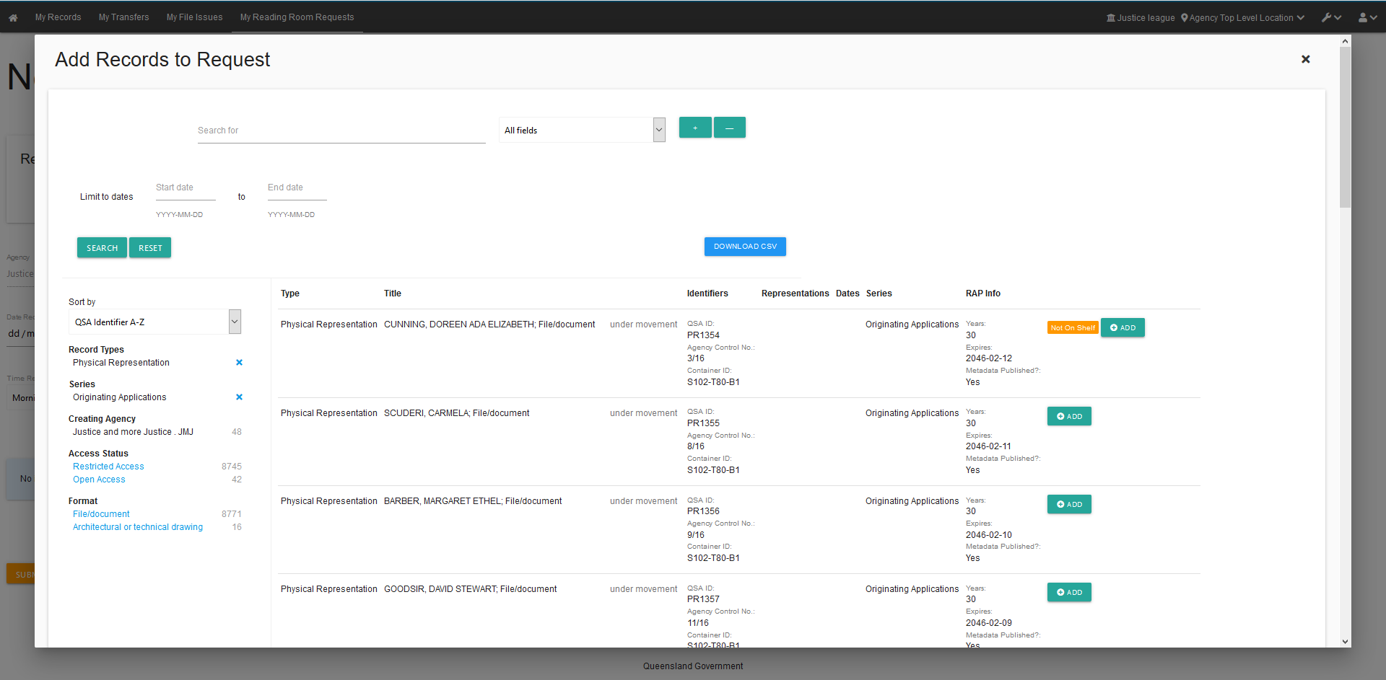
- The button will then change to allow you to remove the representation if necessary.
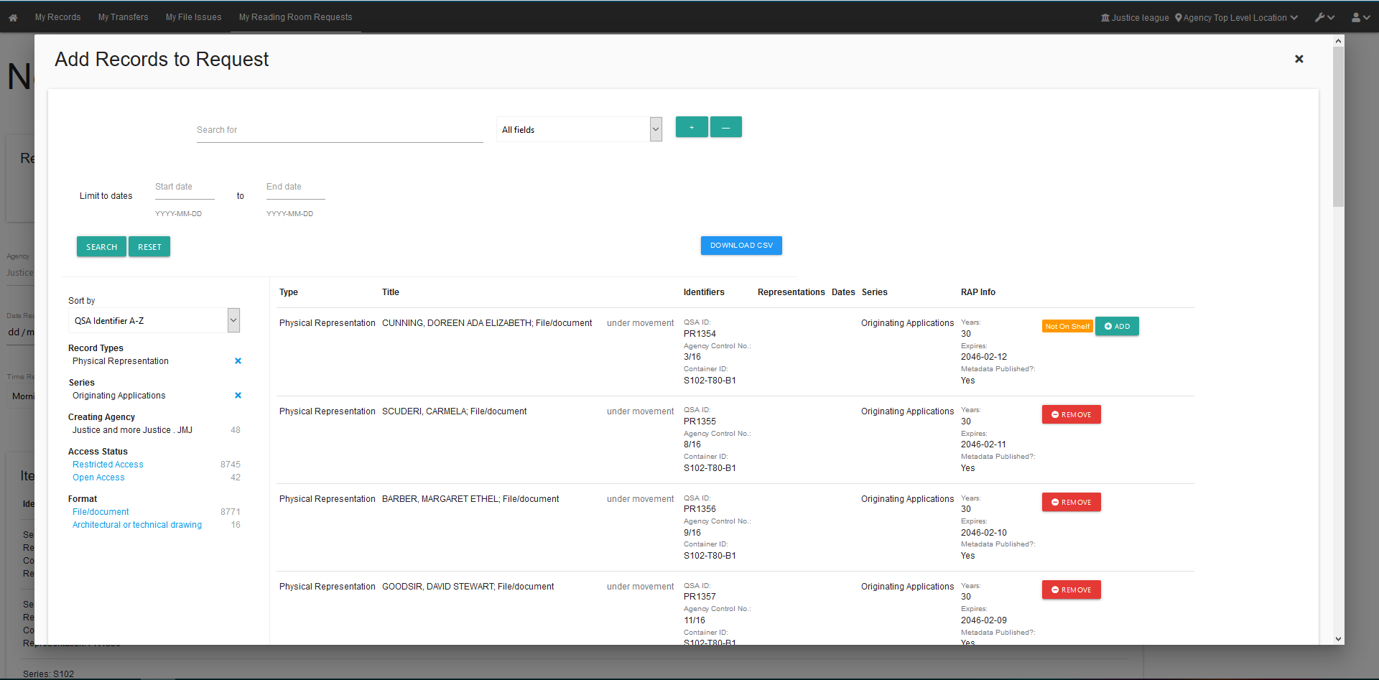

Submitting a Reading Room requests
Once all the physical representations have been added:
- Click on the ‘Submit Reading Room Request(s)’ button.
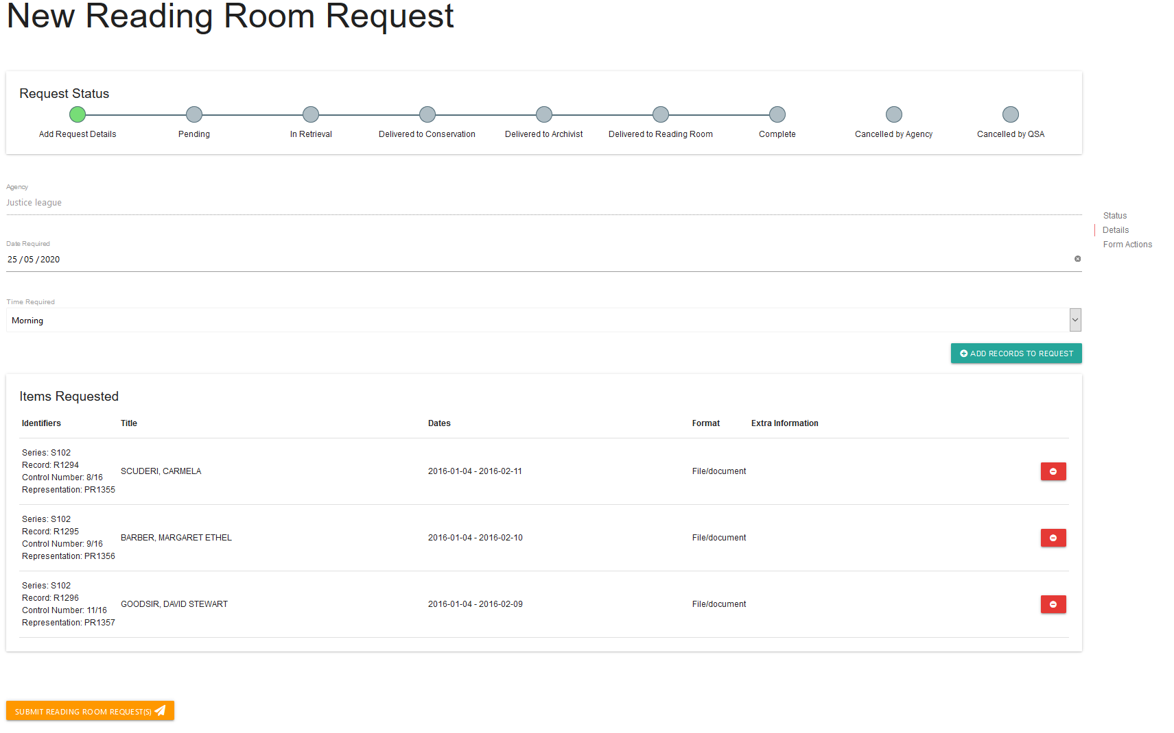
This will create a unique identifer with an ARR prefix for each representation requested and will be sent to QSA for completion.
When the Reading Room request has been submitted, the requests will appear on the home page of ‘My Reading Room Requests’.
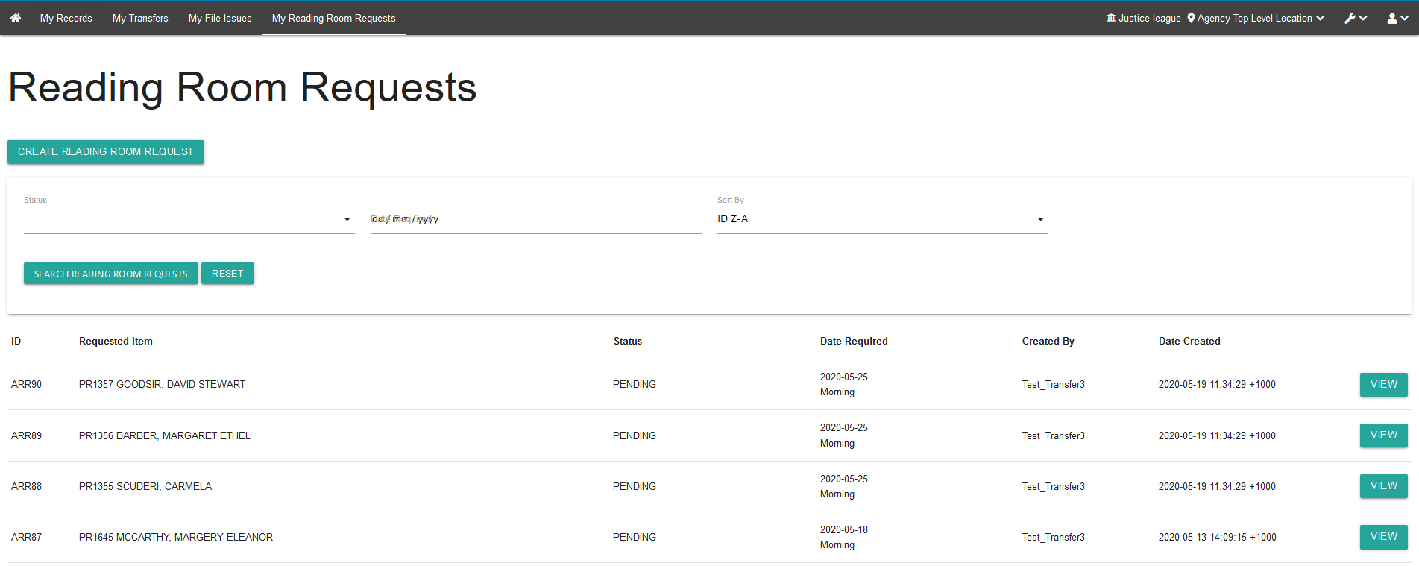

Cancelling a request
Reading Room requests can be only be cancelled by agencies when the status is ‘pending’.
Once the status changes to ‘retrieved’, only QSA will be able to cancel the request.

Cancel a pending request
To cancel pending Reading Room request:
- Click ‘view’ on the requested representation you would like to cancel.
- Scroll down to the bottom of the request
- Click ‘cancel request’.
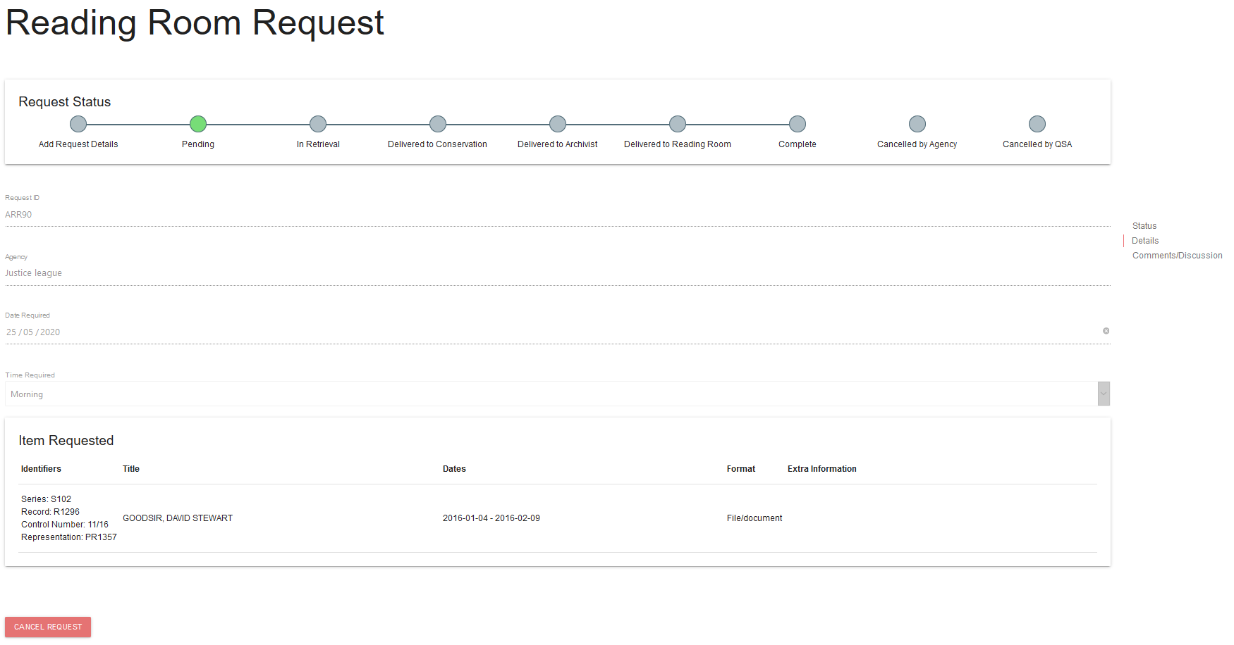
- When the ‘cancel’ button has been clicked a warning will appear asking, ‘Are you sure you want to cancel this request?’.
- To cancel the request, click ‘confirm’ on the warning.
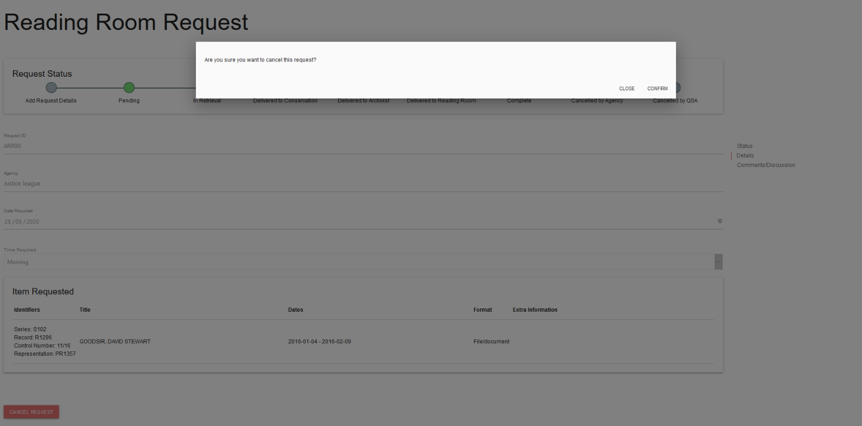
- Once the ‘confirm’ button has been clicked, the status of the request will be updated to ‘CANCELLED_BY_AGENCY’.
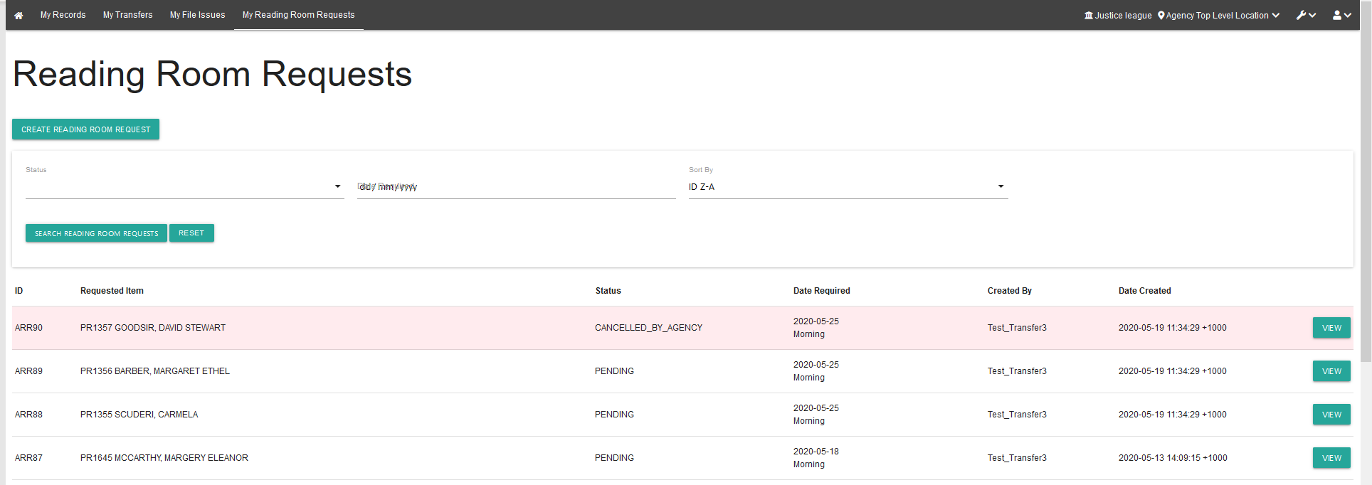
Note: Any requests cancelled by agencies will not be able to be resubmitted to QSA. You will need to create a new request.

Cancel a retrieved request
If you need to cancel a request once it has been retrieved use the comments/discussion feature within that reading room request to communicate this to QSA.
Alternatively, contact the Reading Room team on 07 3037 6777 or email info@archives.qld.gov.au.

Use the comments/discussion feature
The comments/discussion feature within ArchivesGateway can be used to communicate with QSA staff AFTER a request has been submitted.
Note: This feature is also available in the Transfer Proposals/Transfers, File Issue Request/File Issue and Search Request sections within ArchivesGateway.
To send a message to QSA regarding a submitted Reading Room request:
- Scroll down to the bottom of the page to the comments/discussion section.
- Type in your message into the message field.
- Click ‘post message’.
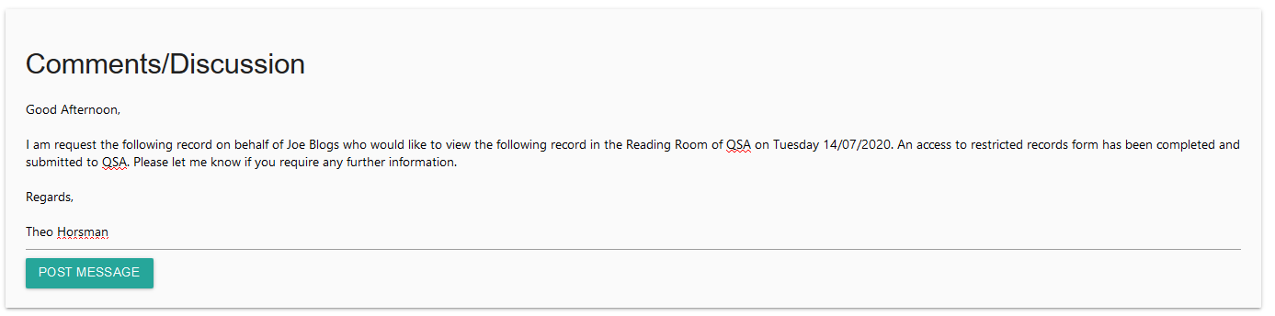
- Once you click on ‘post message’, the message will appear above where the message was typed and QSA will be able to view this message within the search request.
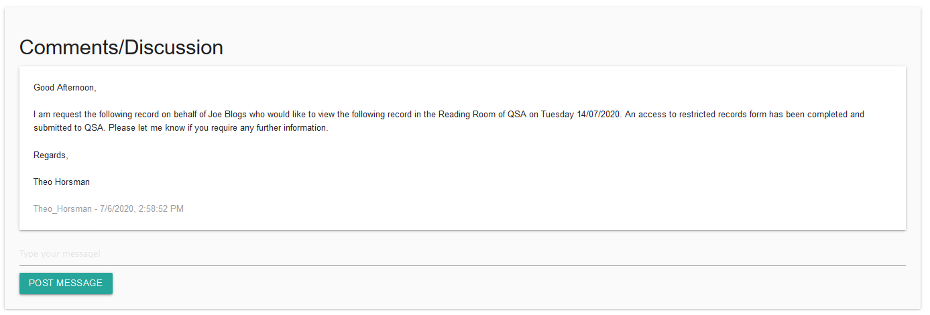
- When QSA responds to your message, it will appear below your original message.
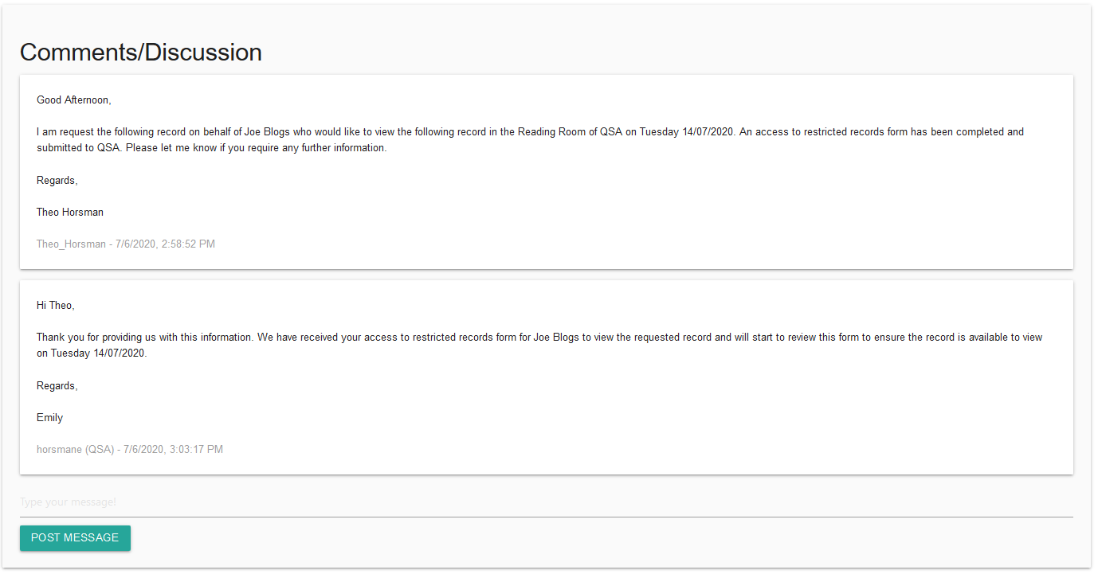
- Use the message field as per steps above to respond to any comments posted by QSA.

More information
Further information about managing records at QSA and using ArchivesGateway is available on the Recordkeeping section of the For Gov website:
- Use ArchivesGateway
- Transfer records to QSA
- Restrict access to records at QSA (Restricted Access Periods)
- Retrieve or access your agency's records at QSA (File Issue service)
- Provide access to closed records.
Other user guides are also available for specific functions within ArchivesGateway and are available on the relevant pages listed above.
If you require further assistance with ArchivesGateway, please contact the ArchivesGateway team via email: ArchivesGateway@archives.qld.gov.au.
You can find further information on accessing records at QSA and using the Reading Room on the QSA website.
Note: Currently, all visitors to the Reading Room need to pre-book a session. To book a session and find out more about accessing the Reading Room, see the Reading Room Bookings in Eventbrite.
If you require assistance with Reading Room requests, contact the Access team via email info@archives.qld.gov.au or call 07 3037 6777.

