Domestic and family violence is a workplace issue
Domestic and family violence (DFV) can impact a person’s safety, wellbeing, attendance and performance at work. Research shows:
- 1 in 5 Australian women say the violence continues at work^{i}
- two-thirds of Australian women experiencing DFV are employed^{ii}
- between 25–50% of Australian women subjected to DFV report having lost a job, at least in part due to the violence^{iii}
- DFV costs employers across Australia at least $175 million annually^{iv}
- Violence against women is estimated to cost the Australian economy $22 billion annually.^{v}
With 65 per cent of Queenslanders in the labour force, workplaces have a significant role to play in creating cultural change.

What a workplace response can look like
The Queensland Government is delivering a comprehensive response to DFV prevention and workforce support.^{vi}
All Queensland employers can make a significant contribution to eliminating DFV.
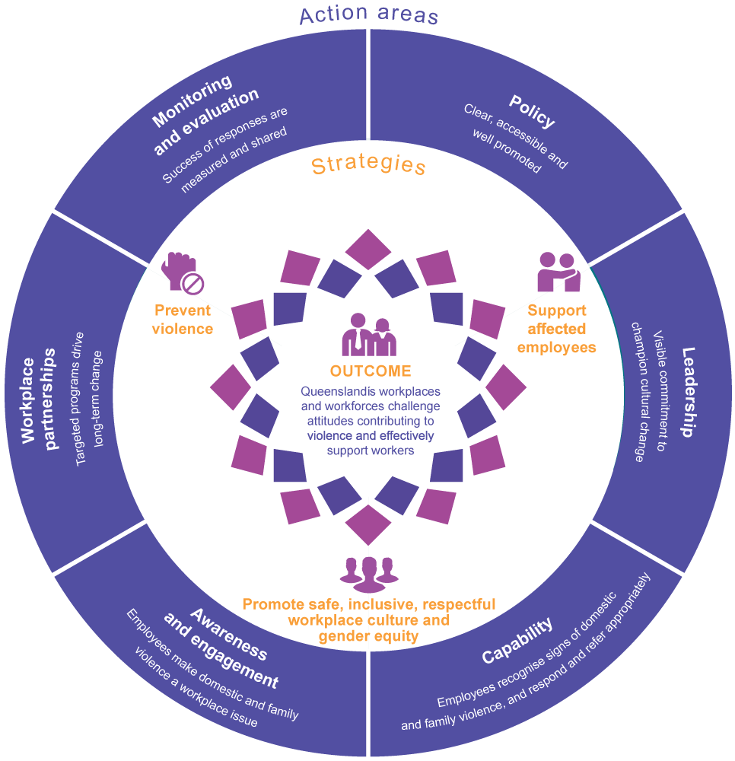

What you can do as a workplace
Business, local government and non-government organisations (NGOs) can adopt and tailor the following Queensland Government products and initiatives to suit your workplace needs.
- DFV workplace package – includes a directive, policy template, leadership commitment statement template, support and referral resources, communication toolkit, list of workplace partners, risk assessment and workplace safety plan, conversations guide.
- Inclusion and diversity and Gender equity strategies – promote respectful workplace cultures.
- DFV workplace policy – state how workplaces support affected employees, provide access to support services and address safety in the workplace.
- Support options – available to victims, employees who use violence, bystanders, carers or those assisting—including counselling, flexible work arrangements, workplace adjustments, and paid leave.
- Leadership commitment statement – make visible commitments to champion cultural change.
- Australia’s CEO Challenge Recognise, Respond, Refer online program – increase employee awareness and understanding of DFV and how to support affected colleagues.
- White Ribbon Australia free e-learning – addressing the causes and impact of men’s violence against women.
- Employee assistance programs – provide confidential external support to employees, managers and families.
- Employee engagement – encourage participation in events Queensland’s Domestic and family violence month in May, White Ribbon Night in July, and White Ribbon Day in November.
- Social Procurement – leverage your purchasing power to promote supportive workplace policies and practices.
- Workplace partnerships – work with key partners (Australia's CEO Challenge, DV Connect and White Ribbon Australia and other workplaces) to strengthen support for people affected by DFV.
- Employee opinion surveys – assess employee views on progress by including DFV workplace-related questions.

What we are doing
As part of the most comprehensive DFV reform package ever initiated in Queensland, the Queensland Government is delivering on workplace-related commitments by:
- implementing workplace-related recommendations of the Not Now, Not Ever taskforce report
- partnering with workplaces to deliver on Queensland’s DFV Prevention Strategy 2016–2026
- leading by example by supporting affected employees including victims and employees who use violence
- supporting the Queensland Government’s multi-agency approach to workplace DFV reform, including all departments to achieve White Ribbon Australia Workplace Accreditation by 2019
- promoting the DFV workplace package to all workplaces, including businesses and NGOs
- supporting national collaboration and strengthening workplace partnerships and capability on DFV workplace issues

More information
Learn about the Queensland Government’s workplace package and how it can be adopted in your workplace.

____________________________________________________

References
- Australian Domestic and Family Violence Clearinghouse and University of New South Wales, Key findings - Safe at Home, Safe at Work? National Domestic Violence and the Workplace Survey 2011, 2011.
- Australian Bureau of Statistics, Personal Safety, Australia, 2005 (Reissue), Catalogue No. 4906.0 (2006), p 35, cited in E Broderick, When domestic violence comes to work, The Punch, 8 March 2011.
- University of New South Wales (UNSW), Domestic Violence and the Workplace: Employee, Employer and Union Resources, 2011.
- Access Economics, The cost of domestic violence to the Australian economy, Office of Women, 2004.
- KPMG (2016). The cost of violence against women and their children in Australia. Canberra: Department of Social Services.
- The Queensland Government’s workplace response to DFV was featured in the UN Women National Committee Australia report, Taking the first step: Workplace responses to domestic and family violence.
- Male Champions of Change, Playing our part: Workplace Responses to Domestic and Family Violence, 2015.
- Powell, A., Sandy L. and Findling, J., Promising Practices in Workplace and Organisational Approaches for Prevention of Violence Against Women, 2015.
- PricewaterhouseCoopers, A high price to pay: The economic case for preventing violence again women.
- Deloitte, 2015, Addressing domestic and family violence together: The role of business, 2015.

