Why is domestic and family violence a workplace issue?
Domestic and family violence can impact a person’s safety, wellbeing, attendance and performance at work. Research shows:

- 1 in 6 Australian women, and 1 in 19 Australian men, has experienced physical abuse from a current or former partner
- Two-thirds of Australian women experiencing domestic and family violence are employed
- Costs employers across Australia at least $175 million annually, and the Queensland economy between $2.7–$3.2b annually
- 1 in 4 Australian women, and 1 in 7 Australian men, has experienced emotional abuse in an intimate relationship
- Between 25–50% of Australian women subjected to domestic and family violence report having lost
a job, at least in part due to the violence
- 1 in 5 Australian women say the violence continues at work
- 9 in 10 incidents are not reported.
With 65 per cent of Queenslanders in the labour force, all workplaces have a significant role to play in creating cultural change and eliminating domestic and family violence.

Our workplace response
The Queensland Government is delivering a comprehensive response to prevention and workforce support:

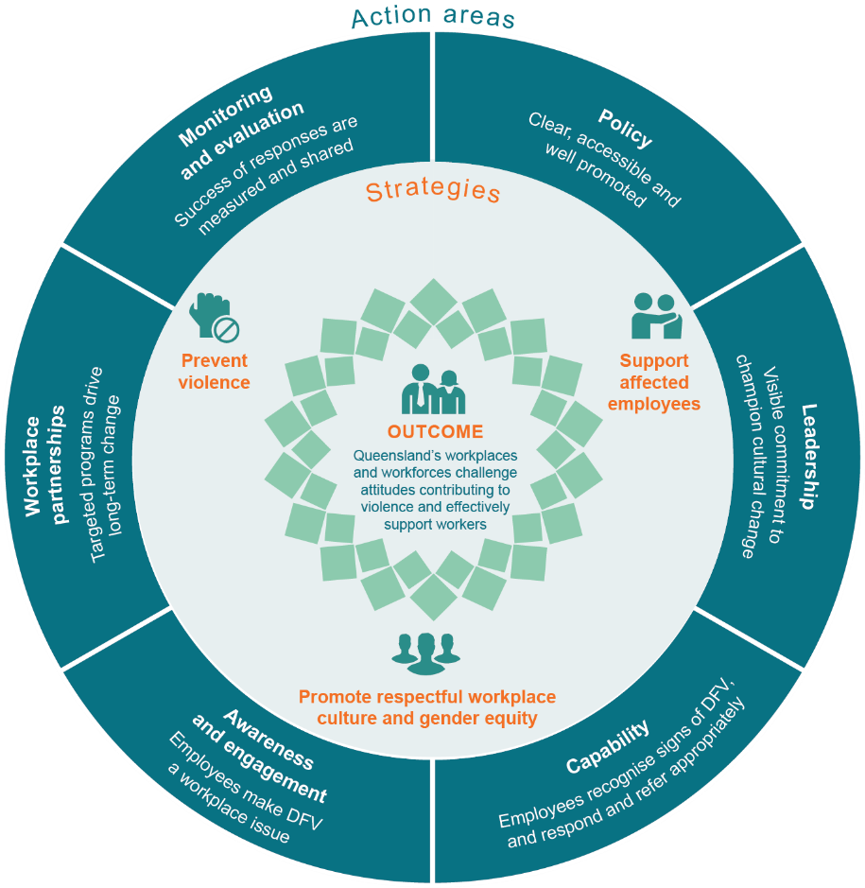

Our workplace progress

Driving a workplace culture of respect, inclusion and gender equity Inclusion and Diversity Strategy 2015–2020 and Gender Equity Strategy 2015–2020
All departments have implemented a domestic and family violence support policy
Partnered with Australia’s CEO Challenge to provide eLearning program (Recognise, Respond, Refer) to all employees
White Ribbon Australia (WRA) workplace accreditation
13 agencies commenced via new business and funding model co-designed with WRA
Best practice and innovation roundtable discussion led by Queensland at the Council of Australian Government’s National Summit hosted by the Premier
Not Now, Not
Ever taskforce report released
Workplace outcomes included in Domestic and Family Violence Prevention Strategy 2016–2026

Leadership Board pledges to end domestic and family violence in Queensland and commits to sector-wide diversity targets including 50% women in leadership
Queensland is the first jurisdiction to embed dedicated entitlements to paid leave, flexible work and dismissal
protections for affected employees into Industrial Relations legislation
Queensland workplace guide promotes business and non-government engagement in domestic and family violence support and prevention initiatives
Employee survey sector-wide
awareness and capability to respond to affected colleagues measured for the first time
Released workplace package to support all employees affected by domestic and family violence, and is available for all workplaces to adopt and tailor

2015

Workplace evaluation indicators and measures identified to track progress in the evaluation framework for the Domestic and Family Violence Strategy 2016–2026
Culture transformation identified as core lever in 10 year human capital outlook and 3 year strategic roadmap
Queensland social survey measures employer involvement in domestic and family violence initiatives
Inclusion, safety and wellbeing are core attributes of the Positive and healthy workplace cultures guide
Partnering with Male Champions of Change to support place-based domestic and family violence responses
Social procurement policy encourages suppliers to adopt domestic and family violence policies and practices
Global UN Women’s
report commends Queensland Government’s workplace response
Increasing awareness and confidence to respond and refer noted in sector-wide employee survey
19 agencies accredited
as White Ribbon workplaces
Flagship evaluation commending Queensland Government’s workplace response released
Proactive focus on employees’ wellbeing and safety in the Be healthy, be safe, be well framework
Driving a workplace culture of respect, inclusion and gender equity Inclusion and Diversity Strategy 2015–2020 and Gender Equity Strategy 2015–2020
All Qld Govt depts. have implemented a domestic and family violence support policy
Partnered with Australia’s CEO Challenge to provide eLearning program (Recognise, Respond, Refer) to all Qld Govt employees
White Ribbon Australia workplace accreditation
13 agencies commenced via new business and funding model co-designed with White Ribbon Australia
Not Now, Not Ever taskforce report released
Workplace outcomes included in Domestic and Family Violence Prevention Strategy 2016–2026

Leadership Board pledges to end DFV in Qld and commits to sector-wide diversity targets including 50% women in leadership
Qld is the first jurisdiction to embed dedicated entitlement to paid leave, flexible work and dismissal protections for affected employees into IR legislation
Comprehensive capability development program, including
e-Learning available to all departments via a
Memorandum of Understanding with Australia’s CEO Challenge
Employee opinion survey sector-wide awareness and capability to respond to affected colleagues measured for the first time
Released workplace package
to support Qld Govt employees affected by domestic and family violence, and is available for all workplaces to adopt and tailor

2018

Monitoring and evaluation
- The Queensland Government’s workplace response to domestic and family violence (workplace response) is comprehensively measured and monitored under the evaluation framework of the Domestic and Family Violence Prevention Strategy 2016–2026.
- A flagship evaluation of the workplace response was completed in 2018 to analyse implementation progress across the Queensland public service.
- Evaluation findings were informed by a range of data sources, including survey results, chief executive interviews, stakeholder consultation and engagement, and analysis of leading practice.
- The report makes 21 recommendations across the six areas of the workplace response model.
Key insights
The flagship evaluation report commends the work of Queensland Government in implementing the workplace response—it sets a strong baseline for driving cultural change and creating workplaces and workforces that challenge attitudes contributing to violence and effectively support workers.
Key insights:
- a collaborative multi-agency approach supports efficient implementation and greater impact
- leadership is a critical success factor in implementing a workplace response
- integrated, comprehensive workplace responses and human capital initiatives embed greater cultural change
- workplace partnerships in targeted initiatives drive long-term change
- capability and awareness enable effective employee support
- measuring impact is complex and safety is paramount for affected employees
- employee confidence in responding to domestic and family violence is slightly higher in WRA accredited agencies
- tailored support resources support effective policy implementation.
Next steps
The Queensland Government accepts the flagship evaluation recommendations in-principle and will continue to:
- deliver on Queensland’s Domestic and Family Violence Prevention Strategy 2016–2026 and future action plans
- support departments to lead by example by supporting affected employees including those experiencing violence, carers, bystanders and those using violence, where appropriate
- enable ongoing access to quality development options to strengthen employee capability
- support the Queensland Government’s multi-agency approach to workplace reform and its commitment for all departments to achieve WRA Workplace Accreditation
- collaborate with workplace partners to model supportive workplace practices and promote the domestic and family violence workplace package to business and non-government organisations
- strengthen monitoring and evaluation to improve our workplace responses to affected employees.
More information

www.forgov.qld.gov.au/domestic-and-family-violence

