Searching and search Request Service
Archives Gateway User Guide
Queensland State Archives
July 2020
Security classification: Public

Table of contents
Table of contents 2
Introduction 4
Definitions and references 4
Brief overview of search request process 5
1 Searching and viewing your records in ArchivesGateway 6
1.1 The My Records screen 6
1.2 Search for records 6
Main search bar 6
Filters and refinements 7
Representations 8
Searching within a series 9
Searching by date 9
1.3 Download records lists and search results 10
1.4 Records inherited or transferred as part of a machinery-of-government change 10
1.5 Downloading digital representations from ArchivesSearch 11
2 Search request status bar 12
3 Submit a search request 12
3.1 Search fees 12
3.2 Creating search requests 12
From the Controlled records screen 13
From the Search requests screen 13
Complete search request form 13
3.3 Saving and submitting search requests 14
Saving a request 14
Submitting a request 14
3.4 Canceling a request 15
From the search request tab 15
From the search request details screen 15
Confirming a cancellation 16
To cancel a submitted request. 17
4 Completed search request 17
4.1 Search results 17
View search results 17
Downloading search results 18
Search results in the Comments/Discussion feature 18
4.2 View search request fees 18
4.3 Request records found in search 19
5 Comments/discussion feature 19
6 More information 20

Introduction
This user guide provides an overview and instructions of how to search your agency’s records in ArchivesGateway and how to submit search requests to Queensland State Archives (QSA) when required records cannot be found.
The information in this guide applies to all government agency staff involved that use ArchivesGateway to manage their records at QSA.
Other user guides are available for other functions within ArchivesGateway. See the more information section for details on how to find and access these other user guides.
See the ArchivesGateway user guide: Manage users and locations for information on how to access ArchivesGateway, create users and set user permissions.

Definitions and references
Relevant definitions of recordkeeping and archival terms used in this guide can be found in the glossary on the website.
See recordkeeping and archival terms and their definitions.

Brief overview of search request process

Searching and viewing your records in ArchivesGateway

The My Records screen
The My Records screen shows a list of all the Series, Records and Representations controlled by your agency.
To see and search the list:
- Log in to ArchivesGateway – see the Managing users and locations user guide for more information.
- Click on the ‘My Records’ tab.
- Go to the ‘controlled records’ tab (if it doesn’t open already)
The sidebar displays the total number of Series, Records and Representations.
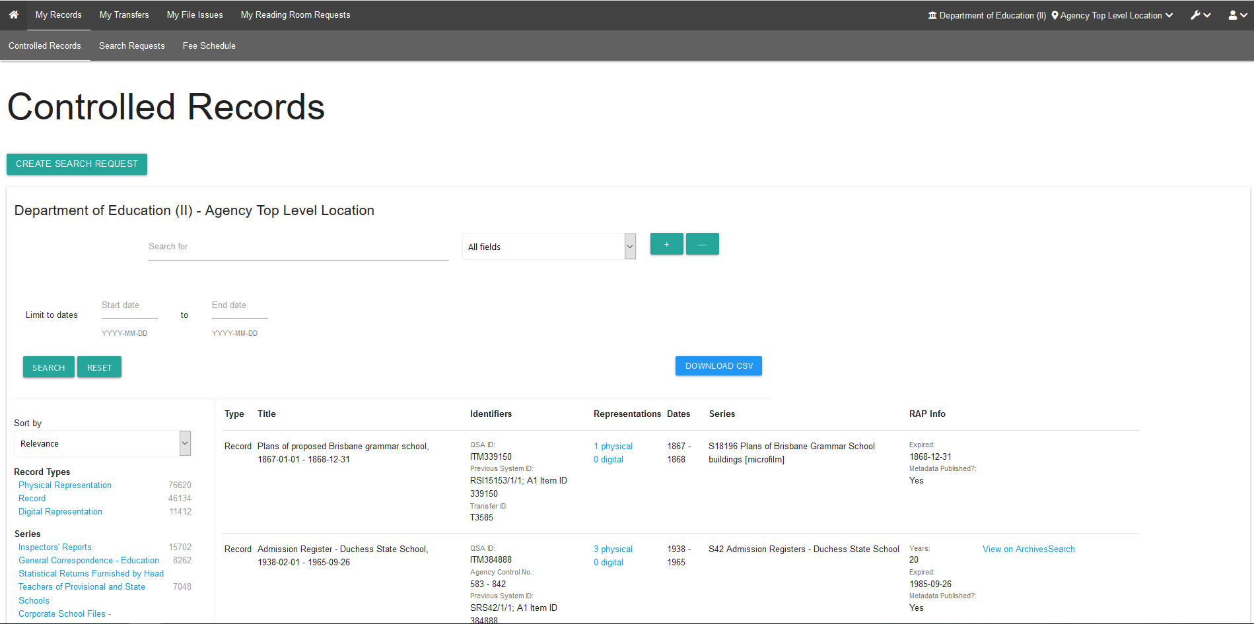

Search for records

Main search bar
The main search bar in the My records screen can be used to search within 1 or more of the categories listed below:
- All fields
- QSA ID
- Agency Control No.
- Title (previously known as Description)
- Transfer ID
- Series ID
- Container ID e.g. S102-T80-B1.00000 or S102-T80-B0.00001.
- Previous System ID
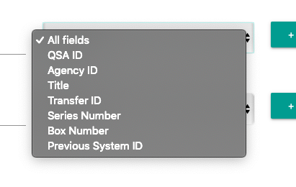
You can use Boolean AND, OR, NOT statements with the search lines.
To add more lines to a search, click on the ‘+’
To remove lines from a search, click on the ‘-’.
Note: This search screen is also used within the ‘My File Issue’ and ‘My Reading Room requests’ tabs, where you select ‘create new request’ and then choose the ‘add records to request’ button.

Filters and refinements
Use the options in the sidebar to refine your search results by the categories listed and/or sort the results as required.
Categories include:
- Record type
- Series
- Creating agency
- Access status
- Format
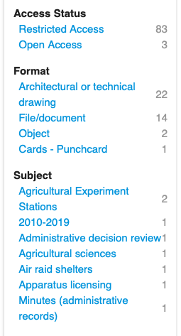

Representations
To see the representations for an item (record):
- Find or navigate to the item in question
- Click the blue linked text in the Representations column.
- You will now see the Representations linked under that Item.
- To collapse the Representations under the Item, click on the blue linked text again.
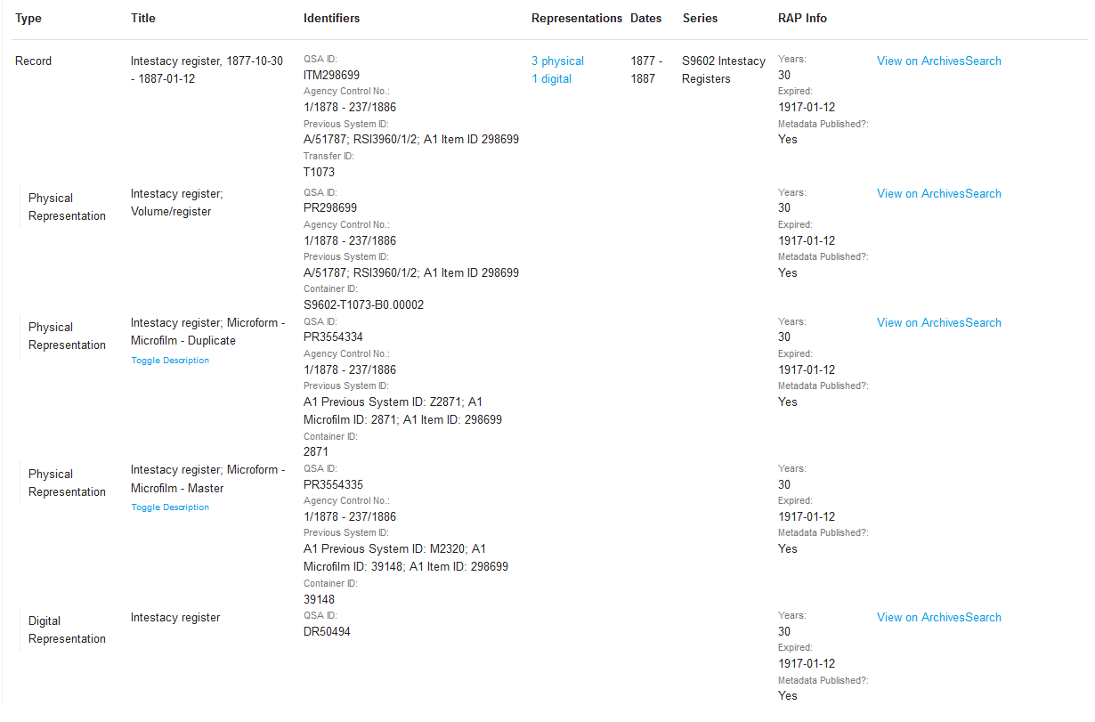
Note: You can also view, access and download Open Access Digital Representations using the ‘View on ArchivesSearch’ button which displays next to the Restricted Access Period (RAP) information in the search results.

Searching within a series
When a series is selected, there is an option to search within that series.
To search within a series:
- Click the ‘search within a series’ option to the right of the series in the list.
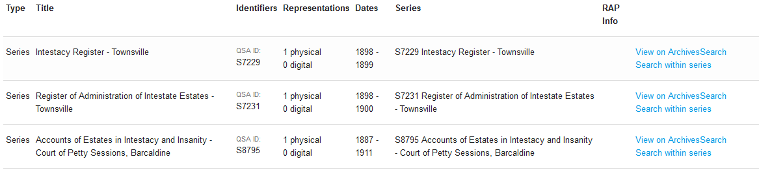
- Type in the keywords you wish to search for within the Series.
- Click ‘search’
- To stop searching within a Series, click on “Reset” next to the name of the Series you are searching in next to the keyword entry field.
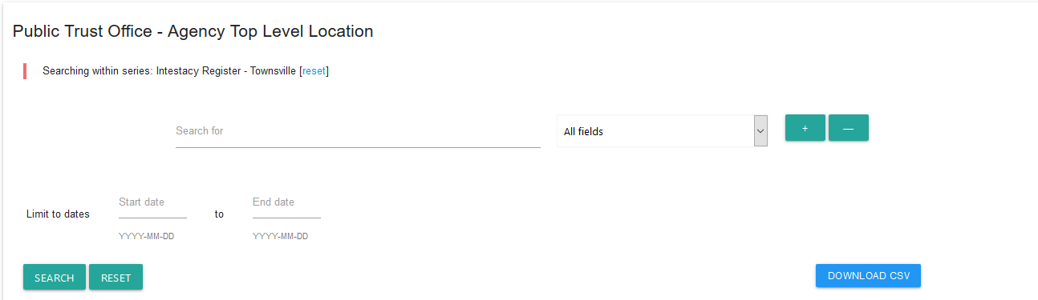

Searching by date
You can search by dates.
This works for overall searching as well as within a Series.
- In the date fields, type the date in as:
  - YYYY
  - YYYY-MM, or
  - YYYY-MM-DD
- Click search.

Download records lists and search results
To download the search results or all your Controlled Records:
- Click ‘Download CSV’
- Confirm that you want to download the CSV.
- Once the ‘download’ button has been selected, a window will open with the option to open or save the file.
- Save or open the file as required.
Note: Columns in the CSV file will only populate if the information is filled out in ArchivesSpace. Additionally, not all columns are relevant to all record types and these are left blank where not applicable.

Records inherited or transferred as part of a machinery-of-government change
Series, Items, and Representations that change ownership due to a machinery-of-government (MOG) change, will have the new ownership reflected in ArchivesGateway.
Where ownership for records is transferred to another agency:
- both the preceding and successor agencies will be able to see the records for a period of 3 months
- the records will show a ‘under movement’ note against them in ArchivesGateway
- can still be requested and issued to the preceding agency
- display as records belonging to the successor agency in their list.
Once the 3-month grace period is finished, the preceding agency will no longer be able to see or access the records in ArchivesGateway.
If access is required, they will need to request access from the succeeding agency.
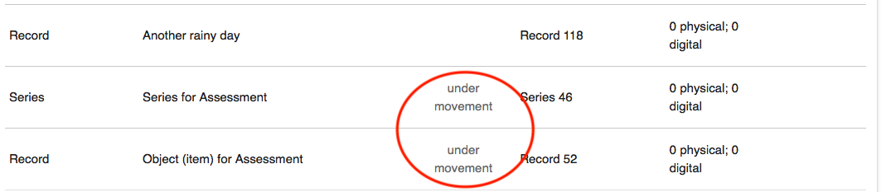
See our advice on Custody, ownership and responsibility for records during a MOG or administrative change for more information on the transfer of ownership for records.
See our advice on Manage and provide access to records during a MOG or administrative change for more information on how preceding and succeeding agencies can manage and arrange access to records both agencies need.

Downloading digital representations from ArchivesSearch
Digital representations of items will be added to the catalogue and can be accessed through ArchivesSearch.
You will be able to see if there is a digital representation attached to an item in the ‘Controlled records’ tab in ArchivesGateway.
You will also see this in the ‘Add records to request’ tab in File Issue and Reading Room requests.
To view, access or download the digital representation:
- Find or navigate to the item in question in the ‘Controlled records’ tab.
- Click the blue linked text in the Representations column.
- You will now see the Representations linked under that Item.
- Click on the ‘View on ArchivesSearch’ button next to the digital representation.
- This will take you to the item in ArchivesSearch, which includes the different representations.
- Click ‘view digital copy’.
- Click on the digital representation you wish to view.
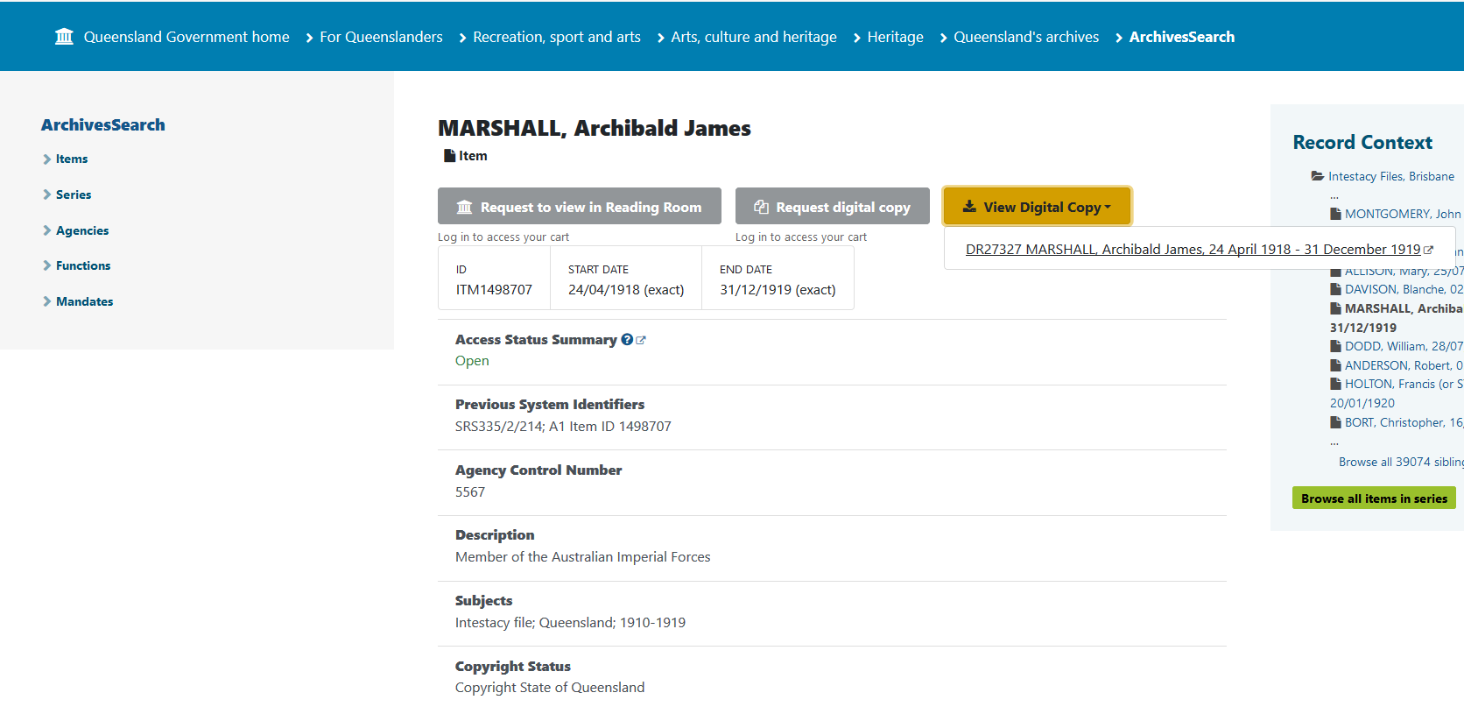
- A pop-up window will open with the option to open or save the file.
- Save or open as required.

Search request status bar
Each Search request created and submitted to QSA includes a status bar at the top of the request screen.
The status bar tracks the progress of a request.

Submit a search request
If you are not able to find any items/records or representations related to your search criteria, QSA can search your agency’s records on your behalf for up to 1 hour.
This is a fee-based service.

Search fees
A standard fee per 15 minutes of searching applies, even if the search returns no results.
To view the fee schedule for searches, click on the View Fee Schedule link in the instructions box. This will open in a new tab.
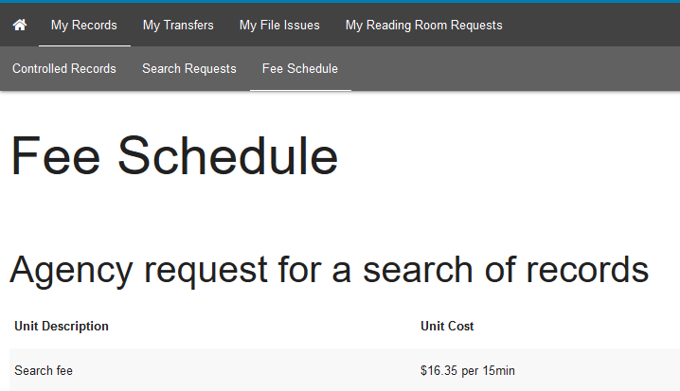
After the search results have been provided by QSA, your agency will be charged for the service.
The search fee for each search request submitted to QSA will be included in the quarterly invoice sent to your agency.

Creating search requests
To create a search request:
- Navigate to the ‘My records’ screen.

From the Controlled records screen
- Open the ‘Controlled records’ tab.
- Click on the ‘Create Search Request’ button.

From the Search requests screen
- Click on the ‘Search requests tab.
- Click on the ‘Create Search Request’ button.

Complete search request form
- Fill out the required fields in the search request form.
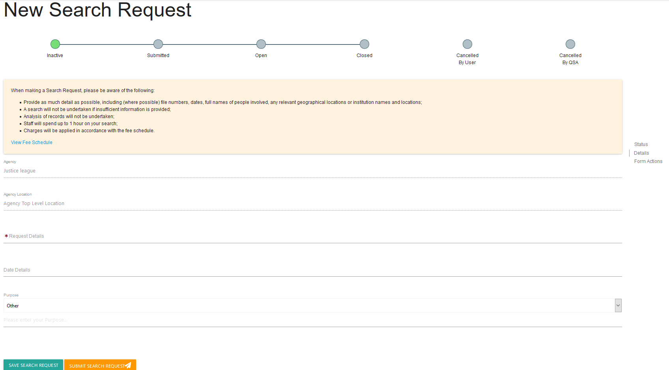
Provide as much information as possible to assist us in our search. Information provided could include:
- The persons name
- Type of record
- Date range
- Purpose of the request
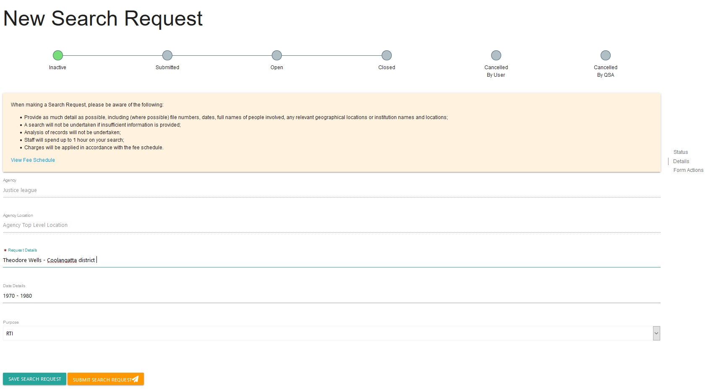
Note: If the reuqest is urgent, use the comments/discussion feature to let QSA know OR include it in the request details field in the form.

Saving and submitting search requests
Agencies have the option to save, submit or cancel a search request.

Saving a request
To save a request:
- Click ‘save search request’ at the bottom of the form.
A unique identifier will be created with an SR prefix.
Saved requests will show as ‘inactive’ in the list of search requests.

Submitting a request
To submit a request to QSA:
- Click on the ‘Submit Search Request’ button.
This will send the search request to QSA for completion.
You will be able to edit the information in the search request until it has been approved by QSA.
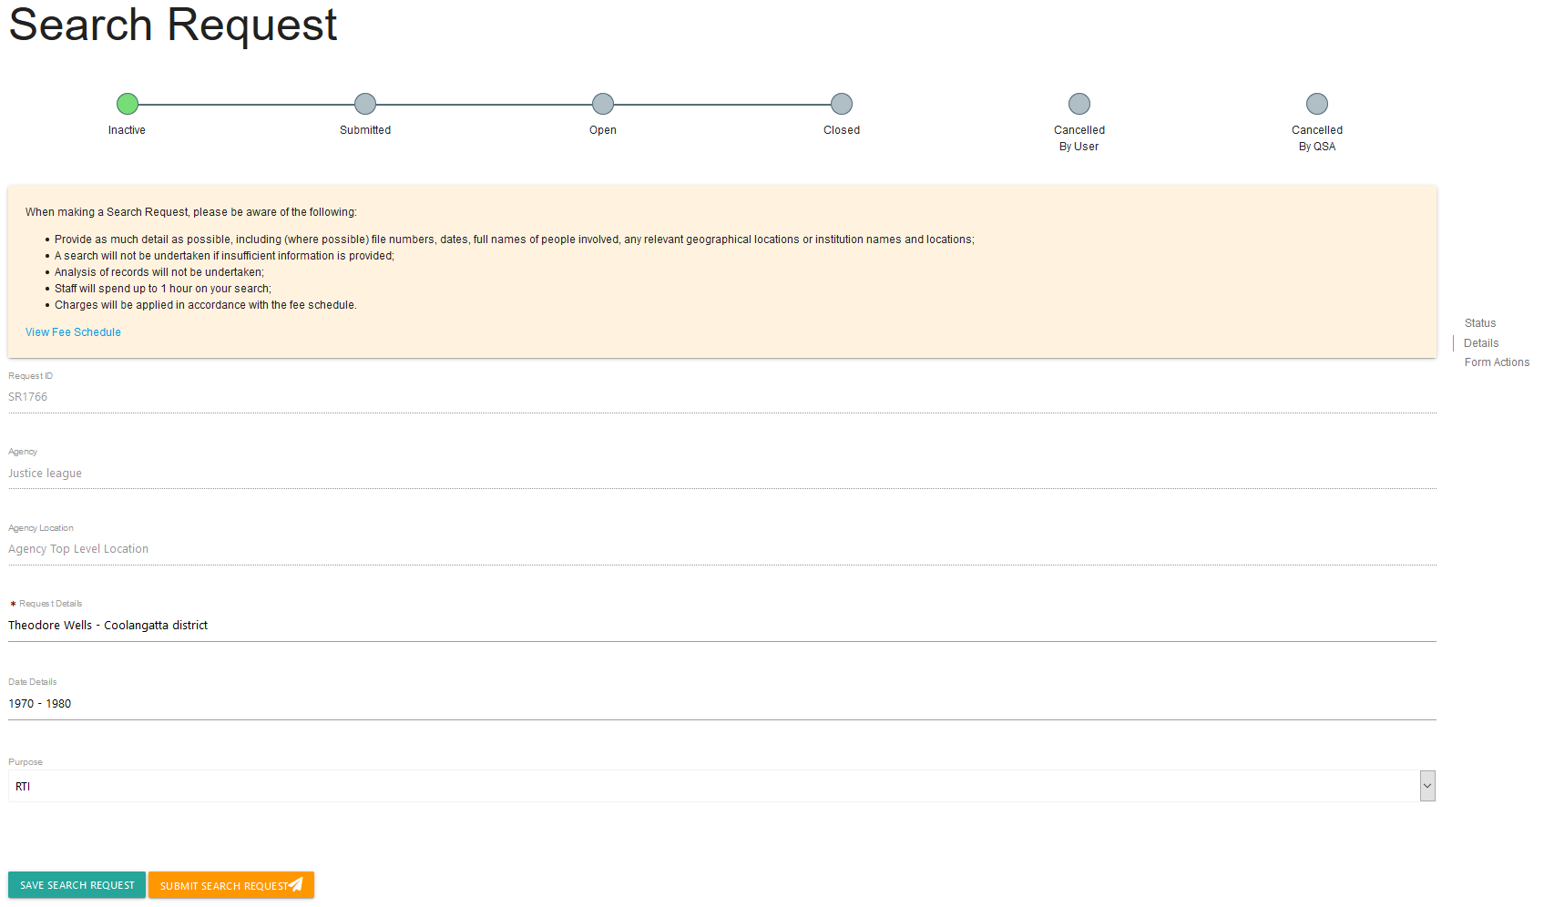
QSA Staff may send you a message using the comments/discussion box at the bottom of the Search Request form.
You may also use this system to respond or send new messages to QSA.
Note: the status of the Search Request will update in the Status Bar as it is progressed.

Canceling a request
Search request can be cancelled through ArchivesGateway until it has been approved by QSA.
To cancel a saved request:
- In the Search request list, navigate to the request you wish to cancel.

From the search request tab
- Click ‘cancel’ button next to the request.

From the search request details screen
- Click view to see the search request details
- Scroll down to the bottom of the form.
- Click ‘cancel’.
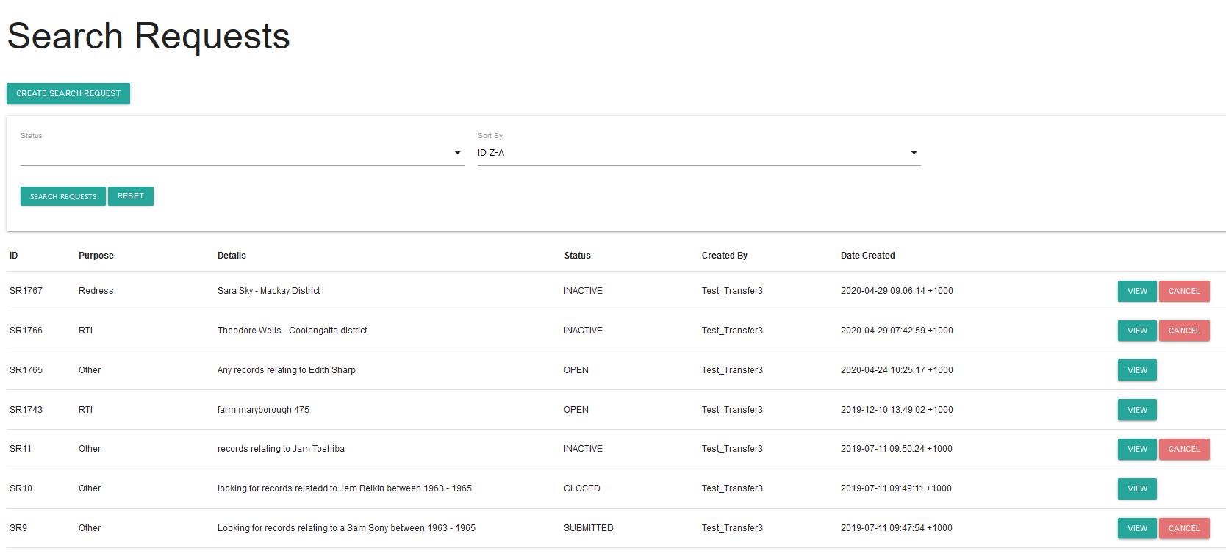

Confirming a cancellation
- A warning will appear asking, ‘Are you sure you want to cancel this search request?’.
- To cancel the request, click ‘confirm’ on the warning.
- Once the ‘confirm’ button has been clicked, the status of the request will be updated to ‘CANCELLED_BY_AGENCY’.
Note: Any requests cancelled by agencies will not be able to be resubmitted to QSA. Instead, a new request must be submitted.
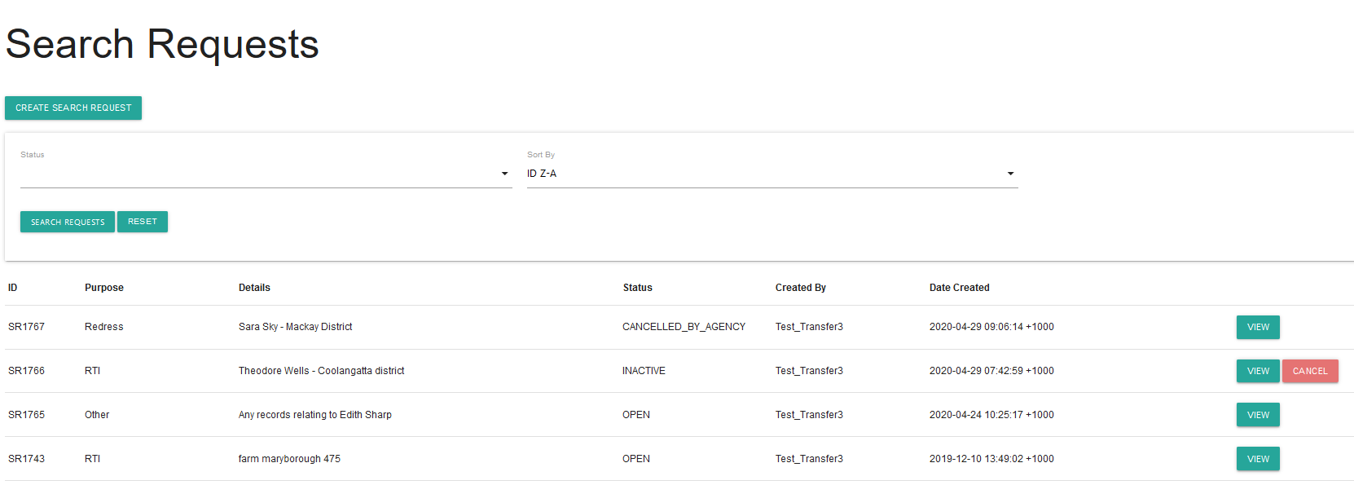

To cancel a submitted request.
Once the request has been submitted and approved, only QSA will be able to cancel the request.
To cancel a submitted requested, use the comments/discussion feature within that search request to advise QSA that the request has been cancelled.

Completed search request
Completed requests will appear as ‘closed’ in the status bar for that request.
Note: Once completed, no changes can be made to the request.

Search results
After QSA has completed the search, you will be notified of the results either by:
- Using the Comments/Discussion feature if:
  - the search was unsuccessful
or
  - there were limited search results
- Uploading a search results document if the search provided many results.
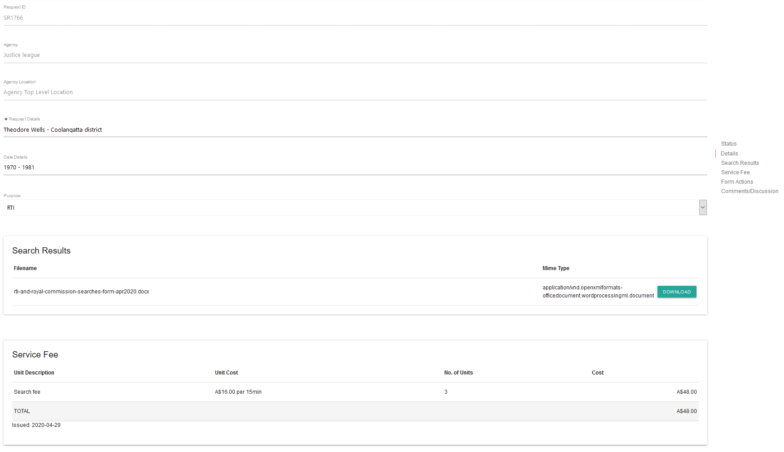

View search results
To view the search results:
- Open your Search Request.
- You will see the search results have populated and the service fee has appeared.

Downloading search results
If QSA has provided your search results in a document, you will be able to download this document.
To download the results:
- Navigate to the ‘Search Results’ section of the Search Request in ArchivesGateway
- Click on the ‘download’ button next to the ‘Mime Type’ column.
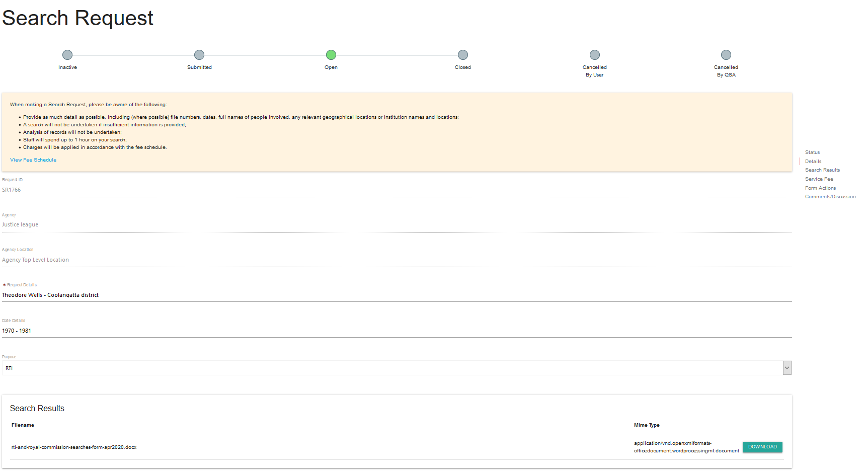
- Once the ‘download’ button has been selected, a window will open with the option to open or save the file.
- Save or open the file as required.

Search results in the Comments/Discussion feature
If QSA has provided search results using the Comments/Discussion feature
- Scroll to the bottom of the Search request details screen.
- View the comment and respond if required.
See the instructions for using the comments/discussion feature for more information.

View search request fees
Once a search request is completed, the search request fee section will be populated by QSA with the cost of the search.
To view the cost of the search:
- Open the search request details page.
- Scroll down to the ‘service fee’ section.
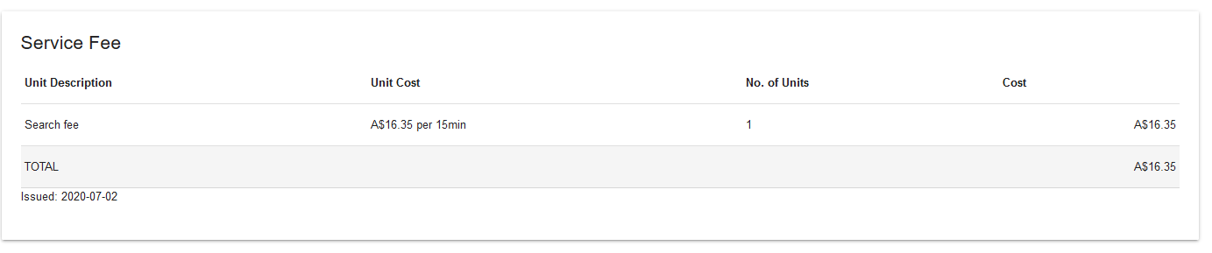Note: Individual search request fees will be included in the quarterly invoice sent to your agency.

Request records found in search
If required, use the search results to create a File Issue request to access the records.
See the advice on how to Retrieve or access your agency's records at QSA (File Issue service) and the File Issue service user guide for further information.

Comments/discussion feature
The comments/discussion feature within ArchivesGateway can be used to communicate with QSA staff.
Note: This feature is also available in the Transfer Proposals/Transfers, File Issue Request/File Issue and Reading Room Request sections within ArchivesGateway.
To send a message to QSA regarding a search request or search results:
- Scroll down to the bottom of the search request page to the comments/discussion section
- Type in your message into the message field
- Click ‘post message’.
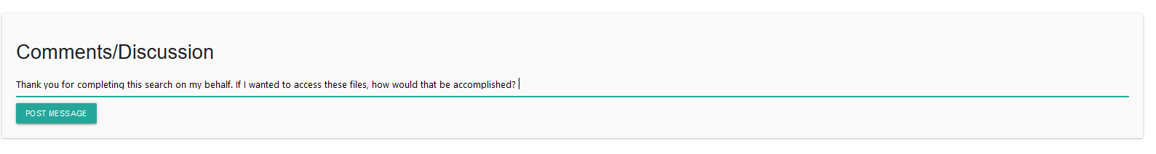
- The message will appear above where the message was typed and QSA will be able to view this message within the search request.
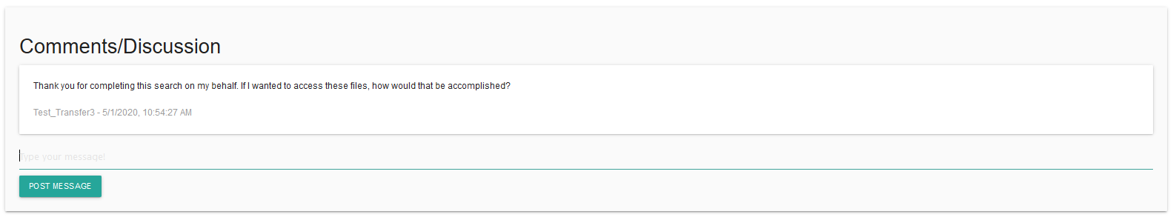
- When QSA responds to your message, it will appear below your original message.
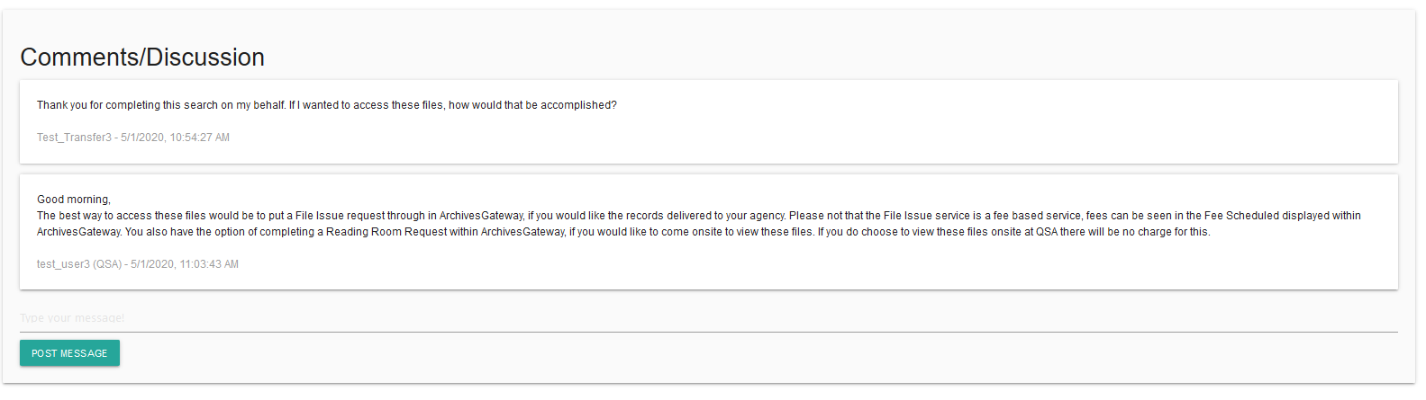
- Use the message field as per steps above to respond to any comments posted by QSA.

More information
Further information is available on the Recordkeeping section of the For Gov website:
- Use ArchivesGateway
- Transfer records to QSA
- Restrict access to records at QSA (Restricted Access Periods)
- Retrieve or access your agency's records at QSA (File Issue service)
- Provide access to closed records
Other user guides are also available for specific functions within ArchivesGateway and are available on the relevant pages listed above.
If you require further assistance with ArchivesGateway, please contact the ArchivesGateway team via email: ArchivesGateway@archives.qld.gov.au.

