**Transferring records**

ArchivesGateway User Guide

**Queensland State Archives**

July 2020

Security classification: Public

# Table of contents

Table of contents 2

Introduction 4

Definitions and references 4

Brief overview of transfer process 5

The ‘my transfers’ tab 6

Transfer proposals tab 6

Transfer proposal status 6

Transfers tab 7

Transfer status 7

1 Propose a transfer 8

1.1 Create a transfer proposal 8

1.1.1 Add series information and metadata 9

1.1.2 Additions to existing series (accruals) 10

1.1.3 Add another series 10

1.1.4 Attach supporting information to a proposal 10

1.2 Saving proposals 11

1.3 Edit a saved proposal 11

1.4 Submitting transfer proposals 11

1.5 Approving transfer proposals 12

1.5.1 Declined proposals 12

1.5.2 Approved proposals 12

1.6 Delete or cancel a proposal 12

1.6.1 Delete a saved proposal 13

1.6.2 Cancel a submitted proposal 13

1.6.3 Cancel an approved proposal 13

2 Managing a transfer 14

2.1 Transfer progress bar 14

2.2 Open and view the new transfer 14

2.3 Item list template 14

2.3.1 Download the item list template 14

2.3.2 Complete the item list template 15

2.3.3 Listing items with more than 1 representation or attachment 18

2.3.4 Upload the item list template 18

2.3.5 Validation of the Item list template 19

2.4 Upload other supporting documents 20

2.5 Schedule and deliver transfers 21

2.6 Completing transfer process 21

2.6.1 Changes report 21

2.6.2 Download the Transfer report 22

3 Viewing past transfers 23

3.1 Transfer reports for transfers managed in the previous system 23

4 More information 23

# Introduction

This user guide provides an overview and instructions of how to propose and manage the transfer your agency’s permanent archival value records to Queensland State Archives (QSA) using ArchivesGateway.

The information in this guide applies to all government agency staff involved that use ArchivesGateway to transfer and manage their records at QSA and should be read in accordance with the *Public Records Act 2002* (the Act)*.*

This user guide also assists staff processing transfers to ensure that all required tasks, documentation, database management and checking are completed.

Transfers are undertaken using a combination of [ArchivesSpace](https://www.forgov.qld.gov.au/glossary/archivesspace) (for QSA users) and ArchivesGateway (for external agency users).

General transfer enquiries such as determining retention schedule coverage or records preparation are managed outside of ArchivesGateway and should be forwarded to the QSA Transfers Team by phone, email or directly from the QSA website.

Other user guides are available for other functions within ArchivesGateway. See the more information section for details on how to find and access these other user guides.

# Definitions and references

Relevant definitions of recordkeeping and archival terms used in this guide can be found in the glossary on the website.

See [recordkeeping and archival terms and their definitions](https://www.forgov.qld.gov.au/glossary?keys=recordkeeping).

# Brief overview of transfer process

# The ‘my transfers’ tab

In the My transfers tab, you can see all current and past transfers, and all transfer proposals done in ArchivesGateway.

If you have access to more than one Agency, you will need to select the Agency you wish to see transfers/ transfer proposals for from the drop-down list at the top right of the screen.

You can also use the Agency Location drop down list to filter transfers/transfer proposals by the location of the Agency User which created them.

See the [Manage users and locations user guide](https://www.forgov.qld.gov.au/use-archivesgateway#more-information) for more information on switching between agencies and locations.

## Transfer proposals tab

To see all current and past transfer proposals done in ArchivesGateway, click on ‘Proposals’ in the toolbar at the top.

From here, you can view, edit or cancel current proposals.

If a proposal has been approved, you won’t be able to edit it any further.

**Note:** In the approved transfer proposal window, you can jump to the attached transfer by using the ‘view transfer’ button at the top.

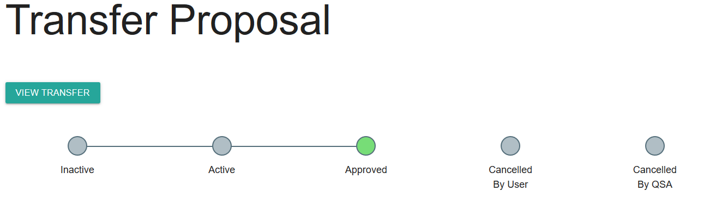

See transfer proposals below for more information.

### Transfer proposal status

There are 4 different statuses that can be against a transfer proposal in the list.

These statuses corresponded to the different stages show in the transfer proposal progress bar.

The following table lists the different statuses and what they mean.

| **Status** | **Meaning** |
| --- | --- |
| Inactive | The transfer proposal has been created by the agency but not yet submitted to QSA. |
| Active | The proposal has been submitted to QSA and is awaiting approval. |
| Approved | The proposal has been approved by QSA and a transfer created. |
| Cancelled by agency | The proposal was submitted to QSA but has since been cancelled by the agency |

## Transfers tab

To see all current and past transfers, click on the ‘Transfers’ tab in the toolbar at the top.

From here you can:

* view and manage all current transfers.
* view and download reports for past transfers.

**Note**: any transfer managed in ArchivesGateway will have a ‘view proposal’ button at the top that allows you to jump back to the related proposal.

See current transfers for more information on managing current and in progress-transfers.

See Managing and viewing past transfers for more information on searching, viewing and downloading reports of completed transfers.

### Transfer status

There are 4 different statuses that can be against a transfer in the list.

These statuses corresponded to the different stages shown in the 2 transfer progress bars.

The following table lists the different statuses and what they mean.

|  |  |
| --- | --- |
| **Status** | **Meaning** |
| Initiated | The transfer proposal has been approved and a transfer created in ArchivesGateway. |
| Pending | The metadata template has been submitted.  The Restricted Access Period (RAP) notice has been submitted or exemption granted.  **Note**: The status of a transfer cannot progress past Pending until the RAP requirement has been satisfied, even if later steps have been completed. |
| In Progress | The transfer has been received by QSA and checking of records has begun. |
| Completed | The metadata has been checked and imported into the system.  The records have been checked.  A ‘changes report’ has been sent to the agency (if required).  The transfer has been completed. |

# Propose a transfer

You must create a transfer proposal to QSA through ArchivesGateway before you can transfer records to QSA.

**Note**: If a user for multiple agencies or locations, you may need to select the correct one from the drop down in the toolbar first.

## Create a transfer proposal

To create a transfer proposal:

1. Go to the ‘My Transfers’ heading on the home page of ArchivesGateway.
2. Select ‘Proposals’ in the toolbar at the top.

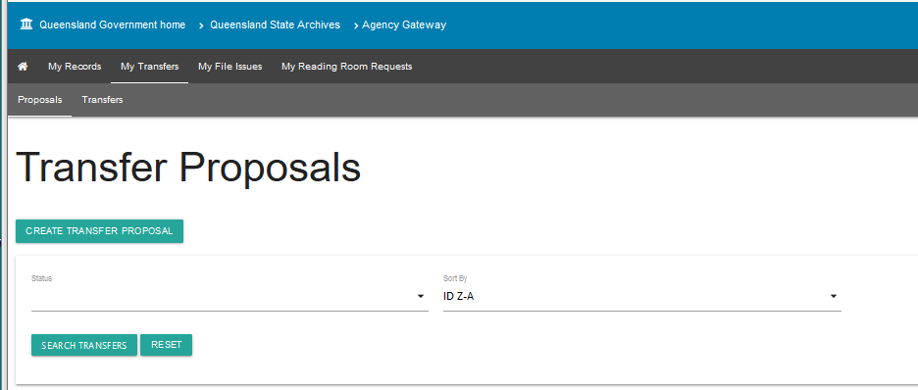

1. Select ‘Create transfer proposal’
2. Add the Title and description – these fields should be used to provide a collective description the records to be transferred to help us identify the transfer.
3. Add the estimated quantity of records to be transferred. This can be number of boxes, registers, maps etc.

**Note:** Mandatory fields are marked with a red star ‘*’.

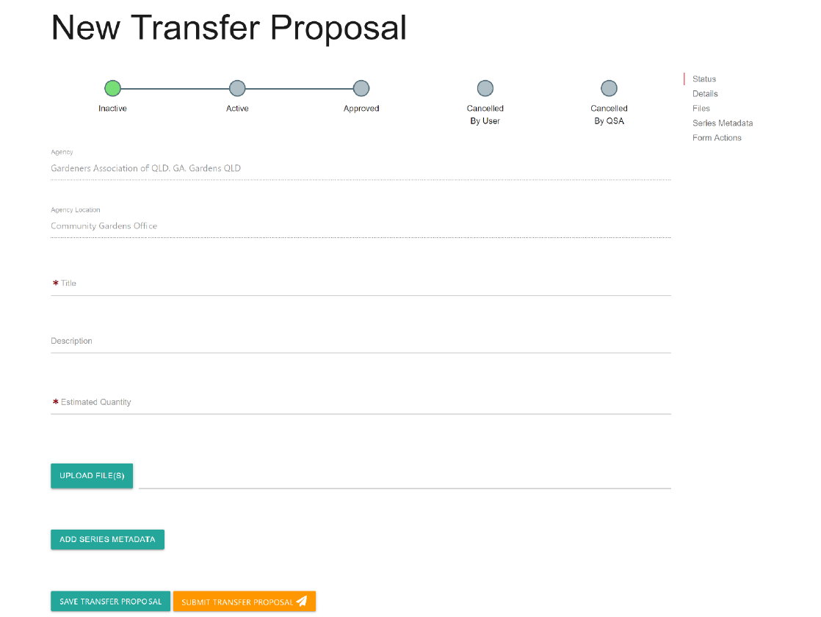

### Add series information and metadata

You will need to add the series information for each series of records intended for transfer.

If you are unsure of what belongs in 1 series (e.g. a group of administrative records), discuss it with the QSA Transfers Officer.

1. Select the ‘add series metadata’ at the bottom of the form.
2. Complete all required fields. Use this table to guide you on how to complete these fields.

| Field | Required | Comments |
| --- | --- | --- |
| Series title | Mandatory | Use actual title or title that best describes the records series /class or a broad description of records if there are multiple classes of records. |
| Description | Mandatory | Information about the purpose, establishment, use or history of the series. |
| Disposal class | Mandatory | Retention and disposal schedule reference deeming the series of permanent value. If outside of a schedule and agreed to by QSA put “QSA approved”. |
| Date range | Mandatory | Approximate or specific date range of all records in series e.g. 1972 – 1994. |
| System of arrangement | Mandatory | Select option from the drop-down menu. |
| Composition | Optional | Click check box of relevant type (should be completed). |

### Additions to existing series (accruals)

If the Transfer is an [accrual](https://www.forgov.qld.gov.au/glossary/accrual):

1. Check the ‘Is transfer an addition to an existing Series at QSA?’ box
2. Add details of the Series the Items should be added to. / complete following fields

|  |  |  |
| --- | --- | --- |
| Field | Required | Comments |
| Creating agency | Optional | Enter name of agency if known, if series date range covers more than one agency enter what agencies are known. |
| Mandate | Optional | Enter relevant legislation applicable to series if known. |
| Function | Optional | Enter function applicable to series if known. |

### Add another series

To add more series:

1. Click the ‘add series metadata’ button for each additional series.
2. Complete the series information and metadata for the new series as above.

### Attach supporting information to a proposal

If requested by QSA, or if you would like to submit a draft item template or other supporting documents, (e.g. scanned images of proposed records), you can upload files within the proposal.

To upload supporting documents:

1. Select the ‘upload file(s)’ option



1. Browse your directories and folders to choose relevant files.
2. Click open. You will now see the file(s) listed below.
3. If required, you can remove the documents from ArchivesGateway.

**Note**: the download button next to each item gives you the option to download and view the document..

## Saving proposals

You can save a transfer proposal at any time without submitting it to QSA.

To save a proposal:

1. Click ‘save transfer proposal’ option at the bottom of the form.



1. The page will refresh to the Transfer Proposals page, which lists all the proposals for your agency.
2. The saved Transfer will be listed with the status of ‘Inactive’.
3. A proposal number will be allocated with a prefix, e.g. P145

## Edit a saved proposal

**Note:** The proposal and series metadata can be updated at any time until approved by QSA. **Approved proposals cannot be edited.**

To edit a saved proposal:

1. Navigate to the Proposal list under ‘My Transfers’.
2. Click on the ‘View’ button next to the transfer proposal you wish to edit.
3. Update the fields in the transfer proposal you wish to update.

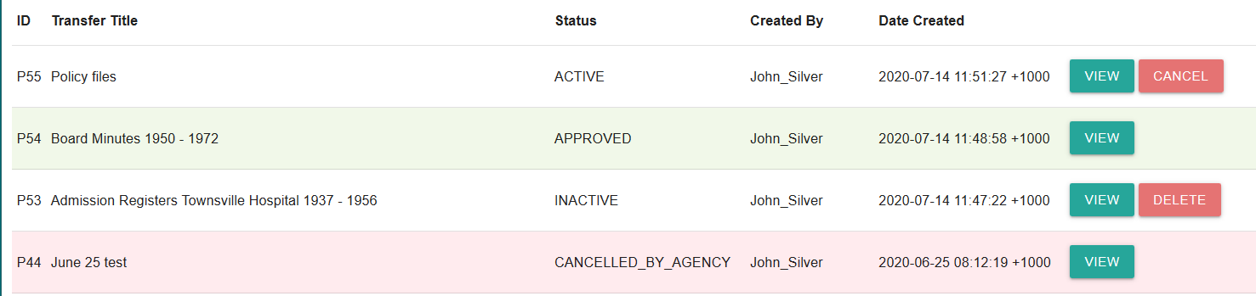

## Submitting transfer proposals

When the proposal is ready to be sent to QSA, it needs to be submitted to QSA for approval.

**Note**: QSA has no visibility of a proposal until it is submitted.

To submit a transfer proposal:

1. Navigate to the Proposal list under My Transfers.
2. Click on the ‘View’ button next to the transfer proposal you wish to submit.
3. Check all details are correct and final

**Note:** After approval, no additional information or series can be added.

1. Scroll down to the bottom of the transfer proposal
2. Click ‘submit transfer proposal’.

Screenshot of ArchivesGateway showing 'submit transfer proposal' button. 

1. Status of proposal will be updated to ‘Active

## Approving transfer proposals

QSA will assess transfer proposals and either approve or decline them.

### Declined proposals

If **declined**, QSA will let you know the reasons for not accepting a proposal or request that you modify the proposal.

See Edit a saved proposal for more information on how to edit and update a proposal.

### Approved proposals

If the proposal is **approved:**

* a transfer number will be generated
* the ongoing management of the proposed records is carried out in the ‘Transfer’ tab in ArchivesGateway
* QSA will forward an approval email to your agency contact officer advising you of the approval and outlining RAP and metadata arrangements.
* the transfer proposal in the list will show a status of Approved.
* a link to the associated transfer will appear in the ‘transfer proposal’ details page.

## Delete or cancel a proposal

If you choose not to go ahead with a transfer proposal, you can:

* delete a saved / not yet submitted proposal OR
* cancel a submitted proposal.

### Delete a saved proposal

To delete a saved proposal:

1. Navigate to the ‘transfer proposal’ list
2. Find the proposal you want to delete
3. Click delete on the right
4. A pop-up message will appear asking you to confirm the deletion.
5. Click confirm
6. The proposal will be removed from list.

### Cancel a submitted proposal

To cancel a submitted proposal:

1. Navigate to the ‘transfer proposal’ list
2. Find the submitted proposal you want to cancel
3. Click cancel on the right
4. A pop-up message will appear asking you to confirm the cancellation.
5. Click confirm
6. The status of the proposal will be updated to ‘cancelled by agency’ in the proposal list.

### Cancel an approved proposal

If a transfer proposal has been approved, it **cannot be cancelled**.

Only the subsequent transfer can be cancelled by either your agency or QSA.

If a transfer is cancelled by QSA, the status of the transfer in ArchivesGateway will change to ‘Cancelled by QSA’.

You will still be able to view the cancelled transfer and any comments by clicking ‘View’ against the Transfer Proposal.

# Managing a transfer

The ongoing management of the transfer is conducted in the ‘Transfer’ tab.

## Transfer progress bar

The Transfer screen has 2 progress display bars.

The 1st (top) bar shows the various steps for a transfer that need to be completed before the transfer can progress.

The 2nd (bottom) bar shows the overall status of the transfer. This bar will progress as the steps above are completed.

See the Transfer status for more information on how the 2 progress bars and the different status relate.

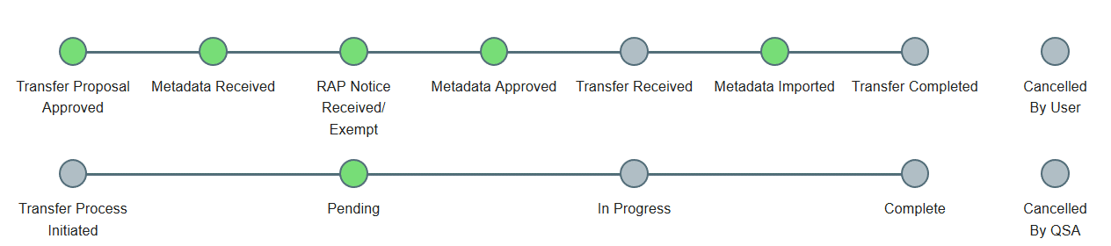

## Open and view the new transfer

1. In the Transfers tab, navigate to the transfer in progress.

**Note**: You can search and sort transfers by title, number, status and creation date.

1. Click the ‘view’ button to see transfer details.

## Item list template

You will need to complete the item list template with the details of the records being transferred.

Listings of transfer items **must** be submitted on the QSA item list template as it will be validated as part of the upload process.

### Download the item list template

1. Navigate to the ‘Transfers’ tab.
2. Scroll down to the ‘upload files’ section.
3. Click on the ‘Download transfer metadata template’ to open the current version of the QSA item list template.

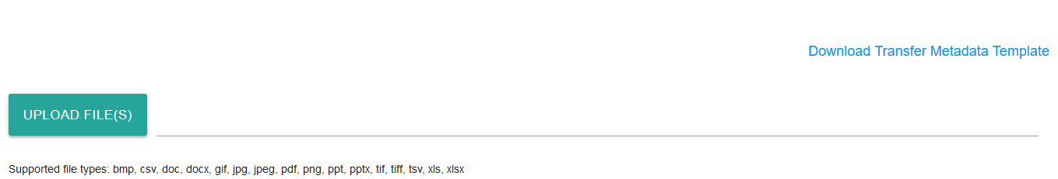

### Complete the item list template

1. Complete all relevant fields in the item list template.

#### Using the template

Some fields use controlled vocabularies and you will need to select a value from the drop-down list in the spreadsheet for these fields.

The item template includes additional tabs that provide further information on each field and the controlled vocabularies used in some fields.

The column heading colours indicate whether the field is mandatory, conditional, or optional:

* red = mandatory
* blue = conditional
* black = optional

When adding the Series, Responsible Agency or Creating Agency to your spreadsheet, please ensure you use the Series ID number, Responsible Agency or Creating Agency you would like to add the record to/ create the relationships to.

The item template includes additional tabs providing further information on each field and the controlled vocabularies used in some fields.

#### Item list template fields

The table below:

* lists the fields in the item list template in order
* identifies the level of requirement
* provides some basic information about how or what data to enter.

Use this table to guide you when completing the item list template.

There is also a tab on the template detailing the rules for entering data into the fields.

| **Field** | **Required** | **Comment** |
| --- | --- | --- |
| Disposal class | Optional | Retention and disposal schedule reference deeming the record permanent value.  If outside of a schedule and agreed to by QSA put “QSA approved”. If a disposal reference is applicable it should be entered. |
| Title | Mandatory | Title of item – include key descriptors such as:   * names * locations * other subject context that provides enough to understand what the record is about. |
| Description | Optional | This field can be used to provide additional or extended information that may not be part of the general title. |
| Sequence number | Mandatory | This field, and the ‘attachment related to sequence number field are used to show the [items](https://www.forgov.qld.gov.au/glossary/item) and the [representations](https://www.forgov.qld.gov.au/glossary/representations) attached to the item.  Enter a consecutive number starting at 1 for all items on the template.  **Note:** if an item is removed, the list doesn’t have to be renumbered. The numbering should remain consecutive but can have gaps if rows have been deleted.  If an item has more than 1 [representation](https://www.forgov.qld.gov.au/glossary/representations) or record attached to it, use the ‘attachment related to sequent number’ field to relate the additional representations to the item.  See Items with more than 1 representation for more information. |
| Attachment related to sequence number | Mandatory / Conditional | Use this field to relate additional representations to the main item.  See Items with more than 1 representation for more information on how to use this field.  If there are no records to be related this field can be left blank.  If a number is entered in this field, then the sequence number field for the item should be blank. |
| Representation type | Mandatory | Select either physical or digital from the drown-down list. |
| Format | Mandatory | Select the relevant format from the drown-down list. |
| Start date | Mandatory | Enter:   * exact date 22/10/1937 or * approximate date month & year 10/1937 or * just year 1937 |
| Start date qualifier | Optional | Select exact or approximate as qualifier |
| End date | Mandatory | Enter:   * exact date 22/10/1937 or * approximate date month & year 10/1937 or * just year 1937 |
| End date qualifier | Optional | Select exact or approximate as qualifier |
| Agency control number | Optional | If an item has any control numbering / file number as an identifier it should be entered |
| Box number | Conditional | If items are boxed, box number must be entered.  Use numeric values only if adding a box to existing list e.g. make it 4.1 not 4A |
| Contained within | Mandatory | Select the container type from the drop-down list.  If not applicable, select ‘no container’. |
| Restricted access period (rap) | Optional | Enter the number of years item is restricted if it is different from the series RAP.  If unknown or same as the series then leave blank |
| Access category | Optional | Select the reason associated with restricted access period from the drop-down list.  Leave blank unless different from series |
| Publish details | Optional | Select from drop-down list:   * Yes – information about the item can be published * No – information about the item must remain closed for the duration of the Access period.   **Note**: if a value is entered in this field then a value must be entered in either the Access Category or RAP field or both.  Leave blank unless different from series. |
| Series id | Optional | If it is an addition to an existing series enter existing Series ID if known otherwise leave blank |
| Responsible agency | Optional | Use if agency known – enter agency name. |
| Creating agency | Optional | Use if agency known – enter agency name. |
| Sensitivity label | Optional | Use if information may be offensive or distressful. |
| Remarks | Optional | Use if additional information to be added. |

### Listing items with more than 1 representation or attachment

If an [item](https://www.forgov.qld.gov.au/glossary/item) in the list has more than 1 [representation](https://www.forgov.qld.gov.au/glossary/representations) or record attached to it, the ‘**sequence number**’ and the ‘**attachment related to sequence number**’ fields are used to relate them in the list.

This can also be for **any** restricted components, electronic attachments, or object attachments that may need to be **managed separately** for access or storage reasons.

To add additional representations or attachments to an item in the list:

1. Insert an additional entry below the existing item
2. Add the same title as the item to the title field
3. Add a description of the attached record to the description field.
4. Add the sequence number of the parent item in the ‘attachment related to sequence number’ field.
5. Remove any number from the sequence number field for the attachment.
6. Complete all other relevant fields for the representation/attachment as required.

**Example:** If the original item was sequence number 12, then for the attached record place 12 in the Attachment Related field and have a blank value in the sequence number field.

**Note:** Dates should not be entered for attached records as they will inherit from linked parent item)

Find out more about [items and representations.](https://www.forgov.qld.gov.au/use-archivesgateway#items-and-representations)

### Upload the item list template

Item list templates must be uploaded to ArchivesGateway and validated to confirm that:

* mandatory data fields are populated
* template field order and titling have not been altered.

This is to allow import into [ArchivesSpace](https://www.forgov.qld.gov.au/glossary/archivesspace), the collection management system at QSA.

To upload the item list template:

1. In the ‘Transfers page’ click ‘upload file(s).



1. Browse your directories and folders to choose the item list file you wish to upload.
2. Click open to upload the file.
3. You will now see the file listed below the ‘upload files’ section.
4. The ‘role’ against the item list template uploaded should be listed as ‘Import’.

**Note**: QSA Item list templates will always automatically be allocated the role of Import. All other documents upload will need a role set by the user.

1. The validation will now run on the item list template.
2. If required, you can remove the uploaded list from ArchivesGateway using the ‘remove’ button against the item in the list.

**Note**: the download button next to the item list template does not allow you to download the list you uploaded but will download a clean item list template. The list you uploaded will stay even if you do download a clean copy.

### Validation of the Item list template

#### Validated

If the template is **validated**:

1. Click the ‘save transfer’ button.
2. Use the comments/discussion feature to notify QSA that the item list template has been submitted.

#### Errors detected

If **errors are detected** during validation:

1. A message will appear saying the template contains errors.

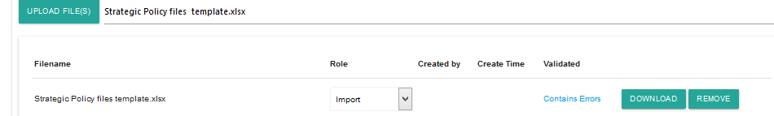

1. Click on that link to see a detailed message identifying the row and error type.
2. Check the errors in the template and remove or amend as required.
3. Resubmit the template as per steps above.

**Note**: Error messages will follow a standard pattern of: ERROR - [Column Name:RowNumber] ‘Error Message’ : ‘Invalid Cell Value’.

**Example errors:**

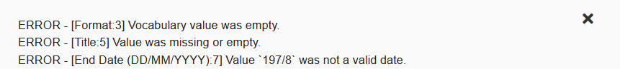

ERROR – [Format 3] Vocabulary value was empty

This example means that in the column named ‘Format’, row 3, there was no option selected from the drop downy for that cell.

ERROR – [Title:5] Value was missing or empty

This example error means that in the Title column, row 5, this field was left blank.

ERROR – [End date (DD/MM/YY):7] Value ‘197/8’ was not a valid date

This example error means that the date entered in the end date column in row 7 is not valid.

## Upload other supporting documents

Upload other supporting documents as required:

1. Scroll down to the upload section
2. Click ‘upload file(s).



1. Browse your directories and folders to choose the relevant file(s) you wish to upload.
2. Click open to upload the file(s).
3. You will now see the file(s) listed below the ‘upload files’ section.
4. Select a role from the drop-down list:
   1. Other – for supporting documents, images, scans
   2. RAP Notice – upload RAP notice if required.

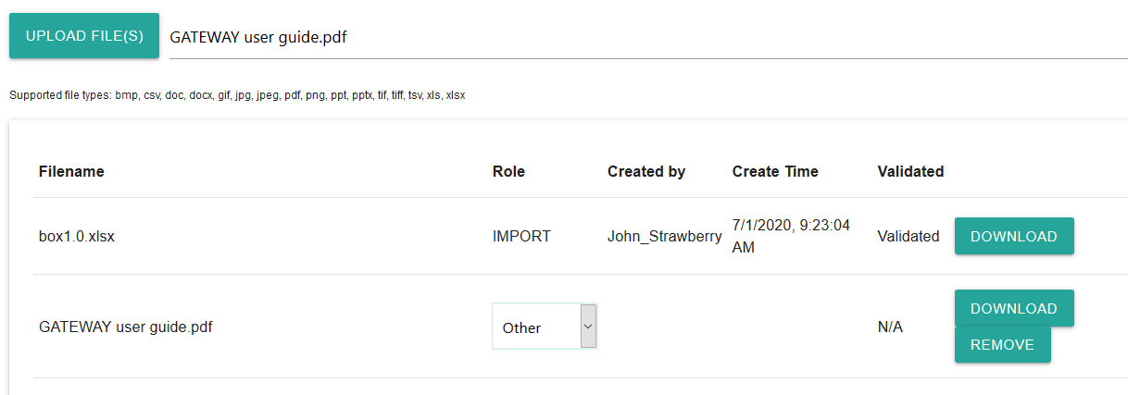

1. Save the transfer.
2. Use the comments/discussion function to send a message to QSA to let them know a new document has been uploaded.

## Schedule and deliver transfers

Once a transfer proposal is approved, provided the RAP arrangements and item template you have supplied are satisfactory, a mutually agreeable transfer date can be arranged.

The decision on a date will be subject to [QSA transfer requirements and priorities](https://www.forgov.qld.gov.au/transfer-records-qsa).

To arrange transfer dates, you can use the messaging feature in ArchivesGateway or contact the QSA Transfers Officer by email/phone.

When a scheduled date is allocated by QSA, it will appear in the ArchivesGateway transfer screen.

QSA will discuss with you if there are any logistical or special delivery arrangements required.

## Completing transfer process

Once records are delivered to QSA, transfers staff will:

* physically check the items received against the item list you supplied
* check for pests, mould or other issues
* make any required amendments and then imported the item list into ArchivesSpace.

This will complete the transfer process unless a RAP notice is still required from the agency.

**Note**: The RAP notice MUST be received by QSA before the transfer can be completed.

When the transfer is completed by QSA, the status will change to Complete in ArchivesGateway.

### Changes report

QSA may send an email to you with a Changes report if required.

The changes report lists the details of any significant discrepancies identified by QSA staff between the records transferred and the final item list submitted e.g. missing or unlisted files.

### Download the Transfer report

A Transfer Report, listing all items and details, is available in ArchivesGateway.

To download the report:

1. In the ‘Transfers’ tab, navigate to the relevant transfer.

**Note**: You can search and sort transfers by title, number, status and creation date.

1. Click the ‘view’ button to see transfer details.
2. At the top of the screen, click the ‘download report’ button

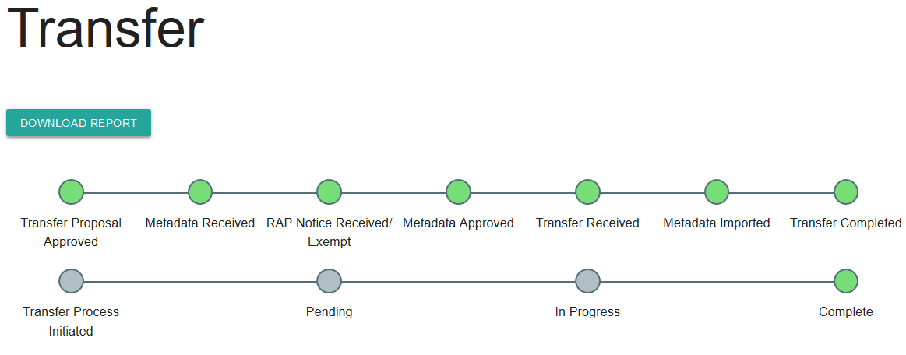

1. Open or save as required.

**Note**: the transfer report will download as CSV file.

# Viewing past transfers

To view past transfers, including download transfer reports:

1. Go to the transfers list in the ‘Transfers’ tab.
2. Search for the relevant transfer.
3. Click ‘view’ to open the transfer and see the details.
4. If you wish to download the report, click the ‘download report’ button at the top.

## Transfer reports for transfers managed in the previous system

You can use the steps above to download a transfer report for a transfer that was managed in the previous archival management system.

These reports are NOT the same as the ones created and sent to you by QSA at the time of the Transfer.

These reports are a list of a list of records that were transferred and is generated by ArchivesGateway based on the import and transfer information attached to each item in the system.

To view the transfer report sent to you at the time of the transfer, you will need to search your records for that report or contact QSA.

# More information

Further information is available on the Recordkeeping section of the For Gov website:

* [Use ArchivesGateway](https://www.forgov.qld.gov.au/use-archivesgateway)
* [Transfer records to QSA](https://www.forgov.qld.gov.au/transfer-records-qsa)
* [Restrict access to records at QSA (Restricted Access Periods)](https://www.forgov.qld.gov.au/restrict-access-records-restricted-access-periods)
* [Retrieve or access your agency's records at QSA (File Issue service)](https://www.forgov.qld.gov.au/access-records-after-transfer-qsa-file-issue-service)
* [Provide access to closed records](https://www.forgov.qld.gov.au/provide-access-closed-records)

Other user guides are also available for specific functions within ArchivesGateway and are available on the relevant pages listed above.

If you require further assistance with ArchivesGateway, please contact the ArchivesGateway team via email: [ArchivesGateway@archives.qld.gov.au](mailto:ArchivesGateway@archives.qld.gov.au).

If you require assistance from the Transfers team, or have an enquiry about transfers in general, please contact the Transfers Officer at [Transfers@archives.qld.gov.au](mailto:Transfers@archives.qld.gov.au).