Document details
Implementing information governance
Final
June 2012
v2.0.0

PUBLIC
Security classification | PUBLIC
Date of review of security classification | June 2012
Authority | Queensland Government Chief Information Officer
Author | Queensland Government Chief Information Office
Documentation status |  | Working draft |  | Consultation release | ☑ | Final version
Contact for enquiries and proposed changes
All enquiries regarding this document should be directed in the first instance to:
Queensland Government Chief Information Office
qgcio@qld.gov.au
Acknowledgements
This version of the Implementing information governance guideline was developed and updated by the Queensland Government Chief Information Office.
Feedback was also received from a number of staff from various departments and agencies, which was greatly appreciated.
Copyright
Implementing information governance
Copyright © The State of Queensland (Queensland Government Chief Information Office) 2012
Licence

Implementing information governance by the Queensland Government Chief Information Office is licensed under a Creative Commons Attribution 3.0 Australia licence. To view the terms of this licence, visit http://creativecommons.org/licenses/by/3.0/au. For permissions beyond the scope of this licence, contact qgcio@qld.gov.au.
To attribute this material, cite the Queensland Government Chief Information Office.
Information security
This document has been security classified using the Queensland Government Information Security Classification Framework (QGISCF) as UNCLASSIFIED – Internal use only and will be managed according to the requirements of the QGISCF.
Contents
1 Introduction 4
1.1 Purpose 4
1.2 Audience 4
1.3 Applicability 4
1.4 QGEA domains 4
2 Background 4
2.1 What is information governance? 5
3 The information sponsor 6
4 Information governance body 6
4.1 Membership 6
4.2 Role 6
4.3 Responsibilities 7
4.4 Authority 10
4.5 Reporting requirements 10
4.6 Delegation 11
4.7 Operation 12
4.8 Review 12
Appendix A Suggested meeting agenda 13
Appendix B Information management legislative obligations 14
Other legislation 15
Appendix C Other whole-of-Government information and information management strategies, policies and initiatives 16
Identification and classification of information assets by departments and Queensland Government ICT service providers 16
Information Queensland (IQ) 16
National Government Information Sharing Strategy 16
Queensland Government Information Management Strategic Framework 17
Queensland Government Libraries Consortium 17
Queensland Public Sector Intellectual Property Principles 17
Recordkeeping Assessment Framework 17
Register of Statistics (ROS) 17
Spatial Imagery Acquisition project 17

Introduction

Purpose
A QGEA guideline is not mandatory. This guideline provides advice to help agencies with suggested approaches for implementing information governance in line with the Queensland Government Enterprise Architecture (QGEA) Information governance policy.

Audience
This document is primarily intended for:
- senior executives, including the senior executive management group
- information governance bodies
- information management operational areas.

Applicability
This guideline applies to all departments and Queensland Government ICT service providers.

QGEA domains
Classification framework | Domain
Business Process | BP-9.1 Plan for information resource management | BP-9.4 Manage information and data
Information management | IM-1.1 Information governance processes  IM-1.5 Information and IM quality management | IM-1.6 Information and IM strategy and planning

Background
In its response to the 2008 independent review of its freedom of information laws, the Queensland Government acknowledged that a whole-of-Government information management strategic framework was essential to achieve an open, accountable and participatory government. The government considered that governance and clear authorising environments were key elements of this framework.
The Queensland Government Chief Information Office (QGCIO) was tasked with developing this framework in 2009. As part of this work, the QGCIO developed the Information policy which required departments to implement formal information governance. This guideline provides departments with the recommended practices for implementing this requirement.
The Information policy was reviewed in late 2011 and reissued as the QGEA Information governance policy to reflect its focus on this subject.

What is information governance?
Information governance is the system by which the current and future use of information and its management is directed and controlled.
The Information management policy framework defines the sub-domains of information governance for Queensland Government in more detail, see figure 1 within this document.
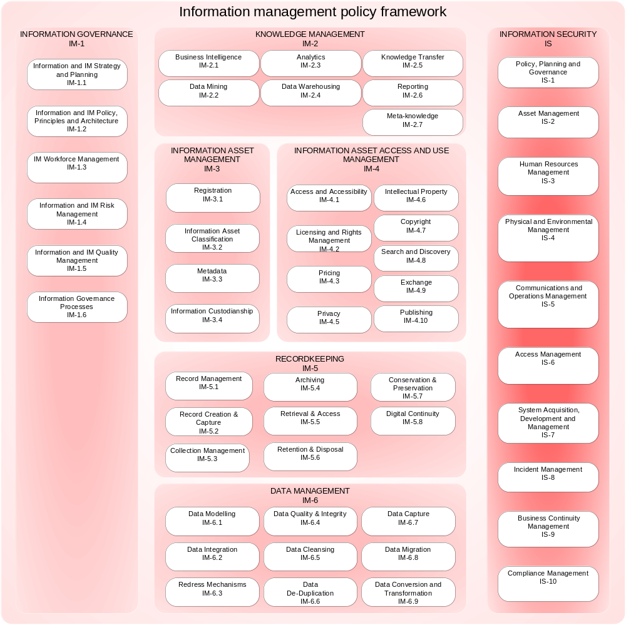
Figure 1 QGEA Information management policy framework highlighting the Information governance (IM-1) domains
It should be noted that the information security domain, whilst technically a sub-domain of information management, is often implemented with its own governance arrangements. For advice on information security governance, see the Implementing internal information security governance guideline.

The information sponsor
There should be a commitment to the value of information as a core strategic asset and effective information management at all levels of the organisation. This should be championed by a sponsor, a senior executive who is ultimately responsible for department information, its management and governance. It is the sponsor’s responsibility to ensure:
- an information governance body is in operation
- significant information issues are escalated as appropriate
- corporate information responsibilities are met.

Information governance body
The Information governance policy requires departments and Queensland Government ICT service providers to implement formal information governance. To fulfil this requirement departments and Queensland Government ICT service providers should either:
- establish a body responsible for information governance (the body)
- assign responsibility for information to an existing body (e.g. information steering committee).

Membership
Membership of the body should reflect the size, geography and complexity of the department. To ensure effective collaboration across the organisation, membership should include:
- the sponsor
- appropriately empowered representatives of information management operational areas (e.g. records management, library, custodians, enterprise architects, right to information officers, information privacy officers, intellectual property officers, knowledge management, data management, web officers, etc.)
- stakeholders (e.g. business area managers, legal, finance, internal auditors, business planners, business analysts, ICT professionals, etc.).

Role
The role of the body is to:
- evaluate, provide strategic direction for, and direct the use of, information and its management
- provide leadership in and direct the preparation and implementation of information management policies, principles and architecture
- review and monitor conformance to obligations and performance
- develop information management capability.

Responsibilities
The information governance body fulfils this role by meeting the responsibilities detailed in this section.

Evaluate and direct the use of information and its management
It is a role of the information governance body to evaluate, provide strategic direction for, and direct the use of, information and its management.

Direct the preparation of, endorse and implement an information management strategy
An information management strategy:
- defines the strategic direction for the utilisation and management of information as a valued core strategic asset
- is consistent with the department’s overarching business strategy and is supported by the ICT strategy
- Includes performance indicators.

Direct the preparation of, endorse and implement an information management work plan
Note that departments and Queensland Government ICT service providers are required to submit their IM activities and initiatives annually as per the Information governance policy.
For further advice please see the Information management work plan guideline and the Work plan template.

Direct the preparation of, endorse and implement a strategic recordkeeping plan
Information Standard 40: Recordkeeping requires public authorities to implement a strategic approach to recordkeeping that is endorsed by the public authority’s chief executive officer (CEO).
The body should review and endorse the recordkeeping strategy, prior to forwarding for endorsement by the department’s CEO.

Direct the preparation and implementation of information management policies, principles and architecture
It is a role of the information governance body to assign responsibility for and direct the preparation and implementation of information management policies, principles and architecture.

Direct the preparation of, endorse and implement information management policies
The body should utilise the Information management policy framework (figure 1, page 5) to identify and prioritise requirements for department policies by classifying current policy effort and identifying gaps or duplications.
Policies should be consistent with the QGEA information principles and whole-of-Government information management policies.

Prepare, endorse and implement an authorising and accountability environment for the routine and proactive disclosure of information
The authorising and accountability environment should support all information access and release mechanisms, including:
- publication schemes
- disclosure logs
- administrative access schemes
- administrative release (i.e. release to the public upon request from a member of the public, not under the Right to Information Act 2009 which should be the last resort).
The body should oversee the development of the elements of such an authorising and accountability environment, which may include:
- policies
- business processes (e.g. internal approval processes for release upon request or publication in a publication scheme)
- procedures
- roles and responsibilities (e.g. who approves release)
- supporting tools and systems.
Further implementation considerations and guidance is available in the following QGEA documents:
- Information access and use policy (IS33)
- Determining the ex ante release status of information guideline
See also the Office of the Information Commissioner’s
- Proactive disclosure and publication schemes
- Administrative release of information.

Contribute information management policies and tools to the QGEA where beneficial
Due to the federated nature of the QGEA, artefacts can be developed by any party that identifies a need and has the appropriate expertise. Department information governance bodies are encouraged to contribute information management policies and tools to the Queensland Government Chief Information Office for possible inclusion in the QGEA via the QGEA collaboration portal. Agency example products can also be made available on the Agency products page (Queensland Government employees only). If you have an example product, please email ictpolicy@qld.gvo.au

Oversee the development and approval of the department’s retention and disposal schedule
The information governance body should oversee the development of the department’s core business retention and disposal schedule. This should include approving the retention and disposal schedule for forwarding to the CEO and/or senior executive management group for approval, followed by the State Archivist. See further Information Standard 31: Retention and disposal of public records (IS31).

Monitor conformance to obligations and performance
It is a role of the information governance body to monitor conformance to legislation, principles, policy and architecture requirements and performance. Refer to the QGEA information webpage for a list of all QGEA information management artefacts. See appendix B for a list of related legislation.

Direct the preparation of and/or review and endorse information management initiatives
The body should review and endorse specific information management initiatives. This applies particularly to those initiatives that involve the whole department or where costs are to be shared. Where required, the body should ensure that the transition of initiatives to operational status is properly planned and managed.

Ensure that information and information management risk and quality management is in place
The body should ensure that:
- the department acts on compliance issues identified by recordkeeping reviews or audits
- the department complies with IS31 including internal authorisation for the disposal of public records in accordance with an approved retention and disposal schedule
- an information profile is completed as part of the ICT Resources Strategic Plan annually (see Information Standard 2: ICT resources strategic planning toolbox – GovNet users only)
- QGEA self-assessments are undertaken annually (see Alignment and exceptions – GovNet users only).

Manage information asset custodianship
This requires the body to:
- oversee implementation/progress of custodianship in the department
- ensure custodianship responsibilities are effectively undertaken across all departmental information
- ensure that standards relating to custodianship are uniformly applied
- report to senior executive management group on appropriate custodianship delegations
- recommendations on continuance of custodianship delegations.
See further Information Standard 44: Information asset custodianship.

Assign responsibility for and oversee maintenance of information registers
There are several information registers that the body should assign responsibility for and ensure are maintained, including:
- department’s information asset register (see Information Standard 44: Information asset custodianship);
- department’s register of information security classified information (see the Queensland Government information security classification framework);
- register of the ex ante release status of the department’s information if other system not in place see the Determining the ex ante release status of information guideline).
- Register of Statistics (ROS) (GovNet users only)
- Queensland Government catalogue (GovNet users only)
- intellectual property register.
Monitor performance against the information management strategy and work plan
The information governance body should monitor performance of information management strategies, initiatives and activities. This should occur quarterly to ensure implementation is on track.

Develop information management capability
The information governance body is responsible for fostering excellence in information management, including developing the information management capability of its information management professionals and all employees.
The information governance body should assign responsibility for and direct the preparation and implementation of information management training and communication.

Assess information management maturity
The information governance body may assess the agency’s information management maturity from time to time. The information governance body should oversee and analyse the outcomes of these assessments. See also:
- Information management maturity development tool
- Information management maturity development guideline.

Authority
The information governance body should have the appropriate authority to fulfil its role and responsibilities as identified in its terms of reference. This should be coupled with clear reporting lines to the senior executive management group.

Reporting requirements
With the exception of those reporting requirements where the audience members marked with a footnote the following are suggested reporting requirements, organised by role.
Role | Reporting requirement | Audience
Evaluate and direct the use of information and its management | Submit proposed IM strategy | Senior executive management group
 | Submit proposed IM activities and initiatives | Senior executive management group  Queensland Government Chief Information Office
 | Submit recordkeeping strategy for approval | CEO
Prepare and implement information and IM policies, principles and architecture | Submission of IM policies, principles and architecture for approval | Senior executive management group
 | Submit a retention and disposal schedule covering the core-business records of the agency which meets the requirements of Queensland State Archives’ Guideline for the Development of Retention and Disposal Schedules | Senior executive management group  State Archivist
Monitor conformance and performance | Report on recordkeeping reviews or audits including exceptions and recommendations on remedial action | Senior executive management group
Monitor conformance and performance | Recordkeeping monitoring and assessment requirements as required by Queensland State Archives | Queensland State Archives
Monitor conformance and performance | Reviews and escalation of issues and exceptions arising from the department’s self-assessment against QGEA IM requirements and targets and recommendations on remedial action | Senior executive management group  Queensland Government Chief Information Office
Monitor conformance and performance | Report on appropriate custodianship delegations, as required | Senior executive management group
Monitor conformance and performance | Make recommendations on continuance of custodianship delegations, as required | Senior executive management group
Monitor conformance and performance | Report on key performance indicators for both IM strategy, initiatives and activities | Senior executive management group
Monitor conformance and performance | Provide annual report on the information governance body’s performance which identifies issues and makes recommendations on remedial actions | Senior executive management group
Develop IM capability | Report on the department’s IM maturity level (see Information policy for details) | Senior executive management group

Delegation
Responsibility for specific aspects of information governance may be delegated. However, accountability for information governance resides with the body and the sponsor.

Operation
The body should convene at least every three months. The timing of these meetings should complement both department planning cycle requirements and ongoing review processes. See also Appendix A.

Review
The body should identify indicators of its own performance and conduct an annual performance review against these. This should culminate in an annual report to the senior executive management group which identifies issues and makes recommendations on remedial actions.

Appendix A Suggested meeting agenda
- Minutes of previous meeting
- Actions arising from previous meeting
- Items for endorsement
- new/revised IM strategies, initiatives, activities, principles, policies and architecture
- other.
- Items for noting/discussion/information
- progress against IM strategy
- external and internal environmental scan – issues that may effect department IM (e.g. new legislation, whole-of-government policy, new technologies, business area IM issues, related internal initiatives)
- IM principles, policies and architecture
  - to be initiated
  - current – issues
  - completed.
- IM initiatives/activities
  - to be initiated
  - current – issues
  - completed.
- recordkeeping update
- ICT Baseline update
- information asset custodianship update
- information registers update (e.g. noting of additions/deletions)
- self-assessment of alignment to QGEA IM information standards, policies, requirements and targets
- to be initiated
- current – issues
- completed.
- IM capability initiatives (i.e. training, workforce management, communications)
- IM maturity assessment update
- information governance body performance review
- items referred from other committees.
- General business

Appendix B Information management legislative obligations
This appendix provides a summary of some of the information and IM legislative obligations of departments and Queensland Government ICT service providers and is largely based on an extract from Queensland Health’s Enterprise Information Management Framework (2007).
The contents of this appendix do not constitute legal advice and should not be relied on as a comprehensive statement of information management legislative obligations or specific advice.
Legislation or regulation | Requirement
Evidence Act 1977 (Qld) | s134A – agency must produce documents for civil proceedings.
Financial and Performance Management Standard 2009 (Qld) | s15 – must have a system for managing financial information, establishment of such a system must have regard for the Financial Accountability Handbook as published by the treasury department and the system must be regularly reviewed.
Financial and Performance Management Standard 2009 (Qld) | s27 – requirements for financial information management.
Information Privacy Act 2009 (Qld) | Governs access to and amendment of a person’s own personal information held by relevant public sector agencies and provides legislative safeguards to the handling of personal information by those agencies.
Judicial Review Act 1991 (Qld) | s20 – review of administration decisions may be sought.
Libraries Act 1988 (Qld) | Part 8 – preservation of publications.
Public Records Act 2002 (Qld) | s7 – agency must keep full and accurate records; and have regard to relevant policy, standards and guidelines issues by the State Archivist. Executive officer of the public authority is to ensure that this occurs.
Public Records Act 2002 (Qld) | s 8 – a public authority is responsible for ensuring the safe custody and preservation of records in its possession.
Public Service Act 2008 (Qld) | s98 (1)(h) – ensure proper standards in creation, keeping and management of public records.
Right to Information Act 2009 (Qld) | The Right to Information Act 2009 provides a right of access to information under the government’s control unless, on balance it is contrary to the public interest. Government information should be released administratively as a matter of course unless there is a good reason not to, with applications under the act being necessary as a last resort.
Statistical Returns Act 1896 | s4(4) – must provide information requested by government statistician.

Other legislation
Departments should also be aware of the following legislation:
- Civil Liability Act 2003 (Qld)
- Classification of Publications Act 1991 (Qld)
- Electronic Transactions (Queensland) Act 2001 (Qld)
- Financial Accountability Act 2009 (Qld)
- Invasion of Privacy Act 1971 (Qld)
- Public Sector Ethics Act 1994 (Qld).

Appendix C Other whole-of-government information and information management strategies, policies and initiatives
Identification and classification of information assets by departments and Queensland Government ICT service providers
Identification and analysis of information assets in departments is one of the elements of the Queensland Government ICT Planning Methodology. The process includes collecting information about the information assets currently held to support each department’s business, classifying and mapping these assets to the Queensland Government Information Portfolio Framework and then summarising and analysing the information into an Information Profile. This profile can be included in the ICT Resources Strategic Plan program of work.
Information Queensland (IQ)
Information Queensland helps you discover access, integrate and share spatial information through services for your agency, your clients and the public. Most are free, and others will incur a comparatively small cost to integrate within your agency:
- Address validation service can be integrated with your agency system to ensure client addresses are correct
- Atlas provides the public with easy access to imagery, property and topographic information
- Catalogue of spatial data and mapping resources held by Queensland Government where you can publish your agency metadata
- Queensland Government Information Service provides public access to your geospatial and associated data for fee or free.
National Government Information Sharing Strategy
The National Government Information Sharing Strategy seeks to identify the best practices, tools and further requirements for sharing information across all levels of Australian governments. It seeks endorsement, agreement and application of information sharing principles which are: providing leadership, demonstrating value, acting collaboratively, establishing clear governance, establishing custodianship guidelines, building for interoperability, using standards-based information, promoting information re-use and ensuring information privacy and security.
.
Queensland Government Information Management Strategic Framework
The Queensland Government Information Management Strategic Framework is designed to ensure that in all aspects of departments’ work the fundamental principles, quality assurance and lifecycle management policies inherent in good information management are applied.
Queensland Government Libraries Consortium
The Queensland Government Libraries Consortium links departmental personnel/staff with information and resources and progresses a whole-of-Government approach to library service delivery including investigating benefits resulting in economies of scale, improved service delivery, information sharing and operational efficiency.
Queensland Public Sector Intellectual Property Principles
The Queensland Public Sector Intellectual Property Principles provides high level policy for the management of intellectual property by Queensland Government agencies.
Recordkeeping Assessment Framework
QSA has developed a Recordkeeping Assessment Framework which includes policy, compliance monitoring and reporting strategies to support compliance with the recordkeeping Information Standards and the Public Records Act 2002. Queensland State Archives also provides information about a range of recordkeeping training opportunities for Queensland public sector organisations and their employees on their website.
Register of Statistics (ROS)
The Register of Statistics is a searchable repository for metadata for describing Queensland Government statistical data. Custodianship of the Register is shared by departments, with coordination provided by the Office of Economic and Statistical Research in Queensland Treasury. Initial metadata was provided by departments through the Census of Strategic Information, completed in December 2002.
Spatial Imagery Acquisition project
This is an ongoing project to acquire and maintain up-to-date aerial photography and satellite imagery over Queensland. It currently has a five year plan for imagery acquisition for the State. The acquisition plan recognises existing imagery holdings of state and local governments, alongside current and emerging business requirements, to provide a structured approach to purchasing spatial imagery under a single licence for use by Queensland Government departments.
Version history
Version | Date | Author | Description
1.0.2 | July 2011 | Policy Governance, ICT Policy and Coordination Office | Update to new QGEA template for review.
1.0.3 | July 2011 | K. Harte | Initial updates.
1.0.4 | July 2011 | K. Harte | Acceptance of changes.  Further updates.
1.1.0 | September 2011 | Policy Governance, ICT Policy and Coordination Office | Informal consultation
1.1.1 | January 2012 | K. Harte | Incorporation of feedback received during the formal consultation.
1.1.2 | May 2012 | Queensland Government Chief Information Office | Template update
2.0.0 | June 2012 | Queensland Government Chief Information Office | Approved by Executive Director, QGCIO

Queensland Government, The right to information: a response to the review of Queensland’s Freedom of Information Act, 2008, p. 4.
Ibid, p. 5.
Queensland Government Chief Information Office, Queensland Government Enterprise Architecture: Information management policy framework, 2009; Standards Australia, AS/NZS ISO/IEC 38500:2010 Corporate Governance of Information Technology, 2010, p. 3.
Queensland Government, Queensland Public Sector Intellectual Property Principles, 2011, p. 8.
Queensland Government, Information governance policy.
Queensland Government, Information Standard 40: Recordkeeping.
Information Standard 31: Retention and disposal of public records.
See the Queensland State Archives’ Assessment framework.
Queensland Government Enterprise Architecture alignment policy.

