managing Users and locations
ArchivesGateway user guide
Queensland State Archives
July 2020
Security classification: Public

Table of contents

Table of contents 2

Introduction 4

Definitions and references 4

1 Initial log in and set up 5
1.1 Set up multi-factor authentication 5
Send a code via SMS 6
Google authenticator app 7
1.2 Logging in after initial setup 10

2 Managing your account 10
2.1 Updating your profile 10
2.2 Password reset 11
2.3 Managing and changing MFA methods 12
2.4 Inactive users 12

3 Users, accounts, agencies and locations 13
3.1 User types 13
3.2 Permissions 13
3.3 Creating users and accounts 14
3.4 Delegates 15
3.5 Creating and assigning locations 15
Adding locations 15
Creating users in location 17
Setting permissions 18
Changing a user’s type 19
Adding existing users to locations 19
Removing users from locations 20
Deleting locations 21
3.6 Editing users and setting position 22
Making users inactive 22
Resetting a user’s MFA 22
Changing a user’s details 22

4 Navigating between agencies and locations 23
4.1 Switch between agencies and locations 23
Change agency 23
Change location 24

5 Machinery-of-government and administrative changes 24

6 More information 24

Introduction
The information in this guide applies to all government agency staff involved that use ArchivesGateway to transfer record to and manage their records at Queensland State Archives.
This user guide describes the key points and processes involved in logging in to ArchivesGateway, setting up users, editing permissions and managing various locations and agencies.
Other user guides are available for other functions within ArchivesGateway. See the more information section for details on how to find and access these other user guides.

Definitions and references
Relevant definitions of recordkeeping and archival terms used in this guide can be found in the glossary on the website.
See recordkeeping and archival terms and their definitions.

Initial log in and set up
Log into ArchivesGateway using your username and password provided.

Set up multi-factor authentication
When you first log in, you will need to set up Multi-Factor Authentication (MFA) for your account.
MFA security codes can be generated using the Google Authenticator app on your mobile device or through a SMS system to your mobile number.
- Log in to ArchivesGateway for the first time
- Select the MFA method you would like to use:
- Send a code via SMS
OR
- Use Google Authenticator
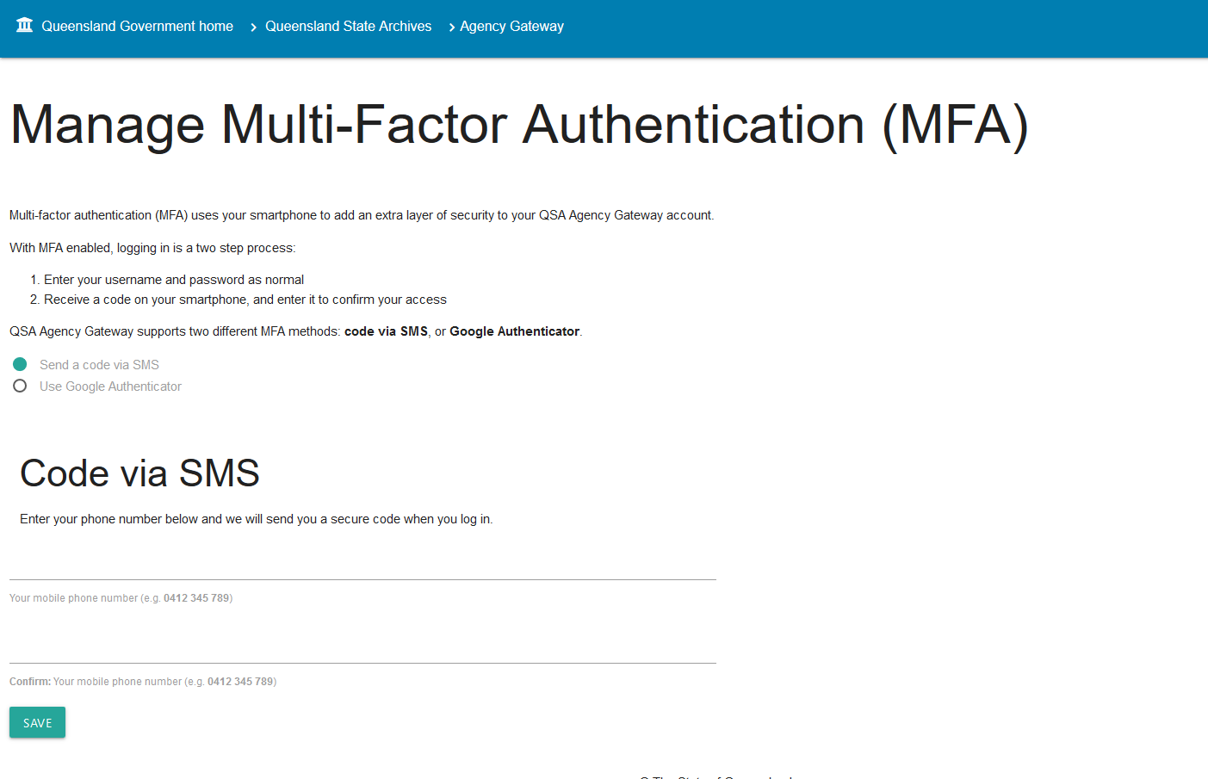

Send a code via SMS
Once ‘Send code via SMS’ selected:
- Enter your mobile phone number
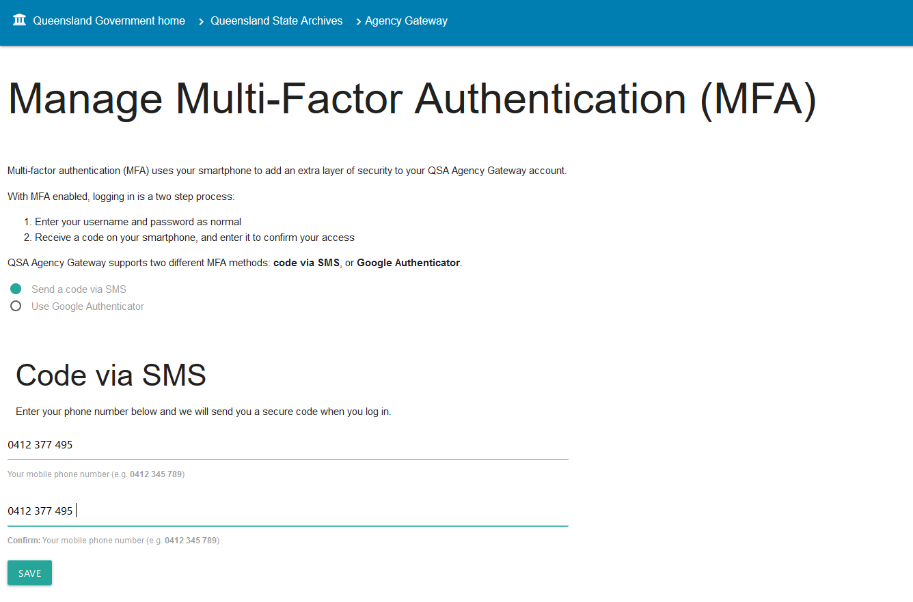
- Click save
- The system will then send you a code via SMS to do an initial verification of your mobile number.
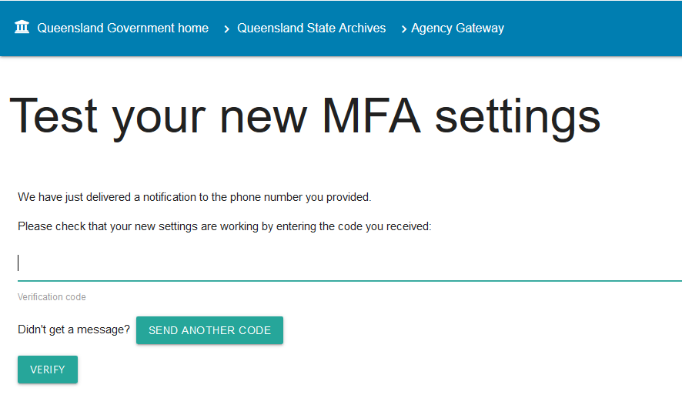
- Enter the code generated
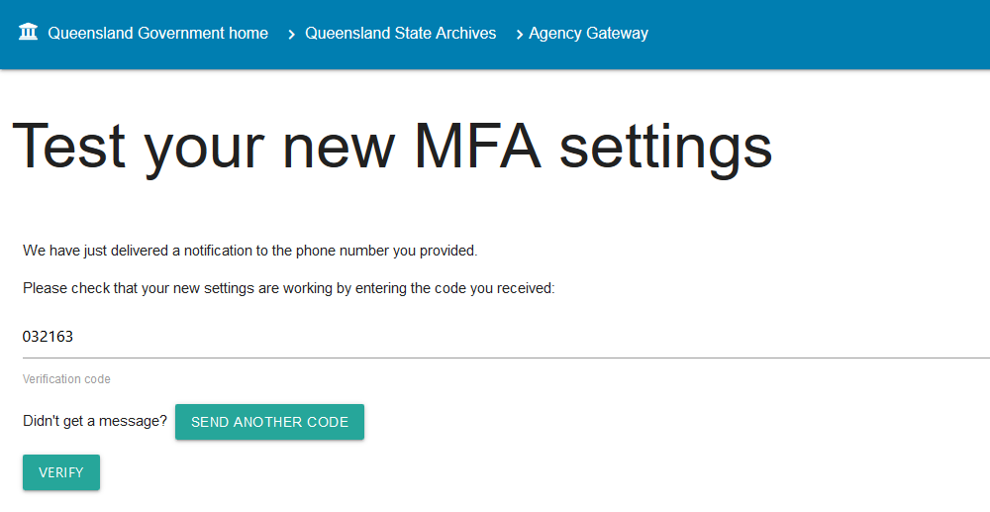
- You will then be taken to the home screen of ArchivesGateway
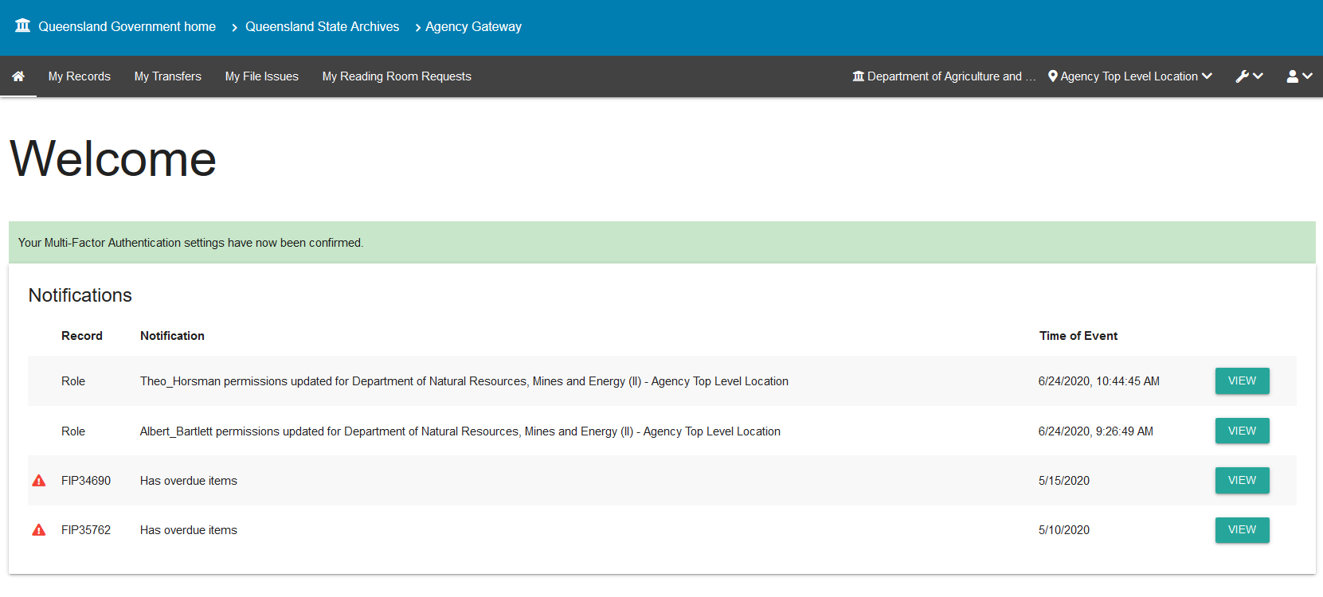

Google authenticator app
Note: To use Google authenticator, you will need to install the Google Authenticator app on your mobile device first.
- Select ‘use google authenticator app’ option.
- The screen will then display a QR code and a long alpha-numerical string as a key.
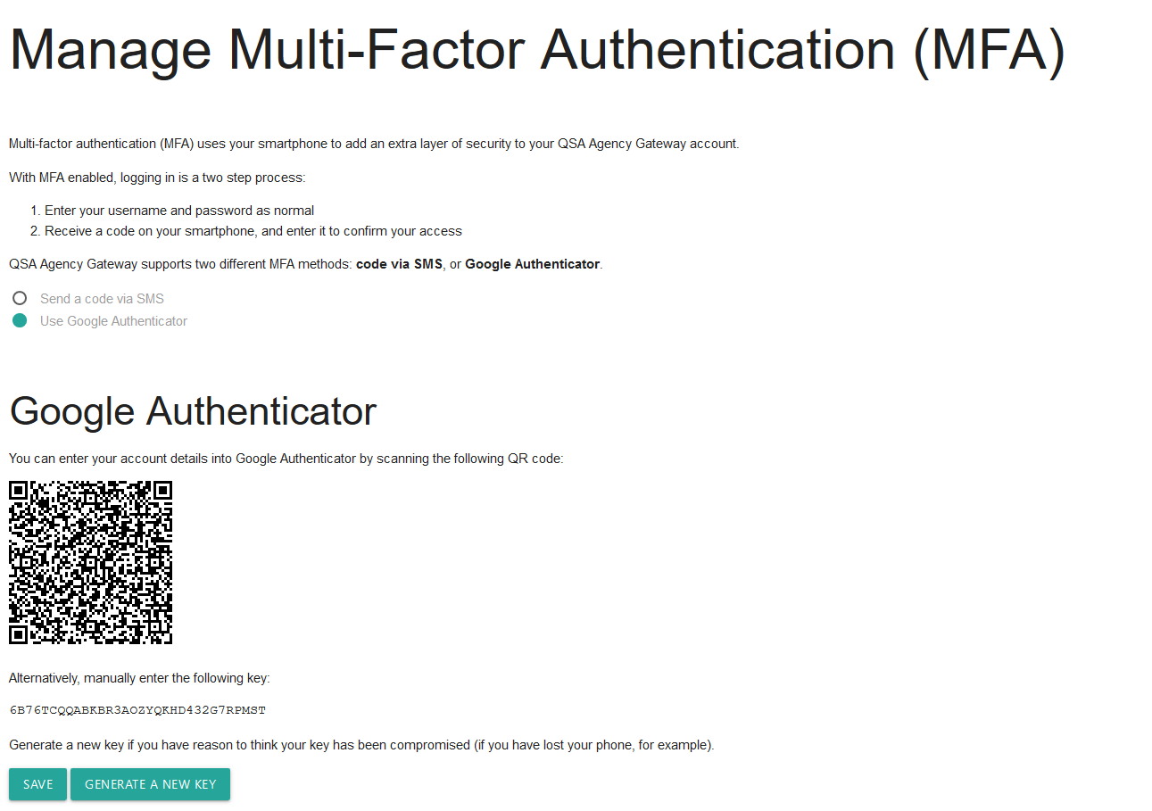
- Open the Google authenticator app on your device.
Note: you may need to give the app permission to use your camera.
- Use your phones camera to scan the QR code
OR
Manually enter the key provided below the QR code.
- Click Save.
- You will then be asked to test your new MFA settings:
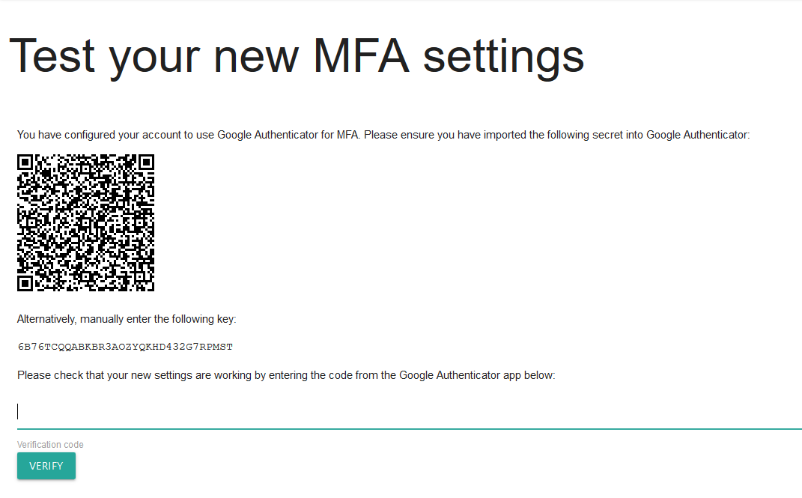
- Entering the code provided by the app in the ‘test your new MFA settings’ screen.
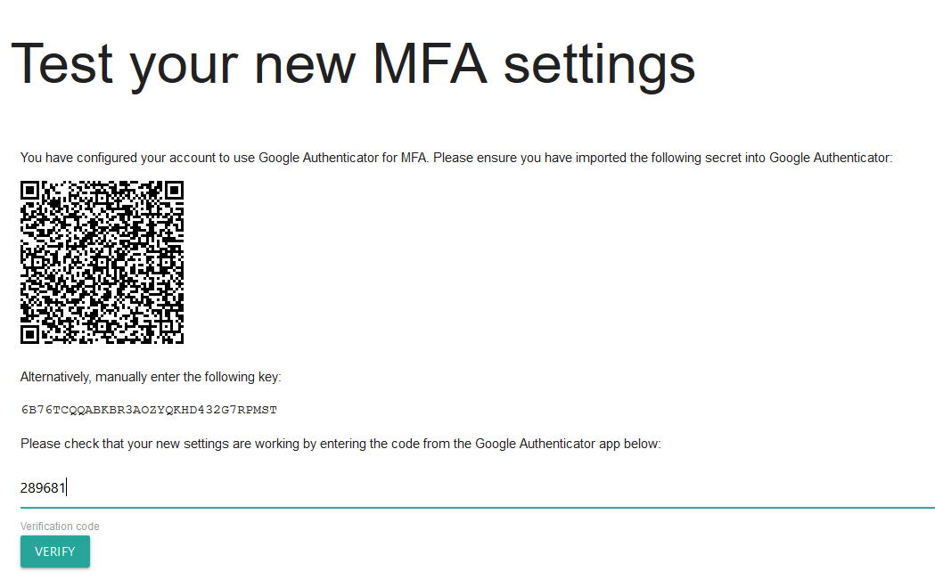
- You will then be taken to the home screen of ArchivesGateway
Note: You can also generate a new key (and QR Code) in the above screen should your key be compromised, or your device lost or stolen.

Logging in after initial setup
When logging in to ArchivesGateway after initial set up, you will need to:
- enter your username and password
- enter in the MFA code provided via the chosen method.

Managing your account

Updating your profile
To update your profile:
- Navigate to the User Menu by clicking on the person icon on the top right and click edit.
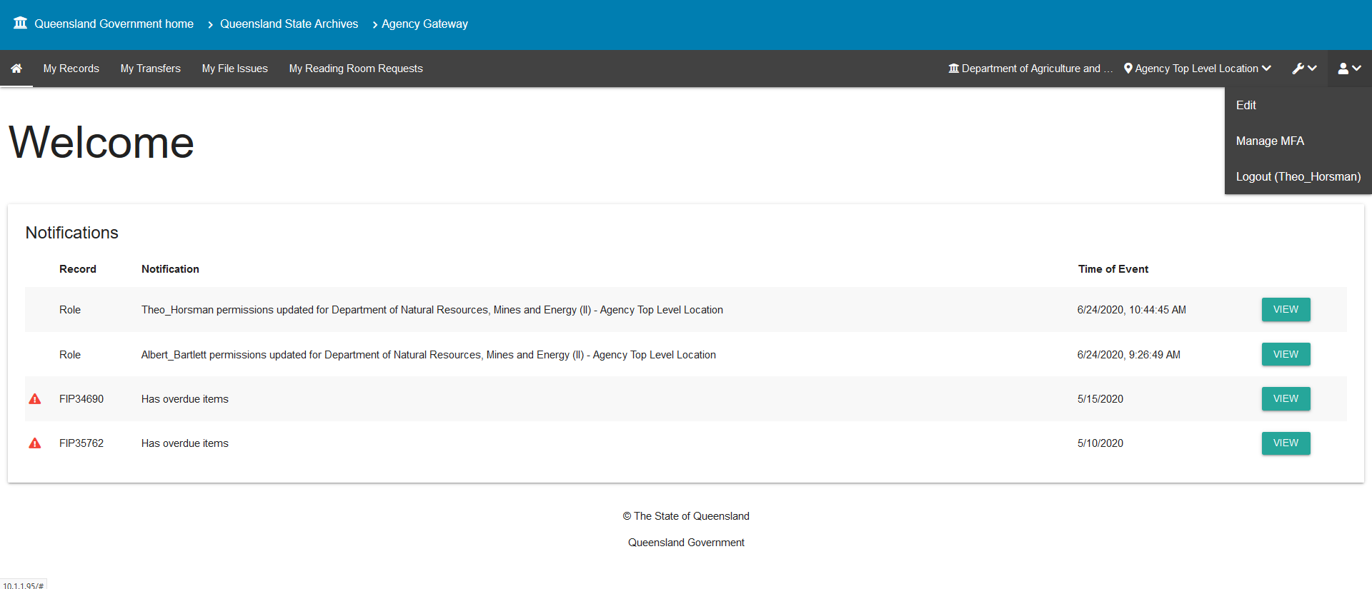
- In the profile form, you can update your:
  - Name
  - Position title
  - Password
  - Email address
You also have the option to reset your MFA.
- Click ‘save user’ to save your changes.
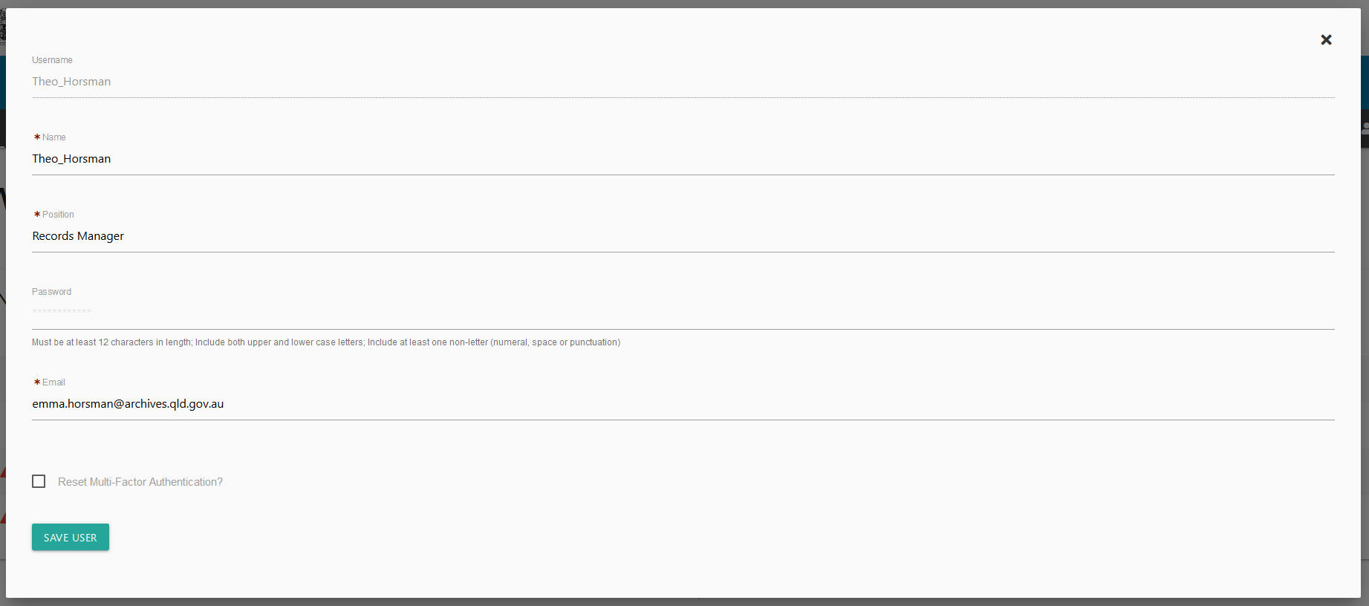

Password reset
- If you forget your password, you can request a new one by following the ‘forgotten your password’ link on the login page.
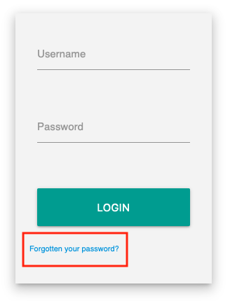
- This will take you to a form where you can fill in your login name, and request the password reset.
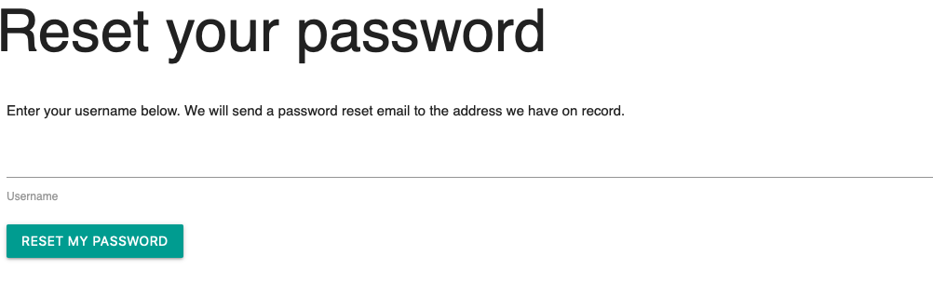
- After clicking this link, you will receive an email with instructions for resetting your password.
Note: you must have an email address in your profile in ArchivesGateway.
- If you do not receive an email, please check your ‘junk’ folder. You may also need to copy and paste the link provided into your browser.
If you cannot reset your password, contact the ArchivesGateway team.

Managing and changing MFA methods
To change the MFA method used:
- Log in to ArchivesGateway
- Navigate to the User Menu -> Manage MFA.
- Change the MFA method as required.
For more information, see the instructions on Setting up multi-factor authentication.

Inactive users
If your account has been made inactive, you will see a message telling you there is an issue with your account when you attempt to log in.
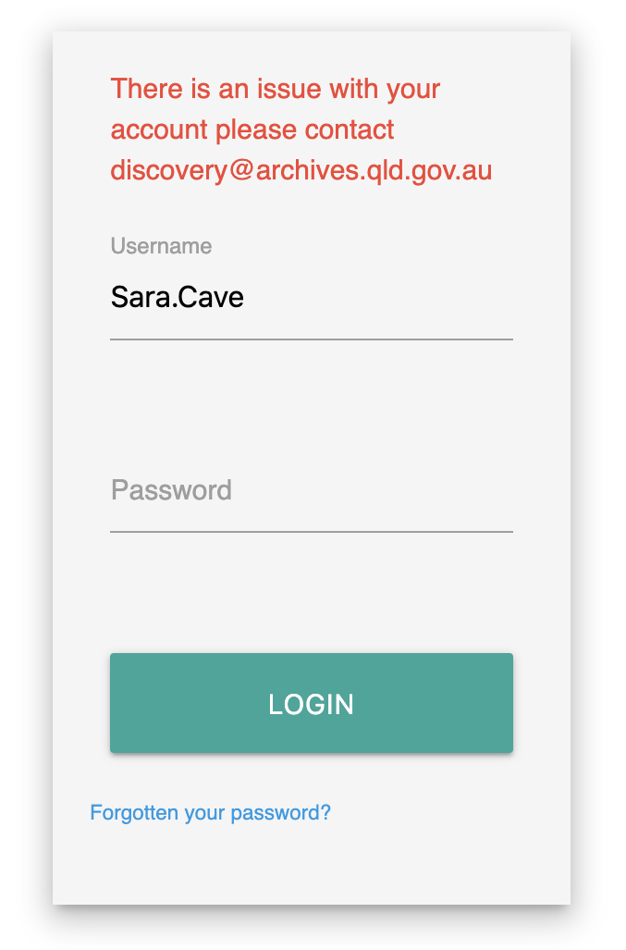
Accounts can be re-activated by the Senior Agency Admin for your agency, or by QSA staff.
Senior agency admin: See the instructions on how to Make users inactive.

Users, accounts, agencies and locations

User types
ArchivesGateway has been set up with 3 levels of users:
- Senior agency administrator
- Agency administrator
- Agency contact
All agencies with records at QSA must have a Senior Agency Administrator user in ArchivesGateway, however not all agencies will require Agency administrator and Agency contact users.
Each user can also be assigned different permissions based on what you need that user to be able to do within ArchivesGateway and their ‘location’.
All users, regardless of permission levels, can search their records in ArchivesGateway and submit Reading Room Request.

Permissions
Permission levels for each of these roles are:
Permission Type | Agency Senior Admin | Agency Admin* | Agency Contact
Assign permissions | All permissions, including to themselves as an Agency Contact | Transfer & File Issue permissions ONLY  Note: Can only assign same permissions that they have been given. | No
View records list^ | Yes | Yes | Yes
Request records to the Reading Room^ | Yes | Yes | Yes
Propose Transfers | If given permission by Agency Senior Admin | If given permission by Agency Senior Admin | If given permission by:  - Agency Senior Admin  OR  - Agency Admin
Request File Issues | If given permission by Agency Senior Admin | If given permission by Agency Senior Admin | If given permission by:  - Agency Senior Admin  OR  - Agency Admin
Set and change Restricted Access Periods | If they are the authorised delegate  AND  given permission by Agency Senior Admin | No | If they are the authorised delegate  AND  given permission by Agency Senior Admin
Grant access to restricted records | If they are the authorised delegate  AND  given permission by Agency Senior Admin | No | If they are the authorised delegate  AND  given permission by Agency Senior Admin
^ Baseline permissions which anyone with Agency access to ArchivesGateway
* Only larger agencies are likely to have this role.

Creating users and accounts
Senior agency administrators must be created by QSA.
To request a Senior agency administrator be created for your agency, contact the ArchivesGateway team.
Agency administrators and Agency contacts can be created by the Senior agency admin for your agency.
To create a user, you must add them to a location.

Delegates
You may need to create an account in ArchivesGateway for the Authorised delegate for your agency.
You do not need to log in to this generic delegate account.
Generic delegate accounts are used as the contact point for any automated requests from the public to access restricted records of your agency.
Find out more about authorised delegates and requests from the public to access restricted records.
Note: authorised delegates are to a position not a person. It is recommended that a generic account is created for the delegate position within your agency, not the person currently in the position, and a generic email address used.

Creating and assigning locations
All users can be assigned to locations within your Agency, where locations are a specific business unit or administrative area.
Users may have 1 or more locations.
Locations will depend on how your agency is set up and your internal processes.
Locations can be used for:
- Different business areas within your agency
- Invoicing and billing purposes (e.g. where separate areas or request types are billed separately)
- Delivery addresses and physical location.
To ensure the audit history of all transactions are captured, especially in larger agencies, it is important that users operate from within the correct location.

Adding locations
An agency top-level location will automatically be created when your agency is created by QSA.
Other locations can be set up by the Senior agency administrator.
To create a location:
- Click the spanner icon in the toolbar
- Select ‘manage agencies’
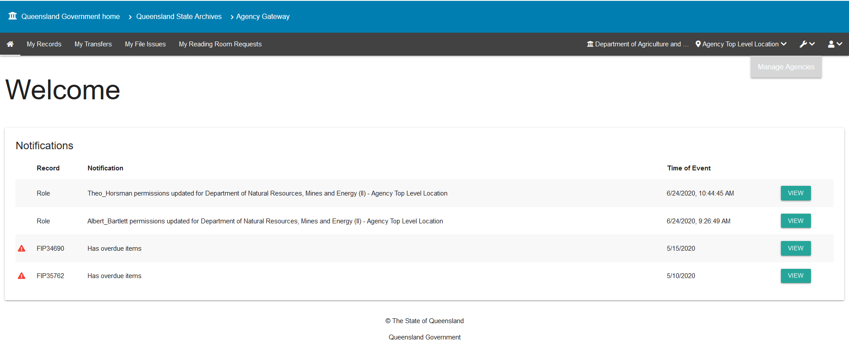
- Click ‘view’ against the required agency
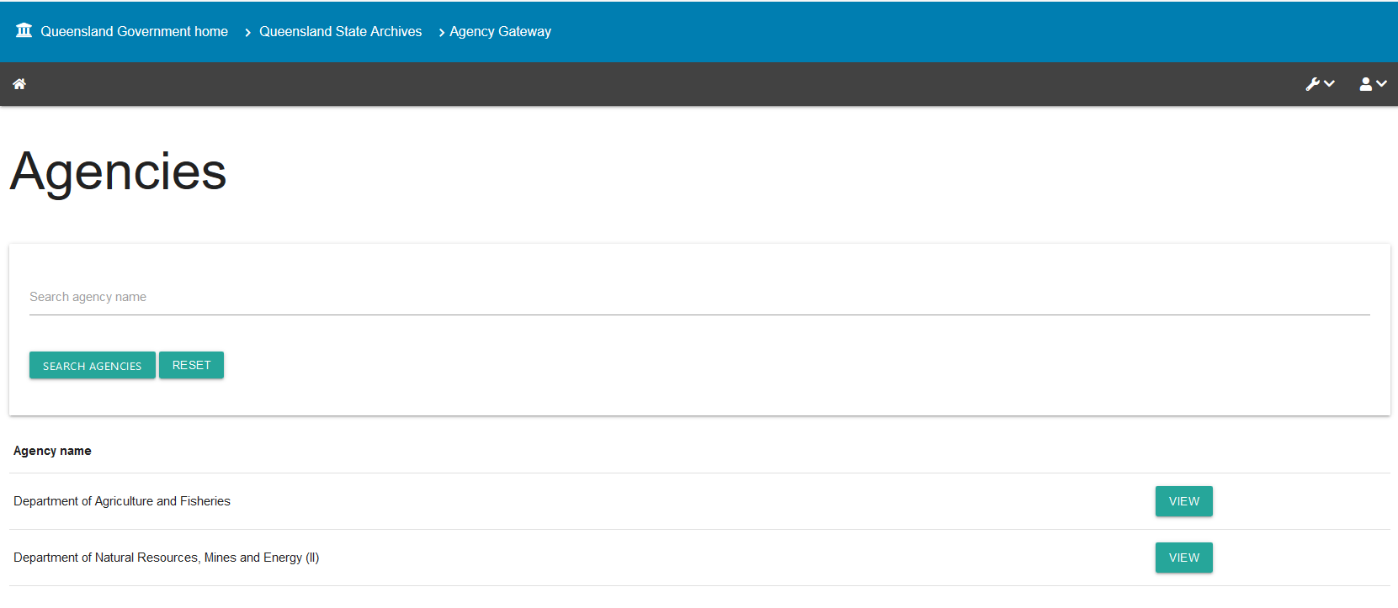
Note: if you are associated with more than 1 agency, you will see a list of these agencies.
- Click ‘add new location’ on the top right.
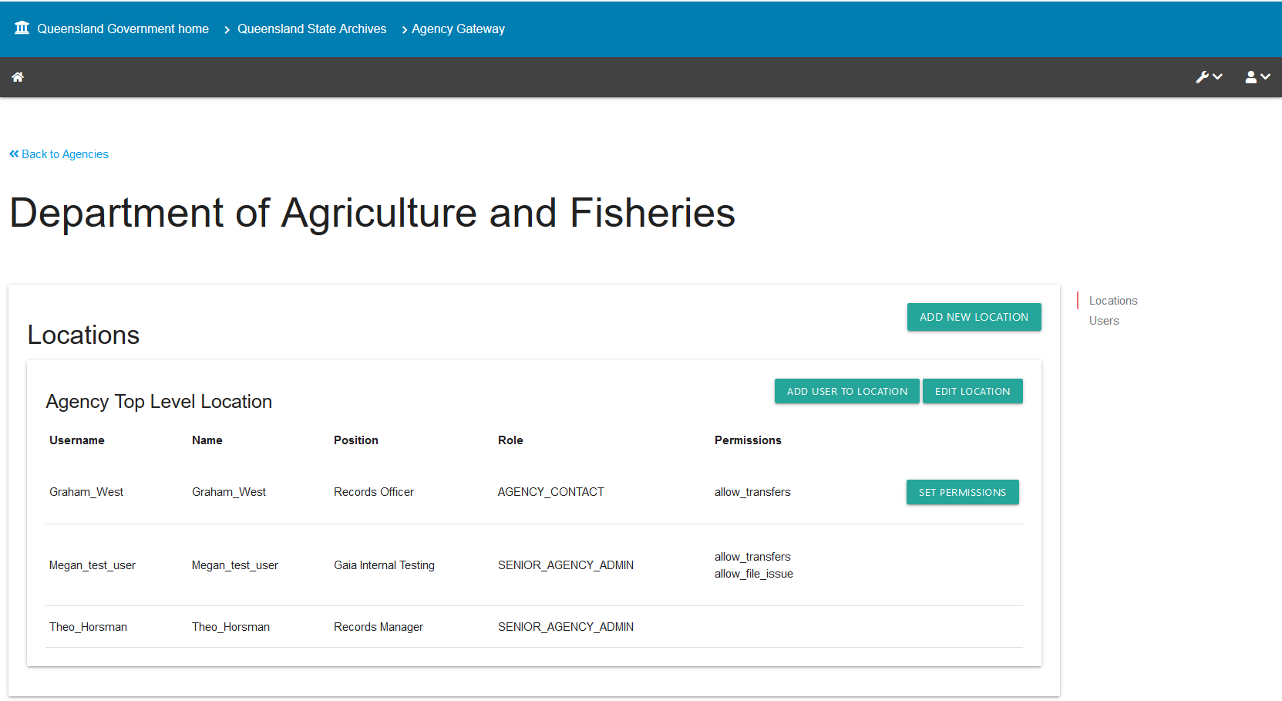
- Add the name and delivery address of the location.
- Click save location.
- You will now be able to see the location created in the agency profile.
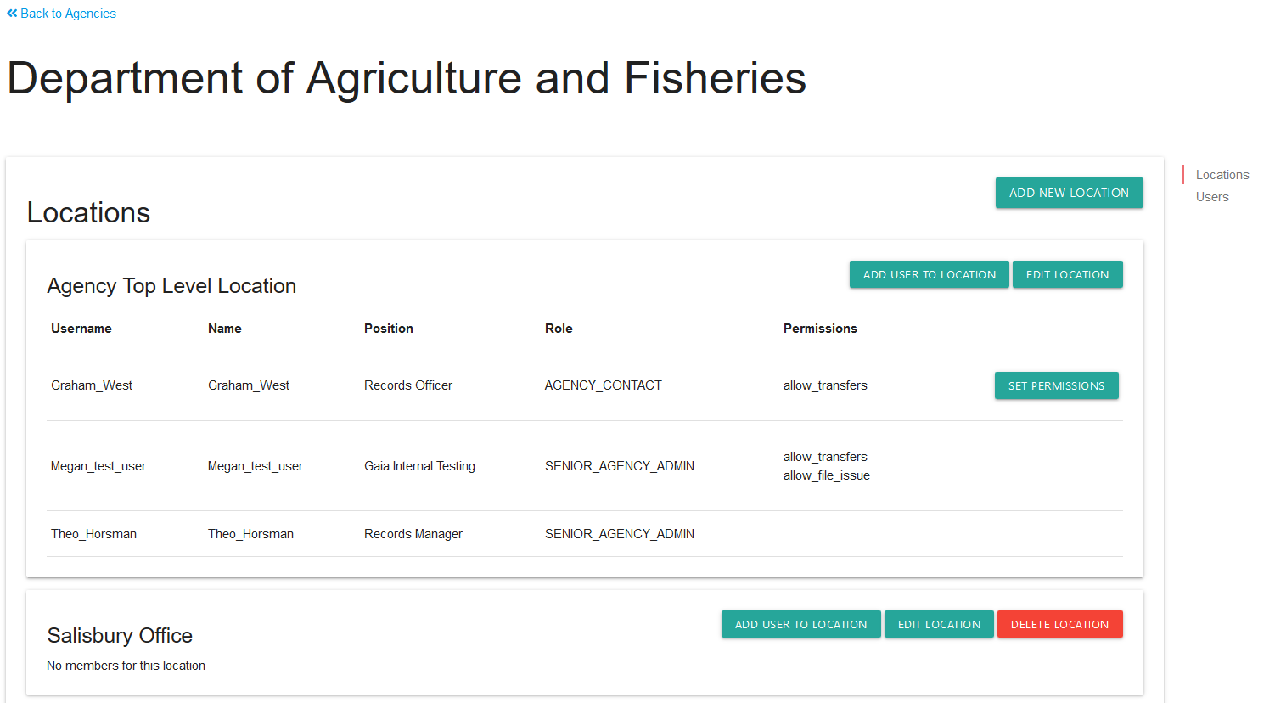
Note: when you create a new location, no users will be attached. You will need to add users to this new location.

Creating users in location
The type of users you can create and the permissions you can assign with depend on whether you are a Senior agency admin or and Agency admin. See permissions for more information.
To create a new user:
- Navigate to the Agency profile page.
- Scroll down to the location required
Note: It is recommended that you add users to the agency top-level location and then add them to sub-level locations as required. Users should only be created in sub-level locations when they only require access to the specific locations selected.
Note: If the sub-level location has to been created, see steps above.
- Click ‘add user to location’
- Use the drop down to select the type of user (Agency Contact or Agency Admin)
- Enter the user’s details in the fields provided.
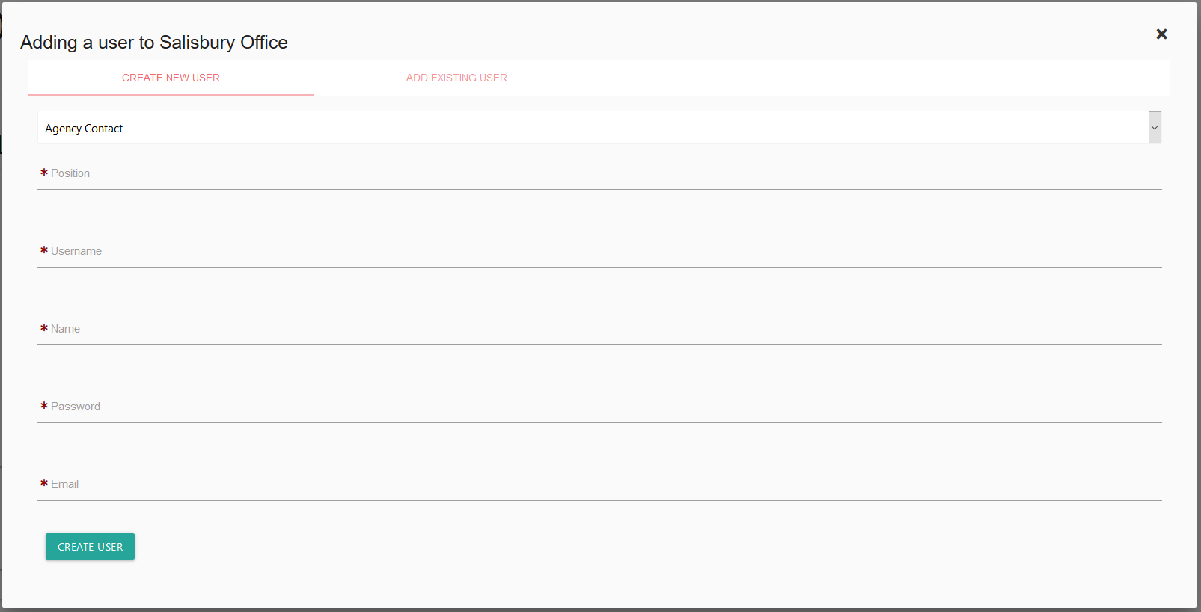
Note: It is recommended that usernames are Firstname_Lastname.
- Click ‘create user’.
- The new user will now show up in the location you added them to.
- You can now add this user to any other locations as required.
Note: Users can be added to multiple Locations within your agency. If you are a Senior Agency Admin for more than one Agency, you can also add them to multiple Agencies.

Setting permissions
Once a user is created, you will need to set their permissions.
Note: Agency admin users can only give Agency Contacts the same permissions that have been provided to you within ArchivesGateway.
For example, if you are an Agency admin with File Issue permission, you will only be able to give an Agency contact File Issue permissions. If you are an Agency Admin with no permissions, you will not be able to give any permissions to an Agency Contact.
To set users permissions:
- In the agency profile page, navigate to the user under the relevant location
- Click ‘set permissions’ on the right
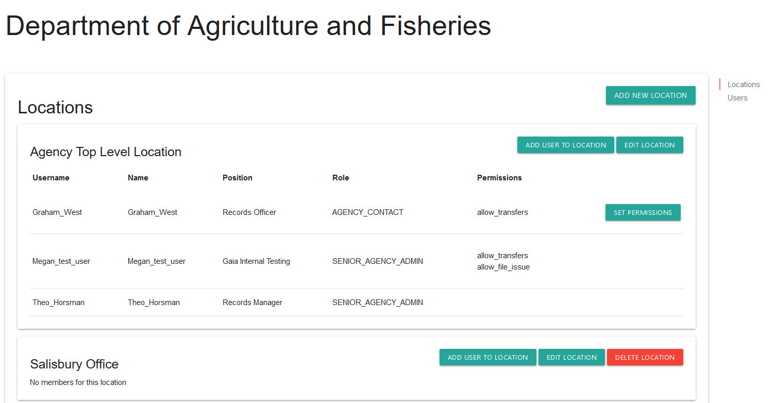
- Tick the appropriate permissions check boxes in the form
Notes: Only tick the ‘allow, set and change RAPs’ and ‘allow restricted access’ permissions IF the user is an authorised delegate for your agency.

Changing a user’s type
Senior agency admin: If required, you can change the user type from Agency admin or Agency Contact or vice versa in the permissions settings window.

Adding existing users to locations
You can add existing users to other locations within your agency.
- On the agency profile page, navigate to the appropriate location
- Click ‘add user to location’
- In the user profile form, select ‘add existing user’
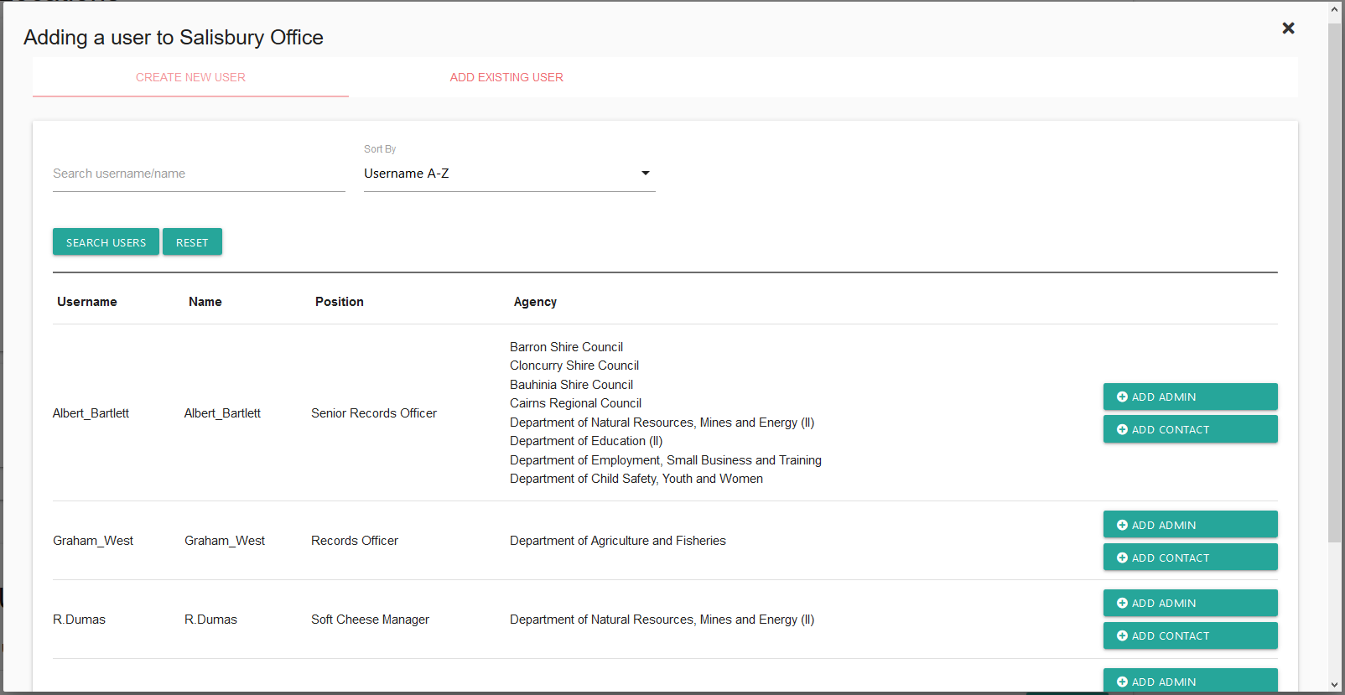
- Use the search option to find the user by either username or name.
Note: users must be associated with your agency in ArchivesGateway.
- Once located, click either:
  - ‘Add admin’ – to set them as an Agency Admin level user for that location
  - Add contact – to set them as an Agency Admin level user for that location
Note: the user type can be different in sub-level locations.
- You will then need to set permissions for that user for that location.

Removing users from locations
- In the agency profile screen, navigate to the location you want to remove them from.
- Click ‘set permissions’ on the right.
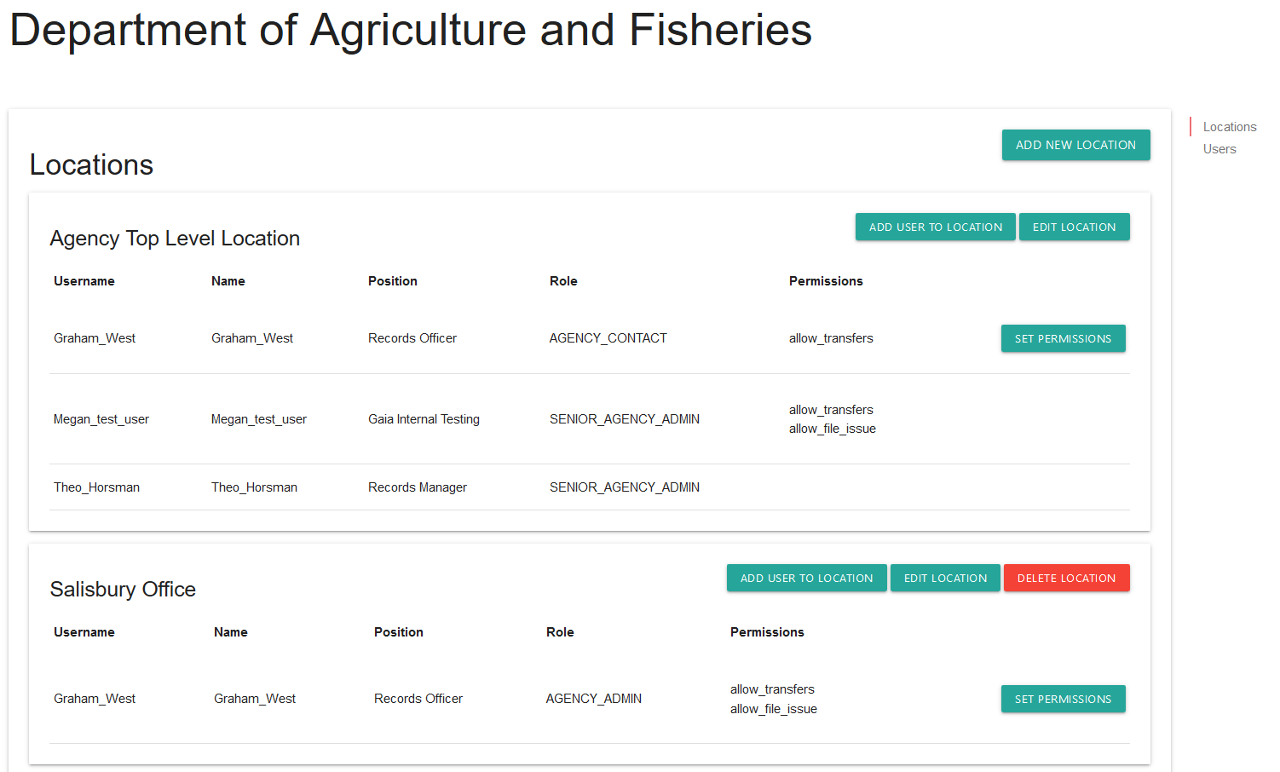
- In the permissions window, click ‘remove from location’ button on the top right.
Note: when removing users from a location, they must remain associated with at least 1 location for your agency – they cannot be removed altogether.
The ‘remove from location’ button will be greyed out if this is their only location.
If you need to remove a user completely, see how to make a user inactive

Deleting locations
Only QSA and Senior agency administrators can delete locations.
Deleting locations is not recommended as you will lose all audit history of transactions completed by users within that location.
If you need to ‘deactivate’ a location, it is recommended that you rename it to include the words DO NOT USE or similar at the beginning.

Editing users and setting position
Senior Agency Admin and Agency Admin users can edit user’s details for users the level below them. This includes making users inactive, updating their details, and resetting their MFA.
See permissions for more details on user levels.
- In the agency profile page, navigate to the users section
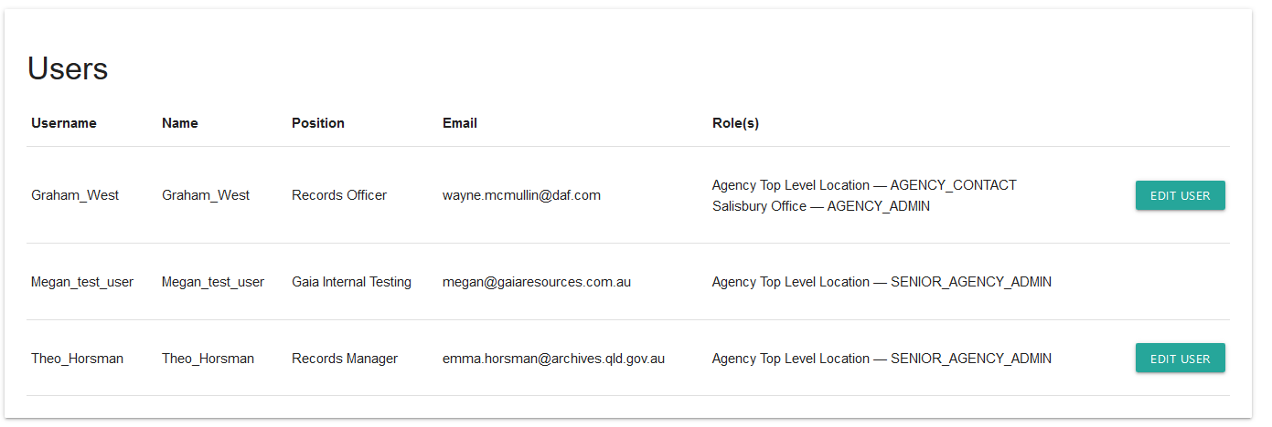
- Click on ‘edit user’ button for the relevant person.
- The edit user screen will open

Making users inactive
- To make a user inactive tick the inactive button at the bottom of the profile page
- Click save.

Resetting a user’s MFA
- Resetting MFA involves resetting a user’s MFA completely so that when they next log in they need to set up their MFA again.
- To reset, tick the ‘reset Multi Factor Authenticator’ checkbox
- Click save

Changing a user’s details
- Update details as required.
- Click save.
Note: You cannot change the username.
Note: If the user you wish to edit also has permissions for another Agency which you do not have permissions for, you will not be able to edit their details. In this case you will need to contact QSA for assistance.

Navigating between agencies and locations
If you are associated with multiple agencies and/or locations in ArchivesGateway, you can switch between them to see the records associated with that agency or location.
You do not need a separate login or need to log out and log back in to ArchivesGateway.

Switch between agencies and locations
To switch between locations or agencies:
Click drop down arrow next to the agency name and location in the toolbar.
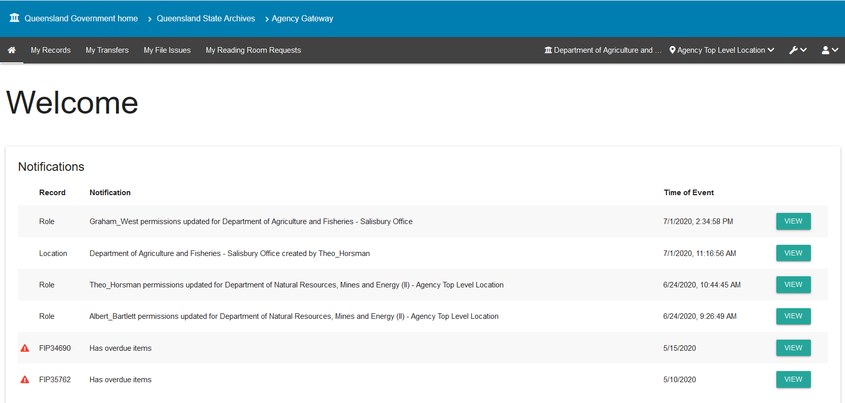
A pop-up window will open.
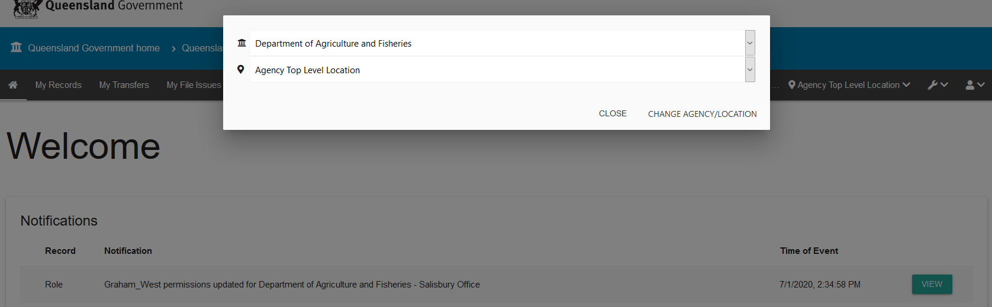

Change agency
Click on the agency drop down (top option)
Select the agency required.
Click ‘change agency/location’ button on the bottom right.
This will change the agency and bring up the records for that agency.
Note: you will to do this before you can select the specific location for that agency.

Change location
Click on the location drop down (second option)
Select the location required
Click ‘change agency/location’ button on the bottom right
This will change the location within the agency selected and bring up the requests done within that location.

Machinery-of-government and administrative changes
When there is a machinery-of-government (MOG) or administrative change and the ownership of records transfers to another agency, there is a grace period of about 3 months where both the preceding and succeeding agency can view and access records, and conduct business such as transferring records.
Both agencies can continue to access the records where responsibility has been assigned.
Succeeding agencies are expected to assign revised or new agency delegates and establish revised user profiles and permissions.
Find out more about Custody, ownership and responsibility for records during a MOG or administrative change.
See also the user guide for Searching records for more information on how records affected by a MOG change will display in ArchivesGateway.

More information
Further information is available on the Recordkeeping section of the For Gov website:
- Use ArchivesGateway
- Transfer records to QSA
- Restrict access to records at QSA (Restricted Access Periods)
- Retrieve or access your agency's records at QSA (File Issue service)
- Provide access to closed records
Other user guides are also available for specific functions within ArchivesGateway and are available on the relevant pages listed above.
If you require further assistance with ArchivesGateway, please contact the ArchivesGateway team via email: ArchivesGateway@archives.qld.gov.au.

