Making Vision6 Accessible
  - Empowered and confident: disabling the barriers

Introduction
As an organisation we should always be working towards disabling all barriers for all employees. A large component of this is ensuring communications going to our internal and external customers are accessible.
More and more Vision6 is being used as a communication tool for email marketing.

Lessons learnt
Recently, an issue was discovered when a communication was sent to an employee who is blind. We learnt that when a Vision6 email is sent, our system performs some functions which remove accessibility elements, including converting text formatted as a header into regular text. This resulted in the information not being fully accessible for the staff member who uses screen reading software.
The information below provides an overview of how to address this issue in Vision6 communications.

How can it be made accessible?
When sending communication in Vision6, creating a ‘View online’ link, which appears at the top of an email, retains the message’s accessibility features.
‘View online email’ link however is not a setting, nor automatically created for emails sent by Vision6. It is a feature available when editing a message that users have to actively create. A view online link can be seamlessly copied and pasted and is compatible with templates, meaning it only needs to be created once for regular emails.
Use the following steps on next page to help make Vision6 accessible

Step 1: Decide where the link will go
Consider where the ‘View Online’ text will go (standard practice is small font at the top of the email).
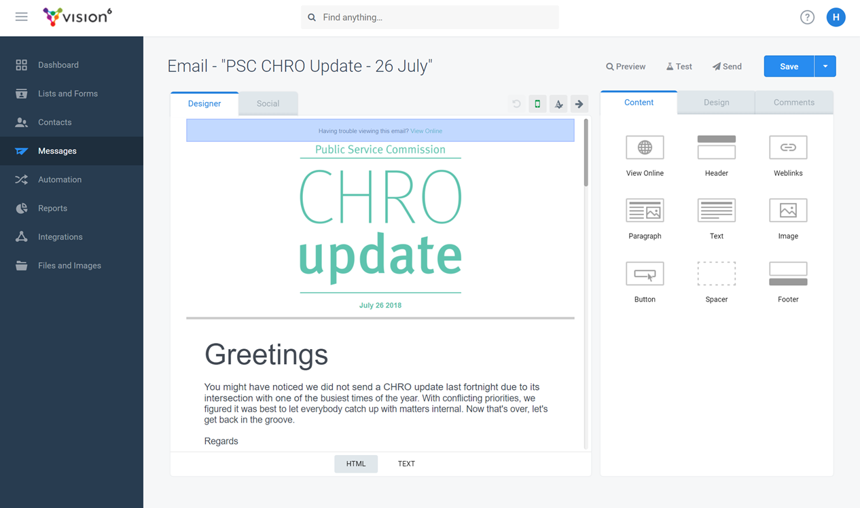

Step 2: Add link
Add text and create hyperlink.
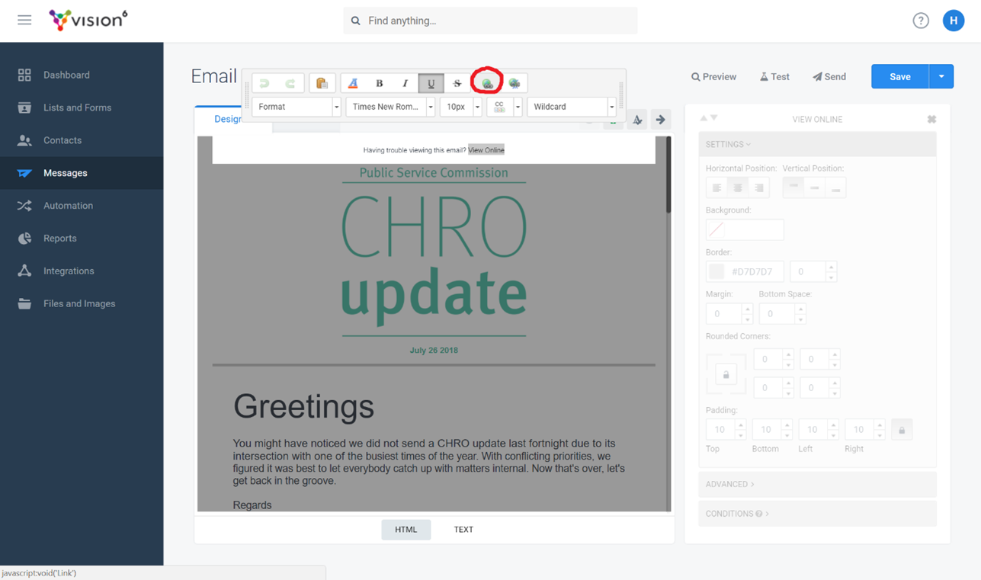

Step 3: Link
Link to ‘View Email Online’. An online version of the email will be generated by Vision6 once sent.
