Invitation to Offer (ITO)
Standing Offer Arrangement - ICT Products and/or Services
<<Principal >>
Invitation Title: <<insert>>
Reference No: <<insert>>
Date of Issue: <<insert>>

Invitation to Offer Template (ITO) – Standing Offer Arrangement - ICT Products and/or Services – Issued January 2022 – Version 2.0.0
INSTRUCTIONS FOR USING THIS DOCUMENT (TO BE DELETED BEFORE SENDING TO SUPPLIER):
This is the standard form Invitation to Offer for the establishment of a Standing Offer Arrangement for ICT Products and/or Services.
It is appropriate for use where the government agency is conducting an open or closed tender process for Standing Offer Arrangements under the QITC framework.

Guidance Notes are available on the https://www.forgov.qld.gov.au/create-ict-contract webpage to help the Customer/Principal complete this document.

The Principal needs to fill out all yellow highlighted sections with details of the Principal’s requirements.
The Principal is to delete all highlighting before giving the Invitation to Offer to potential Suppliers.
The Principal must separately complete and issue with this Invitation to Offer the Standing Offer Arrangement Details – ICT Products and/or Services.
Instructions to Suppliers are included in bold italics. The Principal should retain the instructions to Suppliers in the final version of the Invitation to Offer.
Schedule C of the document refers to the standandised SOA ITO Conditions and should not be altered.

Table of contents

Table of contents 4

1. Information about the opportunity 6

1.1 Summary of opportunity and Principal objectives 6

1.2 Closing date and time 6

1.3 Indicative timetable 6

1.4 Briefing session 7

1.5 Evaluation 7

1.6 Documents in the Invitation to Offer which Supplier needs to complete and return 8

1.7 Formation of a SOA 8

1.8 Offer Validity Period 8

1.9 Requirements to be a Conforming Offer 8

1.10 Offer clarifications or questions 9

1.11 How Offers are to be submitted 9

1.12 SOA Invitation to Offer Conditions 9

1.13 Principal contact 9

1.14 Complaints 9

1.15 Privacy Notice 10

2. Schedule A – Response Schedule 11

2.1 Supplier details 11

2.2 Ethical Supplier Threshold 11

2.3 Financial Information 12

2.4 Conflict of interest 12

2.5 Small to medium enterprises 12

2.6 Background Information 12

2.7 Referees 13

2.8 Overview of the Supplier’s Offer 13

2.9 Relevant experience 13

2.10 Capacity and capability 13

2.11 Ability to meet timeframes 13

2.12 Quality 14

2.13 How does the Supplier’s Offer meet the Principal’s objectives? 14

2.14 Account and relationship management 14

2.15 How does the Supplier's offer meet the Principal's social procurement objectives? 14

2.16 Value for money/value adds 14

2.17 [Principal to insert other questions as required] 14

2.18 Additional information offered by the Supplier 14

3. Supplier execution of Offer 16

3.1 Acknowledgements and certifications 16

3.2 Execution of Offer 16

4. Schedule B – Innovation 17

4.1 Alternative Offers, innovation and improvements 17

5. Schedule C – SOA Invitation to Offer Conditions 18

5.1 Interpretation 18

5.2 Invitation Process 18

5.3 Alternative Offers 18

5.4 No reliance on information 18

5.5 Supplier cost 18

5.6 Subject to contract 19

5.7 Compliance 19

5.8 Anti-competitive conduct, conflict of interest and criminal organisations 19

5.9 Supplier Confidential Information 20

5.10 Definitions 21

6. SOA Details 23

Information about the opportunity
This section sets out information about the Invitation Process, the Principal’s objectives and key details that the Supplier needs to know in order to submit its Offer.
This section will not form part of the Supplier’s Offer.
The Supplier must not make any changes to section 1 of the Invitation to Offer.
  - Summary of opportunity and Principal objectives
<< Principal to insert a brief summary of the opportunity. What is the scope of this ITO? What is the Principal looking for?>>
The Principal has issued this Invitation to Offer with the objectives of:
<<Principal to list objectives>>.
  - Closing date and time
Offers must be lodged by <<time am/pm>> Australian Eastern Standard Time on <<day of the week, day, month, year>>.
  - Indicative timetable
Indicative timetable (subject to change)
See guidance note
Invitation issued
<<insert>>
Briefing session (if applicable)
<<insert date and time>>
Closing date for questions
<<insert date and time>>
Closing date and time for Offers
<<insert date and time>>
Intended completion date of shortlisting Suppliers
<<insert>>
Intended completion date for evaluation of Offers
<<insert>>
Negotiations with Supplier(s)
<<insert>>
Intended date for formal notification of successful Supplier
<<insert>>
Intended <<SOA>> start date
<<insert>>
  - Briefing session
<<If the Principal is not holding a briefing session with Suppliers then delete this section or insert “Not applicable”.>>
The Principal will hold a briefing session at <<time, date, location>>. It <<is mandatory/is not mandatory>> for Suppliers to attend the briefing session in order to submit an Offer.
<<Insert details of other relevant information or restrictions if applicable, e.g. maximum number of attendees, whether Suppliers can ask questions, whether separate or joint sessions.>>
  - Evaluation
The Principal is not evaluating Offers on the sole criterion of price. The criteria against which the Supplier’s Offer will be evaluated includes:
- capability and relevant experience;
- ability to meet the Requirements and the Principal objectives;
- quality;
- cost and value for money;
- contract compliance;
- the creation of employment opportunities for <<insert jobseeker target group eg disadvantaged and vulnerable Queenslanders/people with a disability>>;
- <<[insert other such as any social procurement criteria]>>; and
- opportunities for innovation and improvement (see Schedule B).
The following criteria are mandatory:
a) the Supplier must comply with the Ethical Supplier Threshold and Supplier Code of Conduct; and
b) <<Insert other mandatory criteria if relevant>>.

  - Documents in the Invitation to Offer which Supplier needs to complete and return
This Invitation to Offer is made up of the following documents.
 | Document | Instructions to Supplier
1. | Invitation to Offer | Provides details of Offer conditions, timetable, contacts, evaluation criteria and other general information. Supplier to retain.
 | - Schedule A  (Response Schedule) | Supplier to complete, sign and return with Offer.
 | - Schedule B  (Innovation) | Supplier to complete and return with Offer  (if applicable).
 | - Schedule C  (SOA Invitation to Offer Conditions) | Supplier to retain.
2. | SOA terms - establishing a SOA between the Principal and Supplier | <<The SOA Details must be completed by the Principal as much as possible and issued to the Supplier to complete and return with its Offer.>>  Supplier to complete and return draft SOA Details and other applicable documents which are provided as part of this Invitation to Offer.
  - Formation of a SOA
A SOA will not be formed until all the SOA documentation is agreed to and the SOA is signed by appropriate representatives of both parties.

Offer Validity Period
Offers must remain open and capable of being accepted by the Principal for a minimum period of 120 days.

Requirements to be a Conforming Offer
To be a Conforming Offer, the Offer must:
- be received by the closing date and time;
- be received in the format and method described in this Invitation to Offer;
- be open for the minimum Offer Validity Period;
- satisfy all mandatory requirements;
- respond to all sections of this Invitation to Offer document in full;
- include completed draft SOA Details and any associated documents referred to in the SOA Details;
- <<insert other minimum requirements if applicable>>.

Offer clarifications or questions
All clarifications or questions related to the Invitation to Offer must be communicated in writing directly to the Principal contact identified in 1.13.

How Offers are to be submitted
Offers must be lodged <<electronically/in hard copy>> to <<hard copy tender box address/website address for online submission/email address>>.
<<If the Principal asks, the Supplier must also provide a copy of its response to the draft SOA Details, and SOA Module Orders in Microsoft Word <<insert version numbers if relevant>> format.>>
See guidance note

SOA Invitation to Offer Conditions
The SOA Invitation to Offer Conditions are set out in Schedule C.
See guidance note

Principal contact
The Principal’s contact person/s for the Invitation to Offer:

Name: <<insert>>
Position: <<insert>>
Agency: <<insert>>
Email: <<insert>>

Name: <<insert>>
Position: <<insert>>
Agency: <<insert>>
Email: <<insert>>

Complaints
If at any time during the Invitation Process, a Supplier considers they have been unreasonably or unfairly treated and the issue has not been able to be resolved with the Principal contact person, the Supplier may request for the issue to be dealt with in accordance with the Principal’s complaint management process and directed to:
Complaint Management
Name: <<insert>>
Position: <<insert>>
Agency: <<insert>>
Email address: <<insert>>
  - Privacy Notice
The Principal is collecting Personal Information from the Supplier for the purpose of administering the Invitation Process, SOA and Contracts formed under the SOA. Personal Information may be shared with Queensland Government agencies and bodies, non-government organisations and other governments in Australia for that purpose. Personal Information may be made publicly available in accordance with the requirements of the Queensland Government’s procurement policy. An individual is able to gain access to Personal Information held by the Principal about the individual in certain circumstances.

Schedule A – Response Schedule
The information in this schedule is required for evaluation purposes.
As the Supplier, please respond to all questions in this schedule. All information must be complete, accurate, up to date and not misleading.
<<This Schedule is ‘free text’ – the Principal can include as many questions as it needs to properly evaluate suppliers. The headings below are suggestions only and can be deleted / modified as the Principal sees fit. All questions should directly link to the evaluation criteria specified earlier in the Invitation to Offer.>>
<<Note: Review the example clauses set out in the Social Procurement Clauses factsheet issued by the Office of the Chief Adviser – Procurement and insert appropriate clauses>>

Supplier details
Please provide your details, including the full legal name and contact details of any other entities which are participating in a joint Offer.
Supplier Name:
Name:
ABN/ACN (or ABRN):
Names of other entities participating in a joint Offer with the Supplier:
Insert details or “Not applicable”.
Contact person for this Invitation to Offer:
Name:
Position:
Email address:
Phone number:
Postal address:

Ethical Supplier Threshold
It is a mandatory criteria that the Supplier must comply with the Ethical Supplier Threshold. Please provide the following details about the Supplier:
At any time from 1 August 2019, has the Supplier:
Yes No | (a) contravened a civil remedy provision of Chapter 2 or Chapter 3 of the Fair Work Act 2009 (Cth), or committed an offence against the Fair Work Act?
Yes No  Yes No | (b) contravened a civil remedy provision of Chapter 2, 3, 4, 5, or 7 of the Industrial Relations Act 2016, or committed an offence against the Industrial Relations Act, or failed to pay employment related levies, or other payments, established under Queensland legislation?
Yes No | (c) failed to make superannuation contributions on behalf of employees in accordance with law?
Yes No | (d) purported to treat employees as independent contractors, where they are not?
Yes No | (e) required persons who would otherwise be employees to provide an Australian Business Number so that they could be treated as independent contractors?
Yes No | (f) engaged persons on unpaid work trials or as unpaid interns, where they should be treated as employees?
Yes No | (g) entered into an arrangement for the provision of labour hire services with a person who is not licensed under the Labour Hire Licensing Act 2017, or a supplier who is an unlicensed provider under the Act?
Yes No | (h) paid employees wages below those provided for in an applicable modern award?
If the Supplier answered "yes" to any of the above, insert details about the "yes" response in a separate page attached to this document.

Financial Information
See guidance note

Conflict of interest
Please provide details of any possible Conflict of Interest that exists or may arise in relation to the Invitation Process, or performance of the SOA (if you, as the Supplier are successful).
If there is nothing to declare, insert “Nil”.
Supplier to insert response

Small to medium enterprises
Please indicate how many people you employ by marking one of the boxes below:
0 to 50 Employees 51 to 200 Employees 201+ Employees
Note: As a guide, people are both employees and contractors employed by the supplier.

Background Information
    - Supplier overview
Please provide a brief description of the business and its overall qualifications to meet the requirements. Background information may include: number of years of relevant experience, rate of growth, size, locations, annual turnover etc. Please limit your response to this question to <<1>> page.
Supplier to insert response.
    - Differentiating factors
What differentiates you from your competitors? What is it about the your Offer that you believe is unique to your Offer? Limit your response to <<1>> page.
Supplier to insert response.

Referees
Please provide details of <<insert number>> referees. Include for each referee:
- Name and position;
- Telephone number, email address and postal address;
- Brief description of the work performed by the Supplier for the referee.
Supplier to insert response.

Overview of the Supplier’s Offer
Please provide an overview of your Offer to supply to the eligible Customers under the SOA, demonstrating how the Principal’s requirements will be met. This can be a summary of the detailed requirements/specifications that will appear in the SOA.
Please insert the detail to be included in the SOA specific to the supply of the ICT Products and/or Services under Contracts to be entered under the SOA, comprehensively addressing the Principal’s requirements.
Supplier to insert response

Relevant experience
Provide enough information about recent (and relevant) experience to demonstrate your capability to meet the requirements. What is your recent track record in providing the same/similar Products and/or Services? The response to this question should be limited to <<2>> pages.
Supplier to insert response

Capacity and capability
<< Principal to insert question here if required.>>
Supplier to insert response

Ability to meet timeframes
<< Principal to insert question here if required. For example: “The Supplier must provide a high-level schedule for performing the work, including any applicable lead times, phases of work and key deliverables, and estimated timeframes to complete phases of work. Include any assumptions that the Supplier has made in preparing the high-level schedule.”
Supplier to insert response

Quality
<< Principal to insert question/s here if required.>>
Supplier to insert response

How does the Supplier’s Offer meet the Principal’s objectives?
<< Principal to insert question/s here>>
Supplier to insert response

Account and relationship management
<< Principal to insert question/s here>>
Supplier to insert response

How does the Supplier's offer meet the Principal's social procurement objectives?
<< Principal to insert statement of intent of social procurement objectives>>
Supplier to insert response

Value for money/value adds
<< Principal to insert question/s here>>
Insert Supplier response

[Principal to insert other questions as required]

Additional information offered by the Supplier
<<If the requirements are very well defined and the Principal is not interested in receiving additional information, it may be appropriate to delete this section.>>
Please set out any other information that is relevant to the Invitation to Offer and which a reasonable person would think may affect the Principal’s decision whether to enter a SOA with the Supplier.
Clearly indicate the purpose of the additional information and which part of the Offer the additional information relates to. Where the additional information relates to an earlier item in this Schedule A – Response Schedule, the Supplier is to include a reference to the applicable section number. Keep the information brief and to the point.
The Principal is not required to consider any additional information that the Principal did not specifically request.
Supplier to insert response

Supplier execution of Offer

Acknowledgements and certifications
The Supplier:
- accepts these SOA Invitation to Offer Conditions
- offers to enter into the SOA on the terms described in the Supplier’s Offer and the SOA Invitation to Offer Conditions. The Principal may accept the Supplier’s Offer during the Offer Validity Period.
- certifies that it has read, understands, and complies with all the requirements of this Invitation to Offer, including any changes made by the Principal and notified to the Supplier in accordance with the SOA Invitation to Offer Conditions.
- represents that all the information contained in the Supplier’s Offer is complete, accurate, up to date and not misleading in any way.
- acknowledges that the Principal will rely on the information contained in the Supplier’s Offer (including the warranties and declarations) when deciding whether or not to accept the Supplier’s Offer and that if the Principal accepts the Supplier’s Offer, the Principal will enter into a SOA and eligible Customers may enter into Contracts relying on that information.
- acknowledges that the Principal and eligible Customers under the SOA may suffer damage if any of the information in the Supplier’s Offer is incomplete, inaccurate, out of date or misleading in any way.

Execution of Offer
Date:  EXECUTED for and on behalf of:  Name of Supplier  by its authorised representative, in the presence of:  Signature of witness  Name of witness (block letters)  Address | )  )  )  )  )  )  )  )  )  )  )  )  )  ) | Signature of authorised representative  By executing this Offer the signatory warrants that the signatory is duly authorised to submit this Offer on behalf of the Supplier  Name of authorised representative (block letters)  Position of authorised representative

Schedule B – Innovation

Alternative Offers, innovation and improvements
The Principal welcomes proactive suggestions from the Supplier about innovations or improvements (e.g. to our own processes, workflows, supply chains, or specifications) that will benefit the Principal and meet the Principal’s objectives. If the Supplier wishes to make an alternative Offer, then it must set out details of its alternative Offer/suggested innovations or improvements in this Schedule (by answering the questions below.)
    - What is your alternative Offer/suggested innovation or improvement?
Supplier to insert response
    - What are the benefits to the Principal of your alternative Offer/suggestion?
Supplier to insert response
    - Explain how your alternative Offer/suggested innovation or improvement offers better value for money, and better achieves the Principal’s objectives
Supplier to insert response
    - Outline any assumptions on which your claimed customer benefits are based
Supplier to insert response
    - Is there any other important information that the Principal should know about your alternative Offer/suggested innovation or improvement?
Supplier to insert response

Schedule C – SOA Invitation to Offer Conditions

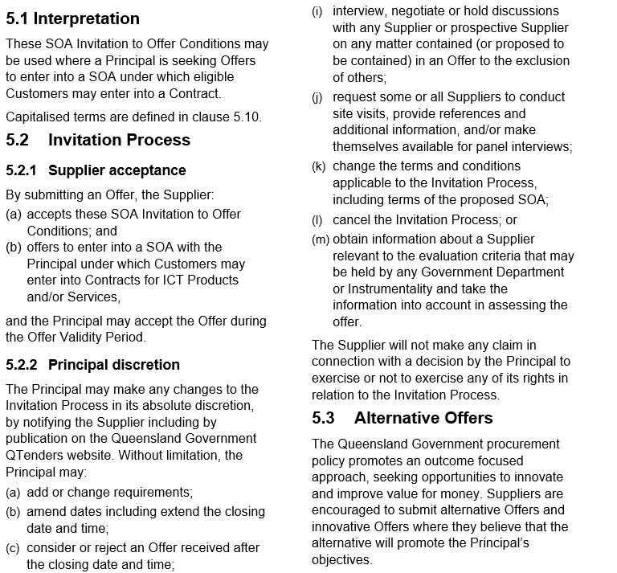
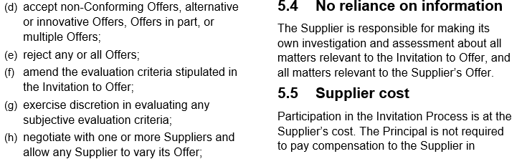
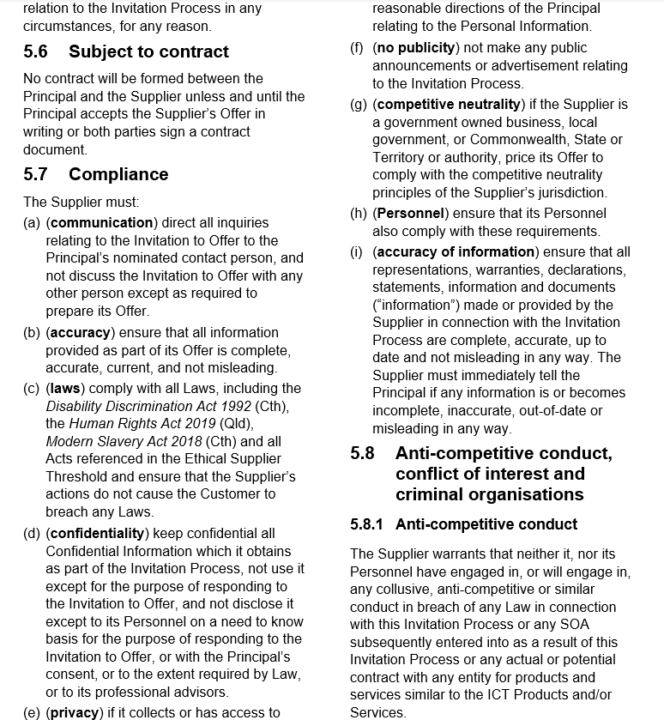
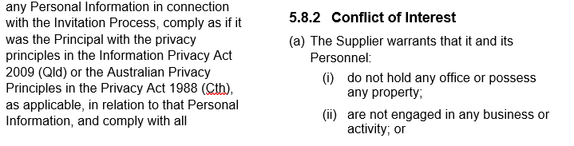
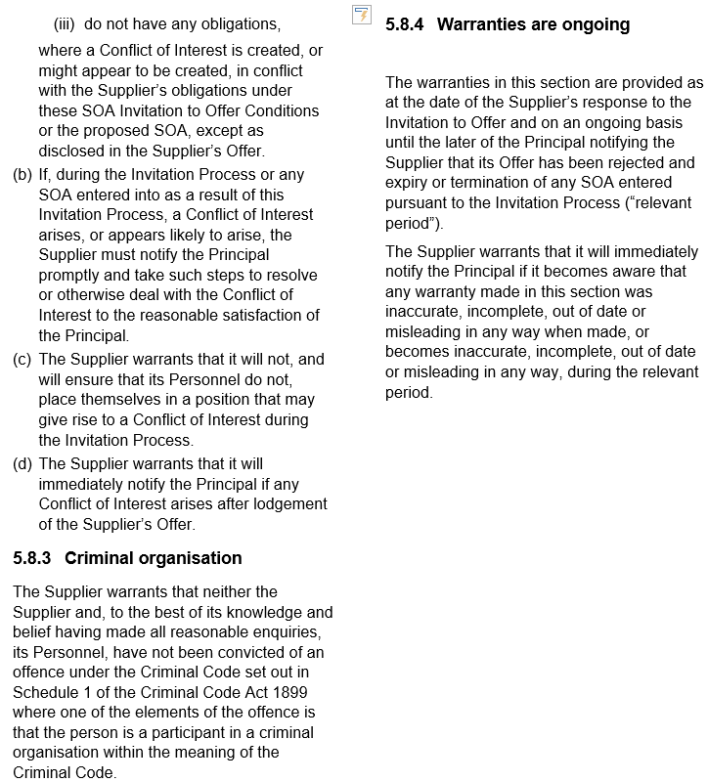

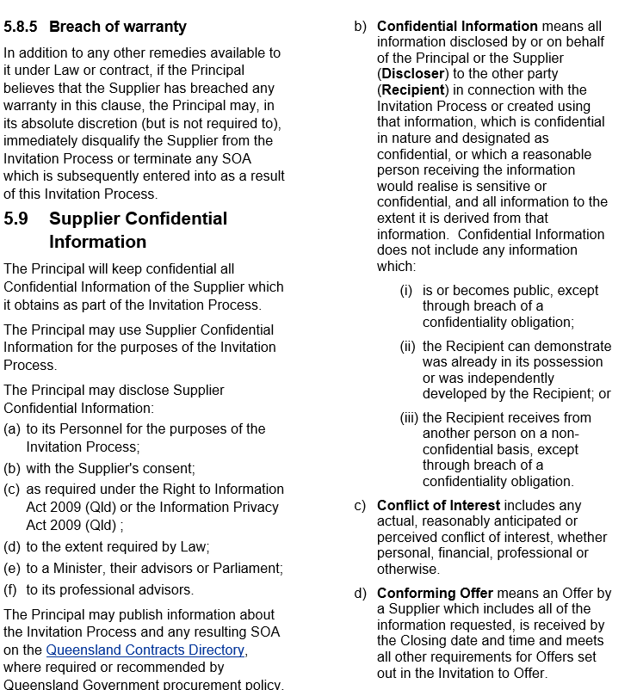
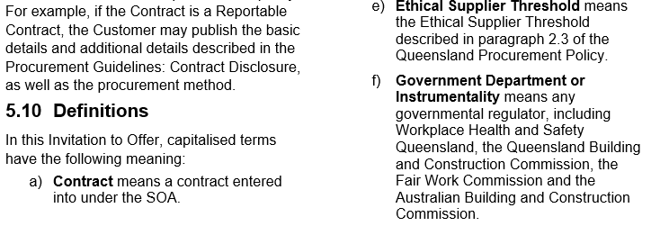
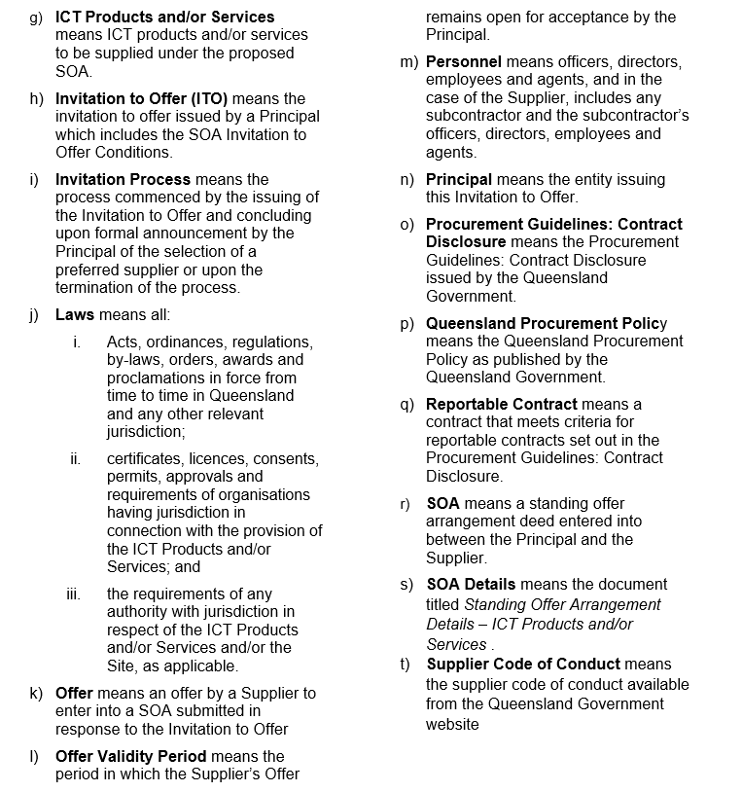

SOA Details
[attach copy of SOA Details (and Conditions) completed by the Principal.]

