Pre-determining the release status of information
Ex ante decision making guideline

Final
February 2018
v3.0.0

PUBLIC

Document details
Security classification | PUBLIC
Date of review of security classification | February 2018
Authority | Queensland Government Chief Information Officer
Author | Queensland Government Chief Information Office
Documentation status |  | Working draft |  | Consultation release |  | Final version
Contact for enquiries and proposed changes
All enquiries regarding this document should be directed in the first instance to:
Queensland Government Chief Information Office
qgcio@qgcio.qld.gov.au
Acknowledgements
This version of the Pre-determining the release status of information: ex ante decision making guideline was developed and updated by Queensland Government Chief Information Office.
Feedback was also received from a number of agencies, which was greatly appreciated.
Copyright
Pre-determining the release status of information: ex ante decision making guideline
© The State of Queensland (Queensland Government Chief Information Office) 2018
Licence
This work is licensed under a Creative Commons Attribution 4.0 International licence. To view the terms of this licence, visit http://creativecommons.org/licenses/by/4.0/. For permissions beyond the scope of this licence, contact qgcio@qgcio.qld.gov.au.
To attribute this material, cite the Queensland Government Chief Information Office.
The licence does not apply to any branding or images.
Information security
This document has been security classified using the Queensland Government Information Security Classification Framework (QGISCF) as PUBLIC and will be managed according to the requirements of the QGISCF.
Contents
1 Introduction 4
1.1 Purpose 4
1.2 Audience 4
1.3 QGEA domains 4
2 Background 4
2.1 What does the term ex ante mean? 4
2.2 Why were the ex ante decision-making considerations developed? 4
2.3 What is the purpose of ex ante decision-making considerations? 5
3 Operation of the ex ante decision-making considerations 6
3.1 What information is subject to ex ante decision-making considerations? 8
3.2 When are the ex ante decision-making considerations applicable? 8
3.3 Applying ex ante decision-making considerations 8
3.4 Information identified as ‘yes – may be released’ 9
3.5 Information identified as ‘undetermined – requires further consideration’ 9
3.6 Information identified as ‘no – may not be released at this point in time’ 10
3.7 Information released under the Right to Information Act 2009 (Qld) 10
4 Implementation considerations 10
4.1 Authorising and accountability environment for the release of information 10
4.2 Modification of ex ante decision-making considerations 11
4.3 Relationship between ex ante decision-making and Creative Commons licences 11
4.4 Relationship between ex ante decision-making and the Queensland Government Information Security Classification Framework 12
Appendix A Ex ante decision-making considerations 13

Figures
Figure 1: Overview of the operation of ex ante decision-making in the RTI environment 8

Introduction

Purpose
A QGEA guideline is not mandatory. This guideline provides advice to help departments with suggested approaches for pre-determining the release status of government information.
It supports policy requirement 1 within the Queensland Government Enterprise Architecture (QGEA) Information access and use policy (IS33).

Audience
This document is primarily intended for:
- creators of information
- custodians of information assets
- information release specialists/decision makers
- policy officers
- information champions
- information governance bodies.

QGEA domains
This guideline relates to the following domains:
Classification framework | Domain
Business services | SL-2.5 Information services
Business process | BP-7.4.2.2 Define information access requirements
Information management | IM-4 Information access and use  IM-4.1 Access and accessibility  IM4.4 Privacy  IM4.7 Sharing  IM-4.8 Publishing and release

Background

What does the term ex ante mean?
The term ex ante is a neo-Latin word meaning ‘before the event’. In relation to the release of information, ex ante refers to a series of considerations to be undertaken prior to determining whether information is suitable for administrative release (see section 2.3 below for more detail on administrative release).

Why were the ex ante decision-making considerations developed?
The ex ante decision-making considerations (see appendix A) were developed in response to recommendation 5 of the Freedom of Information Independent Review Panel’s The Right to Information: Reviewing Queensland’s Freedom of Information Act:
Ex ante decision-making rules…should be introduced as a strategy in routine and proactive disclosure where documents that can be released without difficulty and those that might need specific consideration are identified [by those who understand the documents best] at the outset...
The Queensland Government in its response supported this recommendation stating:
To give effect to this recommendation, the government will develop an ex ante decision-making standard as part of the development of the whole-of-government information policy. This work, led by QGCIO, will establish decision-making rules for the release of information…

What is the purpose of ex ante decision-making considerations?
Right to Information (RTI) seeks to achieve open, accountable and participatory government through a ‘push’ model for the release of information. Its intent is to make formal legislative access requests for Queensland Government information (i.e. the ‘pull’ model) the last resort.
Departments are required to make government information available to the public unless there is a good reason not to. This is embodied in both the Right to Information Act 2009 and the Information Privacy Act 2009 as well as being a policy obligation under the Information access and use policy (IS33).
Ex ante decision-making consideration assists with assessing whether information is suitable for administrative release, however, it is not the sole consideration in determining whether information is suitable for publication or inclusion in a publication scheme. Figure 1: Overview of the operation of ex ante decision-making in the RTI environment on page 7 of this document provides guidance in relation to additional considerations.
As outlined in the Office of the Information Commissioner Guideline: Administrative release of information, there are three main types of administrative release:
- administrative access schemes
- access under specific legislation
- administrative access other than under a scheme.
Ex ante decision-making considerations should be undertaken when assessing whether information is suitable for release administratively other than under a scheme. Other considerations apply for administrative access schemes and access under specific legislation; see the Office of the Information Commissioner Guideline: Administrative release of information.
Ex ante decision-making considerations are intended make formal legislative applications for access to information (i.e. Right to Information Act 2009 (Qld) applications) a last resort, by assisting information custodians to determine whether information can be proactively released or if further consideration is required.

Operation of the ex ante decision-making considerations
Figure 1 on page 7 provides an overview of the operation of ex ante decision-making considerations in the RTI environment and makes reference to other sections of this document for guidance on the application of this guideline.

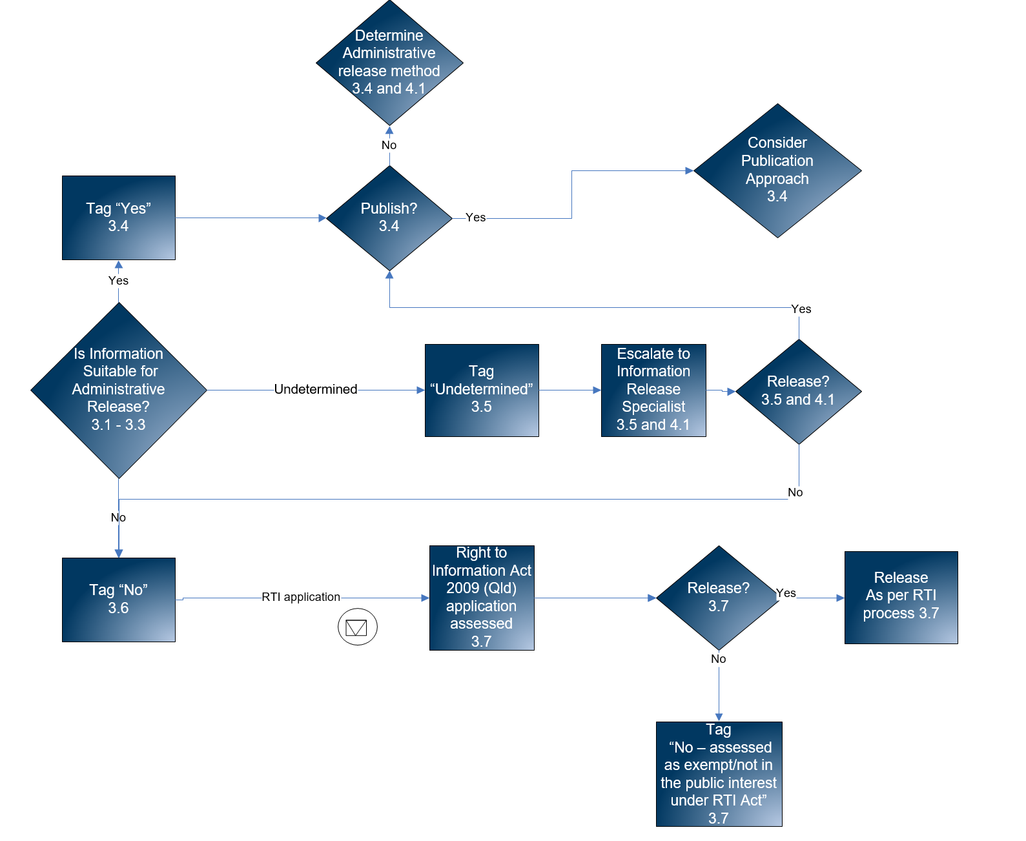
Figure 1: Overview of the operation of ex ante decision-making in the RTI environment

What information is subject to ex ante decision-making considerations?
Ex ante decision-making considerations are applicable to all Queensland Government non-personal information.

When are the ex ante decision-making considerations applicable?
As illustrated in figure 1, departments should determine what is an appropriate trigger for the application of ex ante decision-making considerations. Triggers may include:
- a request for information
- creating a record in a document and records management system or eDRMS
- finalisation/approval of information
- revision of content
- revision or assignment of a new security classification
- addition to an information asset register.
Appropriate triggers may vary based on the content type or format of the information. For example:
- in the case of ‘unfinalised’ information stored in transactional database systems, the information undergoes ex ante release consideration once it is in operational use.
- an email may undergo ex ante decision-making consideration when it is determined to be a public record.

Applying ex ante decision-making considerations

Ex ante release status categories
Figure 1: Overview of the operation of ex ante decision-making in the RTI environment, illustrates how ex ante decision-making considerations sort information into three initial release status categories:
- yes – may be released
- undetermined – requires further consideration
- no – may not be released at this point in time.
The table in appendix A lists each of the considerations and their outcomes. Departments may find it useful to adapt this table to record their release status decisions.

How are the ex ante decision-making considerations applied?
It is recommended that decision-making operates as follows:

Outcome of considerations | Release tag
All considerations have resulted in a ‘yes’ response | Yes – may be released
Considerations have resulted 0 ‘no’ responses with at least 1 ‘undetermined’ response | Undetermined – requires further consideration
Considerations have resulted in at least 1 ‘no’ response | No – may not be released at this point in time

Where is the ex ante release status recorded?
Departments should adapt existing methods for recording the ex ante release status of information where appropriate (e.g. an information asset register, a document property field, or a field within document and records management system or eDRMS). It is important that the ex ante release status is documented so that the assessment is not repeated, unless triggered by a new event.

Information identified as ‘yes – may be released’
Once information has been identified as ‘yes – may be released’ a decision regarding its publication should be made. In making this determination, departments should refer to internal publishing policies and procedures. There are two possible outcomes:
- Suitable for publication - firstly determine whether it is appropriate for publishing within the department’s publication scheme. Implementation of publication schemes is a legislative obligation under the Right to Information Act 2009. The following documents provide guidance to departments when determining what information is suitable for inclusion in a publication scheme:
Ministerial Guidelines for operation of publication schemes and disclosure logs
Office of the Information Commissioner Guideline: Proactive disclosure and publication schemes. (this guideline provides additional guidance on approval processes).
If the information is not suitable for publishing within the publication scheme, then it should be published elsewhere in accordance with departmental publishing policies and procedures.
- Unsuitable for publication - if it is determined that the information is not suitable for publication, then consideration should be given to its administrative release (see section 2.3 for types of administrative release). In making this determination, departments should refer to their own administrative access policy and arrangements, and the Office of the Information Commissioner’s Administrative release of information guideline.

Information identified as ‘undetermined – requires further consideration’
Information that has a release status of ‘undetermined’ should be escalated to the department’s information release specialists for further consideration. See section 4.1 of this document for authorising and accountability considerations at this point. There are two possible outcomes after consideration by an information release specialist:
- yes - if it is determined that the information could be released it should be tagged ‘yes’ and follow the process outlined in section 3.4 of this document
- no – if it is determined that the information is not suitable for release, it should be tagged ‘no’ and follow the process outlined in section 3.6 of this document.

Information identified as ‘no – may not be released at this point in time’
Information that has a release status of ‘no’ is not to be released. However, this determination may be subject to further consideration over time (e.g. a restricted access period may expire triggering a reassessment). See figure 1, page 7.
Information initially identified as ‘no’ will continue to be subject to legislative access applications (see figure 1 on page 7 and section 3.7 below).

Information released under the Right to Information Act 2009 (Qld)
Information that is released under a formal Right to Information Act 2009 (Qld) application should, where appropriate, subsequently be published to the department’s disclosure log. The following documents provide guidance to departments on the operation of disclosure logs:
- Ministerial Guidelines for operation of publication schemes and disclosure logs
- Office of the Information Commissioner Guidelines: Disclosure logs.
Information subject to a formal application under the Right to Information Act 2009 should be subsequently tagged either:
- yes – assessed under RTI legislation
- no – assessed as exempt or release is not in the public interest under RTI legislation (see Figure 1: Overview of the operation of ex ante decision-making in the RTI environment on page 7).
Information tagged ‘no – assessed under RTI legislation’ could also be reassessed and subsequently tagged otherwise. For example, cabinet information is exempt for a period of 10 years. After expiration of this period, it may be reassessed and tagged as ‘yes’ or ‘no’.
In the case where information is tagged ‘no’ for a defined period, a review or release should also be recorded.

Implementation considerations

Authorising and accountability environment for the release of information
To support the right to information agenda and implement the requirements of IS33, departments should establish an authorising and accountability environment for the routine and proactive disclosure of information. In the context of determining the ex ante release status of information, departments should implement:
- policies
- clear decision-making and business processes
- procedures
- roles and responsibilities
- supporting tools and systems
- appropriate governance.
Aspects of ex ante decision-making that require particular attention are:
- responsible officers –who will make the initial assessment on release status? triggers –policies and procedures on what a department determines is a trigger for considering whether information is suitable for administrative release
- escalation points – this includes establishing the roles and responsibilities of information release specialists and processes for escalating information tagged ‘undetermined’ to these specialists for further consideration
- release administratively upon request – this includes identifying who (usually a chief executive officer, information champion, or other senior officer) has the authority to sign off on the release or publication of information identified as ‘yes’ for release.
It is critical that the department’s authorising and accountability environment is communicated to and understood by all staff.
Related advice is available in:
- Information access and use (IS33) guideline
- Information governance guideline
- Office of the Information Commissioner Guideline: Proactive disclosure and publication schemes
- Office of the Information Commissioner Guideline: Administrative release of information.

Modification of ex ante decision-making considerations
Departments should consider what modifications or additional ex ante decision-making considerations are required in their specific context.

Relationship between ex ante decision-making and Creative Commons licences
The following table summarises the relationship between ex ante decision-making and Creative Commons licences in certain scenarios.

Scenario | Potential outcomes
Information has:  - A Creative Commons licence  - not been given ex ante decision-making consideration. | - Information with any of the six creative common licences should be tagged ‘yes’ for release.
Information has no Creative Commons licence | - If the information has not been given ex ante decision making consideration, it should now go through this process.  - Information identified as ‘yes’ suitable for release and publication should go through the Creative Commons licensing review process to assign one of the six creative commons licences.
Further information about Creative Commons licences is available from the Creative Commons website.

Relationship between ex ante decision-making and the Queensland Government Information Security Classification Framework
The following table summarises the relationship between ex ante decision-making and the Queensland Government Information Security Classification Framework (QGISCF) in certain scenarios.

Scenario | Potential outcomes
Information has:  - not been assessed under the QGISCF  - has been considered for ex ante release. | - Information is tagged ‘yes’ for release and is to be published should be classified as PUBLIC.  - Information is tagged ‘yes’ for release and is not to be published should be classified as UNCLASSIFIED.  - In all other cases (i.e. ‘undetermined’ and ‘no’) a security classification should be determined in accordance with the QGISCF.
Information has not been considered for ex ante release. | - If the information does not have a QGISCF security classification, it should be assessed in the first instance under the QGISCF.  - Information classified as PUBLIC should be published (i.e. tagged ‘yes).  - Information that is UNCLASSIFIED requires review under ex ante decision-making considerations (i.e. could be tagged either ‘yes’, ‘undetermined’ or ‘no’).  - Information that is classified as X-IN-CONFIDENCE or above, or is national security information should not be released (i.e. tagged ‘no’). Note: that this information will continue to be subject to legislative access applications under the Right to Information Act 2009 (Qld).

- Ex ante decision-making considerations

Considerations | Yes | No | Undetermined
Release of the information is in the public interest and may result in any of the following:
- promote open discussion of public affairs and enhance the Government’s accountability
- contribute to positive and informed debate on important issues or matters of serious interest
- inform the community of the Government’s operations, including, in particular, the policies, guidelines and codes of conduct followed by the Government in its dealings with members of the community
- ensure effective oversight of expenditure of public funds
- allow or assist inquiry into possible deficiencies in the conduct or administration of an agency or official
- reveal or substantiate that an agency or official has engaged in misconduct or negligent, improper or unlawful conduct
- advance the fair treatment of individuals and other entities in accordance with the law in their dealings with agencies
- reveal the reason for a government decision and any background or contextual information that informed the decision
- reveal that the information was either incorrect, out of date, misleading, gratuitous, unfairly subjective or irrelevant
- contribute to the protection of the environment
- reveal environmental/health risks or measures relating to public health and safety
- contribute to the maintenance of peace and order
- contribute to the administration of justice generally, including procedural fairness
- contribute to the administration of justice for a person
- contribute to the enforcement of the criminal law
- contribute to innovation and the facilitation of research.
Source: RTI Act 2009 Schedule 3 Part 2
The information is required to be published/released or has previously been published/released.
There is an alternative access mechanism available for the information. (Note: this does not preclude an agency from being able to charge for such information).
The information is classified as PUBLIC under the Queensland Government Information Security Classification Framework.
Source: Queensland Government Information Security Classification Framework
The information is available under a Creative Commons licence.
Source: Creative Commons Australia
The information is tagged as ‘may be released under FOI’ or ‘may be published’ in the ‘record access’ element qualifier, ‘access rights’.
Source: Queensland recordkeeping metadata standard and guideline
The information has previously been assessed by an authorised officer as exempt or not in the public interest to release.
Note: this information should be tagged ‘no – assessed under RTI legislation’.
Source: RTI Act 2009 Part 4, Part 5, Schedule 3
There is clearly the possibility of harm being occasioned by release of the information. That is, release of the information could reasonably be expected to result in any of the following:
- prejudice the collective responsibility of Cabinet or the individual responsibility of members of Parliament
- prejudice the private, business, professional, commercial or financial affairs of individuals or entities
- prejudice the fair treatment of individuals and the information is about unsubstantiated allegations of misconduct or unlawful, negligent or improper conduct
- prejudice security, law enforcement or public safety
- impede the administration of justice generally, including procedural fairness
- impede the administration of justice for an individual
- prejudice the security or good order of a corrective services facility
- impede the protection of the environment
- prejudice the economy of the State
- prejudice the flow of information to the police or another law enforcement or regulatory agency
- prejudice intergovernmental relations
- prejudice trade secrets, business affairs or research of an agency or person
- prejudice an agency’s ability to obtain confidential information
- prejudice the competitive commercial activities of an agency
- prejudice the financial or property interests of State or agency
- prejudice the conduct of investigations, audits or reviews by the ombudsman or auditor-general
- prejudice the management function of an agency or the conduct of industrial relations by an agency
- prejudice a deliberative process of government
- prejudice the effectiveness of testing or auditing procedures.
Source: RTI Act 2009 Schedule 4 Part 3
Disclosure of the information is prohibited by an Act.
Source: RTI Act 2009 Schedule 3
The information is either a Cabinet matter or Cabinet information, unless it is published by decision of Cabinet.
Source: RTI Act 2009 Schedule 3
The information is Executive Council information.
Source: RTI Act 2009 Schedule 3
The information is briefing an incoming Minister.
Source: RTI Act 2009 Schedule 3
The information reveals communications between the Sovereign and the Sovereign’s representative.
Source: RTI Act 2009 Schedule 3
The information reveals communications between the Sovereign or the Sovereign’s representative and the Premier.
Source: RTI Act 2009 Schedule 3
Release of the information would be contempt of court (including a royal commission, commission of inquiry or other having power to take evidence on oath) or Parliament.
Source: RTI Act 2009 Schedule 3
The information is subject to legal professional privilege.
Source: RTI Act 2009 Schedule 3
Release of the information would found an action for breach of confidence.
Source: RTI Act 2009 Schedule 3
The information is national or state security information.
Source: RTI Act 2009 Schedule 3
Release of the information may prejudice law enforcement or public safety.
Source: RTI Act 2009 Schedule 3
The information is investment incentive scheme information.
Source: RTI Act 2009 Schedule 3
The information is tagged with any of the following under the Queensland recordkeeping metadata standard’s access rights scheme:
- ‘not for release’
- ‘limited release’
- ‘open after <x> years’
- ‘embargoed’.
Source: Queensland recordkeeping metadata standard and guideline
There may be risk of damage to the information if it is released or made available for viewing.
The information contains intellectual property under development.
Source: IP Principle 2.4 Queensland Public Sector Intellectual Property Principles
The information is classified as X-IN-CONFIDENCE or above under the Queensland Government Information Security Classification Framework
The information is no longer readily available as it is contained in files that have been placed in archive storage, or is difficult to access for similar reasons.
Source: Queensland Government Information Security Classification Framework
Any of the following applies to the information:
- restricted copyright licence (commercial)
- copyright is not owned by the Crown.
The information is in draft form.

Queensland Government, The right to information: A response to the review of Queensland’s Freedom of Information Act (PDF), accessed 4 January 2018.
Although this is a policy obligation, some administrative release arrangements have statutory authority. See further the Office of the Information Commissioner’s Administrative release of information guideline.
See footnote 1.
See further the QGEA Definition Paper: Information Architecture.

