Managers guide to encouraging flexible work

Flexible by Design

Flexible work can deliver real benefits – for organisations, teams and employees.

The evidence is clear, flexibility is good for business and those applying best practice understand:
- the opportunity to capitalise on the diversity dividend to achieve better business outcomes
- mutually beneficial flexible work arrangements that align with service delivery optimise and prioritise business performance
- contemporary and innovative approaches to work attract and retain employees that value balance and flexibility.
An evaluation of flexible work practices in three Queensland public sector agencies found a direct correlation between flexibility and performance, specifically:
- employees with managers sensitive to work and personal life felt more motivated to exceed expectations
- teams with lower flexibility showed higher rates of feeling ‘burnt out’.
There are three key actions for managers keen to encourage and enable flexible working:

1. Start team conversations
Ask your team to identify flexible work approaches that suit your team and are less about rules, process and structure, and more about culture, outcomes, ways of thinking and wellbeing. You will need to remind them that personal reasons for flexibility are not the driver.

The Industrial Relations Act 2016 provides for anyone to request flexible work, not just parents or carers.

Some good ways to start the conversation are:
- reflecting on the way your approach to flexible work has evolved over time
- recognising and celebrating all of the great ways you work flexibly now
- reviewing flexible work possibilities and discussing how you could make these work to suit the team, roles and service delivery.

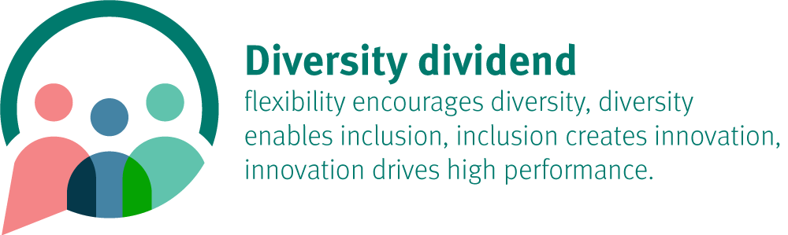

It is a good idea to have flexible work myths handy to bust as they come up in these conversations.

There are a couple of great benefits of taking this approach:
- the clock is not ticking when managers start the flexible work conversation. Unlike when employees submit a request there is 21 days to respond
- teams can moderate and openly discuss impacts and solutions
- a team-designed agreement resonates much more than a direction or rule.

2. Role model and share stories
Leading by example is the best way to influence team culture. By being vocal and sharing your own commitments to work-life balance gives permission for others to do so too.

Anyone, including managers, can work flexibly.

Check out flexible work case studies and pilots from across the sector and share them with your colleagues.

3. Embed the new norm
Make flexible work part of ‘the way we do things around here’ by:
- considering requests for flexible work with an open mind and willingness to try new things
- embedding flexible work into all roles and promote heavily during recruitment
- creating collaborate work environments and provide access to mobile technology
- managing by outcomes (DOCX, 250KB)
- dedicating a portion of each team meeting to looking ahead the next few weeks and seeing where flexibility needs to adjust, both ways, to ensure service delivery is optimised.

4. More information
To learn more, visit Flexible by Design.

